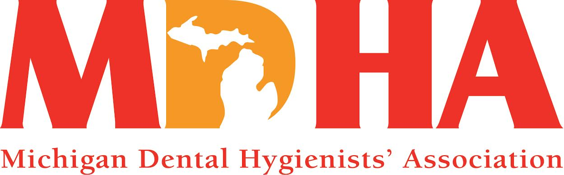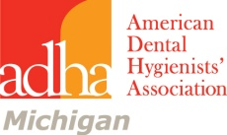
September 2014 Newswire
Stay in contact with MDHA visit our website
http://www.mdhatoday.org
President’s Message September 2014
Autumn signals many events, harvest time, the first day of school, football, and the Michigan Dental Hygienists’ annual House of Delegates. Last year we celebrated our 90th anniversary. We have entered the last decade of our first one hundred years. We need to make it count. My theme for this year was “Frame Your Future and Together Lets Frame the Future of the Michigan Dental Hygienists’ Association”.
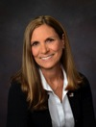
Be a part of the change. If you have never attended a house of delegates, make this one your first. It is a powerful experience. It is being held at the Troy Marriott in Troy, MI on October 17-19, 2014. When calling to make reservations reference, House of Delegates. (248-680-9797) I look forward to seeing you there.
We are planning an all day seminar on the Friday prior to opening ceremonies of the House of Delegates. Our seminar should prove to be not only informative but exciting. Health care delivery systems are changing, driven by access to care issues and the demand for affordable quality health care. As a profession we need to be proactive and prepared for what the future holds for dental hygienists. We have two speakers planned. The morning session will feature Beth Nicely, our district V trustee to ADHA, providing us with the new strategic plan ADHA has adopted to better position dental hygienists for the future. She will explain how ADHA plans to provide the profession of dental hygiene with the necessary credentials to be acknowledged as the primary care providers of preventive oral health. The afternoon session will feature Kathy Sheppard explaining how to educationally prepare the dental hygienist to the next level, as the advanced practice dental hygienist. Following the seminar there will be a welcome reception where you can mingle with friends, old and new. Friday evening is the opening ceremonies and our keynote speaker will be Kathy Sheppard, focusing on empowerment. We are stronger in numbers, we need a strong voice to send a strong message, be a part of that voice. We are dental hygienists, we are the preventive oral health care specialists, let’s send our message loud and clear. If not a member, join. This is our time and this is your time, join today at ADHA.org
Respectfully submitted,
Cheryl Bentley, RDH
MDHA President

JOB OPPORTUNITIES
Did you know that you can find great job opportunities on the MDHA website? Check it out today, visit http://www.mdhatoday.org/members/Employment%20Opportunities.html

Communication Council News
visit
www.mdhatoday.org

Please remember, if you have information regarding seminars, newsletters, or anything you feel it is pertinent for your members and students, please post it on the MDHA website, www.mdhatoday.org!!

If you have any questions, please contact our webmaster, Jen Suminski, jen_suminski@yahoo.com.

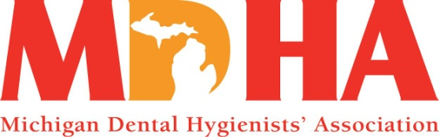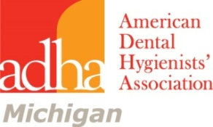
Continuing Education Seminar
Featuring Amanda Slawter
Presenting Motivational Interviewing
Where and When Fairfield in Okemos September 13
4-6pm following the Saturday Meeting of the BOT
Everyone welcome
6-7pm Wine and cheese Tasting
$20 for 2 CE Course __________
Wine and Cheese tasting $15 __________
each attendee will receive a RDH wineglass
Register for both and save! Total $30 __________
Name______________________________________
Address____________________________________
____________________________________
Phone______________________
Mail to: Joyce Losen 2310 Jolly Oak Rd Okemos, MI 48864
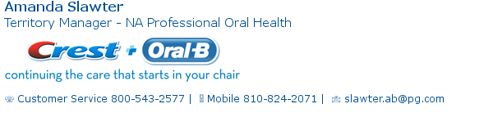

Membership Council News
10 MOST COMMON REASONS PEOPLE DO NOT JOIN ASSOCIATIONS
- No one invited me to join.
- I attended a meeting and did not feel welcomed.
- No one responded to my emails/phone calls for membership information.
- The association does not meet my needs.
- I don’t have time to attend—too busy
- The component meetings are on days/times that are not convenient for me.
- I would participate if the organization offered more online resources (chat rooms, webinars, etc.)
- Dues are too expensive for what the organization offers.
- Board members seem to be “cliquish”.
- Association does not do a good job of communicating the benefits of joining.
Remember, membership recruitment is everyone’s concern. The responsibility of recruiting and retaining members should not just be left for the Membership Council Chair and membership Council members to handle. Recruiters can be found in every level of the organization. It is a good time to remind all members of the key role they play in member recruitment and retention.
WHAT IS A TRIPARTITE ORGANIZATION?
Tripartite ( tri-par-tite) is defined as: involving three people, groups, or parts. Did you know that when you are a member of the American Dental Hygienists Association, you are a member of a tripartite organization? The national organization (ADHA), the state (constituent) organization (MDHA) and the local (component) organization. The Tripartite organization supports all levels of membership and there is no separation between the three levels. When you join one you join them all!

ATTENTION STUDENTS
The Michigan Dental Hygienists’ Association-Springboard Award applications are due:
September 15th 2014

MDHA will provide one (1) ADHA Annual Membership ($288.00) to the recipient of this award. The purpose of this award is to provide monetary relief to the recent graduate selected as the recipient of the current year Springboard Award.
We are looking for a student intent on contributing their outstanding efforts, leadership skills, activities and involvement into their professional association.
Criteria include:
• A recommendation by their local state component
• An essay: What do I foresee as my future contributions to this professional organization and how do I plan to help increase its membership?
The award will be announced at the MDHA Recognition Luncheon during the Annual House of Delegates
The award applications and descriptions can be found under the Students section of the MDHA website and also can be accessed directly at: http://www.mdhatoday.org/awards/
When filling out the application forms, please type directly into the spaces provided, then save the document to your computer. Attach the document to an email and send to Kim Amico, RDH at: kimamico_rdh@wowway.com

ATTENTION STUDENT MEMBERS!
Be sure to convert your student membership to active membership. Just follow one of these easy steps:
- Access your online profile at www.adha.org and login to your ADHA account and click the “Convert to Active Member link. OR
- By calling Member Services at 312-440-8900, press 1.
- Email: student.relations@adha.net Include your name, ADHA member ID number, license number and state of licensure.

CONTINUING EDUCATION
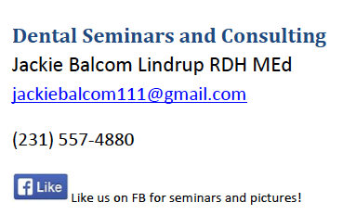
Sept. 12th The DiGangi Code for Clinicians…..$80.00
Dec. 5th Dental Ergonomics through PT and MAPS – Michigan Automated Prescription System and Narcotics abuse… $60.00 Earlybird registration, then $80.00
Seminars in Muskegon at GVSU Marec Food by Grand Traverse Pie

Russell W. Bunting Periodontal Society Seminars
Friday November 14, 2014 Speaker: Allan G. Farman, BDS, PhD Trends and Influences Affecting Dentistry through Multidimensional Imaging Location: Weber's Inn, Ann Arbor Registration 8:30 am Lecture 9-5 Visit Website, Russell W. Bunting Periodontal Society

Ferris State University Dental Hygiene Workshops
The link to all of our dental offerings is: http://www.ferris.edu/HTMLS/administration/academicaffairs/extendedinternational/cps/pages/dentalhygiene/index.htm

The link to the 2013-14 Brochure is: http://www.ferris.edu/htmls/administration/academicaffairs/extendedinternational/cps/pages/dentalhygiene/DentalWorkshopBrochure.pdf
FUNDRAISERS

MDHA Annual Coffee Sale
Do you need ideas for holiday gifts? Look no further. The annual MDHA coffee sale can help. The following coffees will be available for purchase during the fall sale. Coffee will be delivered at the November BOT meeting-just in time to enjoy during the November and December holidays. Regular coffee is $16.00 and decaf coffee is $18.00 a bag.
Check with your components for fall coffee order due dates and delivery! Help support MDHA with a cup of coffee a day!
The following coffees will be featured during the Fall 2014 sale.
Unflavored Coffee
Breakfast Blend: This mix of four beans roasted light and dark makes for a slightly stronger taste. Perfect for the morning commute or anytime. Caff or Decaf
Bunches: A blend of three beans from Central America, Africa and Indonesia, resulting in a mild but flavorful cup of coffee. Caff or Decaf
Winter’s Blend: A very popular blend of both light and dark roasted Costa Rican. This makes a smooth, full flavored and clean cup of coffee. Caffeinated only
Colombian Supremo: Rich, well balanced, and deep with a medium body. A very popular coffee around the world. Caffeinated only

Flavored Coffee
Coffee Cake: You can smell it baking in the oven! A hint of nuts, ginger, orange, cinnamon and spices. Caffeinated only
Cookie Doodle: Just like a popular old fashion cookie! Light cinnamon with hazelnut and vanilla. Caff or Decaf
Jamaican Me Crazy: A cool blend of Caramel, Kahlua, and Vanilla. A top seller! Caff or Decaf
Holiday Flavored Coffee
Christmas Spice: Egg nog with cinnamon and spices. A Favorite! Caffeinated only
Pumpkin Spice: Fresh baked pumpkin pie right from the oven. Just add whipped cream! Caffeinated only
If you have immediate questions, contact Eve Sidney at sidneyej@gmail.com

BONNIE NOTHOFF MEMORIAL FUNDRAISER FOR MDH-PAC
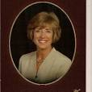
Bonnie Nothoff was President of the Michigan Dental Hygienists’ Association in 1998-99. She became MDHA’s Governmental Affairs Liaison in 2001, Director of Governmental Affairs in 2003 and was our Lobbyist from 2008 until her death in July, 2013. She worked tirelessly to organize, educate and inspire dental hygienists in Michigan to take an active role in pursuing many legislative initiatives. She helped us pass legislation that has greatly impacted the scope of practice of dental hygienists in Michigan and resulted in improved dental care for the public.
The legislation she helped MDHA pass was monumental: administration of local anesthetic and nitrous oxide analgesia by the dental hygienist with direct supervision by the dentist, our education in law not rule, impressions for mouth guards, bite splints, orthodontic appliances and bleaching trays, mandated one hour of pain management per license renewal period and the expansion of PA 58 to PA 161. This was her proudest achievement for it allowed expanded functions to underserved populations in specific sites such as schools, nursing homes and community health programs. The last legislation she was involved with was “second pair of hands” which allowed a dental hygienist to receive assistance by another individual.
Bonnie taught us the legislative process and encouraged each hygienist to contact his or her state senator and state representative and establish a working relationship with them. She would be the first to say our work is not done. This is an election year and the Michigan Dental Hygienists’ Political Action Committee needs your help.
The MDH-PAC is establishing an annual fundraiser in memory of Bonnie and all she did for dental hygienists in Michigan. The PAC uses its funds to support state senators and state representatives that support our legislative goals.
Please make a donation to the MDH-PAC in any amount in Bonnie’s memory. Help MDHA continue to pursue the legislative activity that she worked so hard to maintain.
Mail your check payable in ANY amount to MDH-PAC to Jackie Oliver, RDH 309 W. Saratoga Ferndale MI 48220 jacqoliver@gmail.com Employer information is required.
Name_______________________________________Evening phone__________________Email_____________________________
Address_____________________________________________City, ZIP__________________________________________________
Employer_______________________________Employer Address____________________________City,ZIP____________________
Paid for with regulated funds by MDH-PAC.
COMPONENT NEWS

Oakland Dental Hygienists’ Association
I am excited that we now have an OCDHA website. On our site you will find current information, board roster, CE classes offered and link to join ADHA. Please visit it often to keep current with OCDHA. This will also be the only way to get your registration forms for the CE classes offered. All you have to do is click on the link, print it off and send it out. No more searching through a newsletter. We are hoping to have PayPal added in the near future to make signing up even easier. Visit www.ocdha.com. I would like to remind those who do enjoy our CE classes to please give us your email address when signing up. We will no longer be printing off handouts; they will all be emailed if possible. We are open to any suggestion one might have on speaker topics, location of courses and anything that you might feel would be helpful to improve our courses. So please let’s hear them! You can email us at ocdha@ocdha.com.
2014-2015 OCDHA Events
9/10/14 OCDHA Business Meeting
9/17/14 Diane Culik, M.D.“ Inflammation and the Body: High Sensitivity C Reactive Protein and Gluten Sensitivity Common Underlying Causes and Findings in Disease” Ginopolis Restaurant, Farmington Hills
10/17-19 MDHA House of Delegates Troy Marriott
11/12/14 OCDHA Business Meeting
12/5/14 Amar Katranji , D.D.S., M.S. “The Hygienist’s Role in Periodontal Therapy
Curtis Smith, Pharm D., B.C.P.S. “Important Pharmacological Issues That Impact the Dental Office” Red Run Golf Club, Royal Oak
1/15/15- Jan Miller, R.D.H.- CPR Farmington Community Library
1/28/15- OCDHA Business Meeting
2/25/15 Michelle J. Tiberia, D.D.S., M.S. “Keeping Up With The Joneses…Policy updates for Pediatric Dentistry” Troy Community Center
3/26/15 Sharyn Miller, R.D.H, B.S. “Essential Oil Uses in Dentistry” Baker College Auburn Hills
4/29/15 Kongrit Chaiyasate, M.D., F.A.C.S. “Smile Reconstruction” Bloomfield Township Library
5/1-3/15 Spirit Of Michigan
Please see www.ocdha.com for registration forms and current schedule.
Contact- Deb McKelvey, RDH 3268 Catalpa Dr. Berkley, MI 48072 (248)398-7990 berkleyjimanddeb@aol.com.

The Sunrise Side Component hosted several well attended seminars this past year. It is a goal of the component to provide area hygienists with the opportunity to obtain continuing education credits locally. Topics covered included HPV &Oral Cancer, Physical Therapy Implications for TMD, Water Quality and Dental Health, and a VOCO fluoride seminar. Our spring seminar is our larger CE offering. The subject was Protecting Michigan's Most Vulnerable Children and Adults & Darkness to Light - End Child Sexual Abuse for the Dental Professional. All seminars were provided at no charge for Sunrise Side members. As always, area hygienists provided Children's Dental Health education for the area first grade students in February. We recently elected officers for the 2014-2015 calendar year. They are as follows: Becky Nunnelley, President; Brenda Budnik, Trustee; Stephanie Couture, Treasurer; Allison Johnson, Secretary; and Cheryl Smigelski, Editor. We are always looking for hygienists interested in supporting their profession to join us and take part on a local level.
Plans for this year are well underway. On October 2, 2014 we will host a pain management seminar provided by Lisa Darrow at the Alpena County Library from 6-8PM. All future seminar dates and information will be posted to the website.

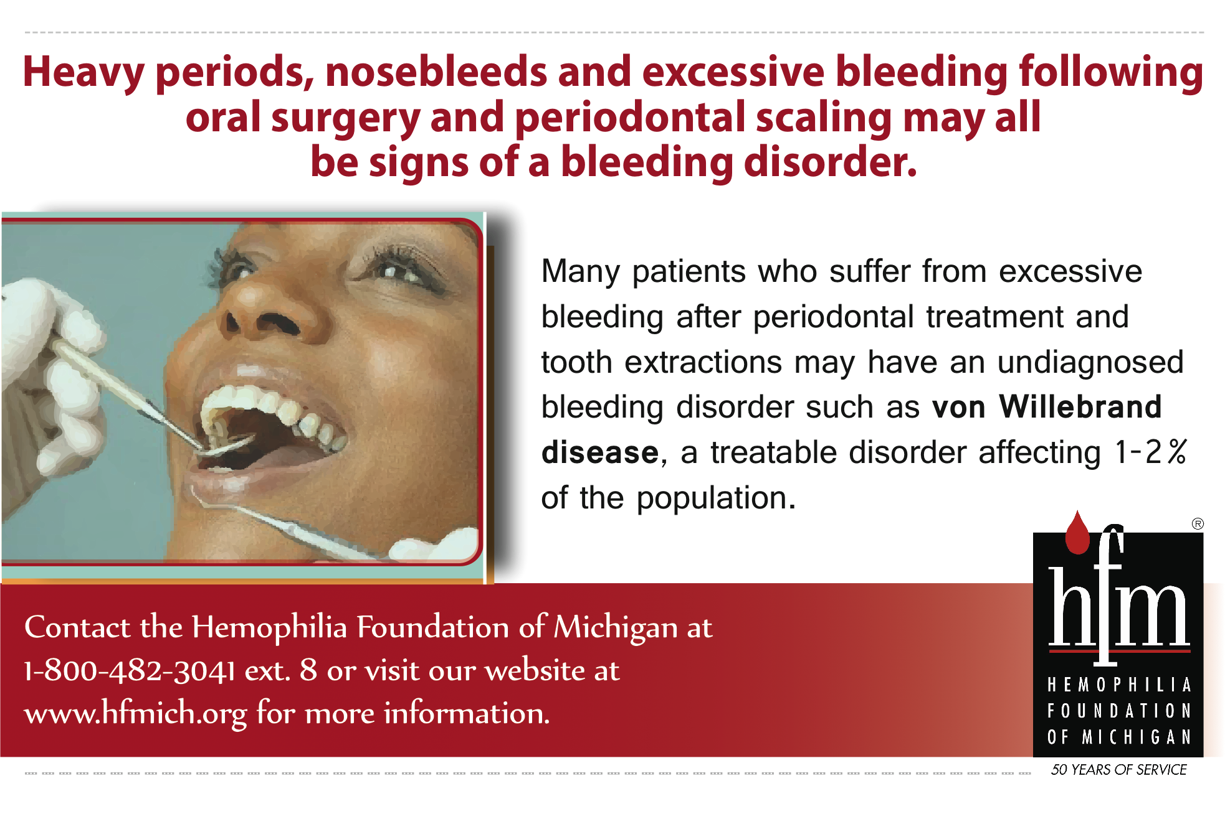

Become familiar with www.mdhatoday.org and learn to navigate MDHA’s website!! There is an easy link for a membership application, and many opportunities for continuing education credits through various components.
Advertisers: This Newswire is being sent bimonthly to approx. 1000 registered dental hygienists throughout the state. It reaches these RDH’s and then some! If you would like to have your logo appear in this publication, please visit our website www.mdhatoday.org and click on the “advertisers” link. To our readers, you are encouraged to patronize our sponsors! Thank you!

