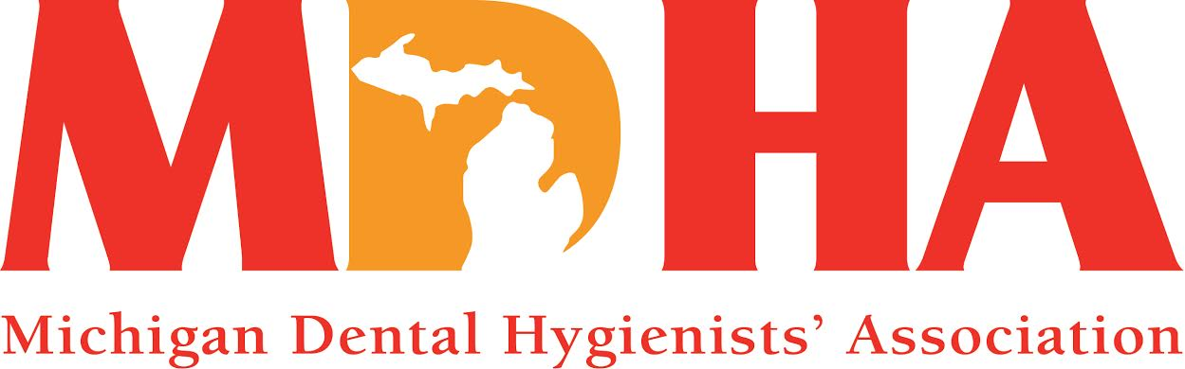
JANUARY 2015 Newswire
Stay in contact with MDHA visit our website
http://www.mdhatoday.org
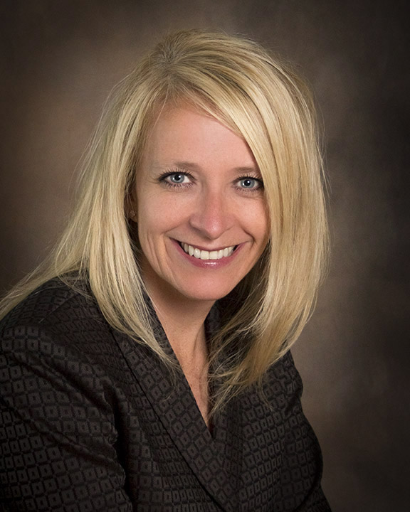

Greetings…and HAPPY NEW YEAR!!
It is that time of year where most people look back on their year and make “resolutions” to do things differently, or improve upon their previous year. It’s the 92nd year of the MDHA, and I know we are doing things differently than in 1923.

However, one thing that has not changed is that your professional association is promoting the highest standards of dental hygiene education, licensure, practice and research; helping to ensure access to quality oral health care; and representing your legislative interests at the local, state and federal levels.

Change is inevitable and we are embracing the opportunity to improve in 2015! To kick off the new year, there are new legislators in Lansing and we will prepare for our Legislative Blitz, which is a concerted effort by MDHA Officers and Legislative Council members, to build relations with our friends in the House and Senate, providing them with information about Registered Dental Hygienists, our association and how we can work together to improve the oral health in the State of Michigan. Our lobbyist, Sarah Hubbard, met with our Board of Trustees and reviewed our legislative strategic plan, and we have determined our priorities that will protect and enhance our scope of practice, increase access to dental hygiene services, and increase utilization of Registered Dental Hygienists. We look forward to working with our peers to make this happen!

Mark your calendars for March 14th when the MDHA will host a continuing education seminar in Traverse City. Shirley Branham from Dentsply will be offering 6 CEs regarding caries management, so take advantage of this MDHA benefit and come “get smart” with us! See our Education Council section of this Newswire, or check the events calendar on our website (www.mdhatoday.org) for more details.
Another important event is the annual Spirit of Michigan meeting being held April 22nd-25th. This event is great for continuing education, networking, and one-on-one opportunities to talk to vendors about the latest products. This event supports our budget, and is a wonderful way for you to help your professional association, so plan on attending the MDHA-sponsored seminars and have some fun in Lansing! Be sure to see your Trustee to purchase a $10 ticket for our Weekend Getaway Raffle! The drawing will be held April 25th.

Though we are focused on the future, there are several things that must be recognized from our past. First, and most importantly, we ended our 2013-14 fiscal year with a surplus and I credit all Officers, Council Chairs and our Association Administrator, for being responsible with their budgets! It is imperative that MDHA be fiscally sound, and you should be proud that your Board of Trustees is making your dues dollars count. When I attended the ADHA Unleashing Your Potential weekend in Chicago, I gained valuable knowledge about corporate governance and fiduciary responsibilities, from which I presented a summarized version to the Board, so that everyone is on the same page and can benefit from the information. This will definitely be helpful in moving our Association forward and in the right direction.
We have updated our Bylaws, Policies and Standing Rules, per the House of Delegates, as well as reviewed and updated our Policy & Procedure manual to reflect current needs and situations.
Finally, we heard a presentation from Teri Battaglieri, Director of the Delta Dental Foundation and are expanding our relations with this Foundation to “improve oral and overall health and well-being of Michiganians!” There is nothing better than working together to enhance our mission and vision than collaborating with others who make oral health a priority!

I hope you will join us to reach our goals and will then celebrate our successes when we look back on 2015 with pride!

In harmony...
KATHY MIELKE, BS, RDH
THANK YOU
President Bentley was presented with her outgoing president’s gift! We so greatly appreciate all that she did to “Frame the Future” of MDHA
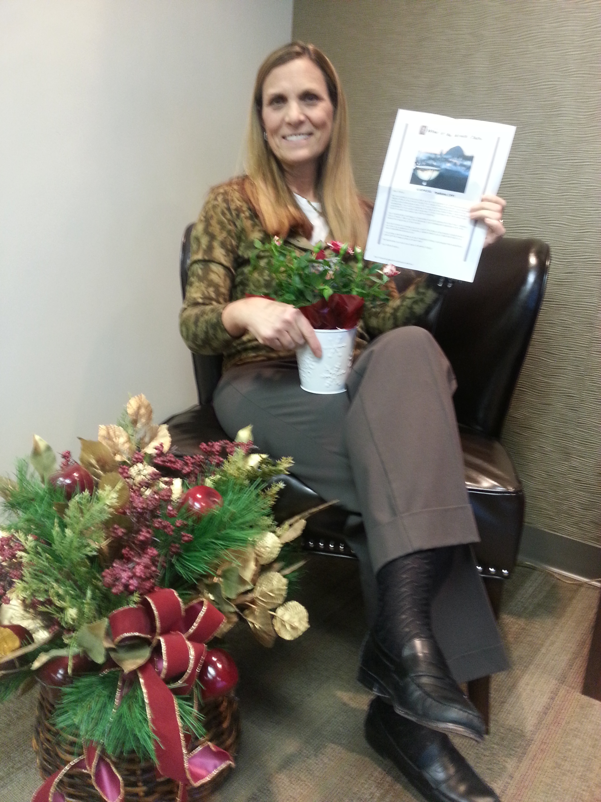
December BOT Meeting (Joyce Losen-AA, Allison Restauri-President Elect,
Cheryl Bentley-Past President, Kathy Mielke-President, Vicki Yahn-Vice President)

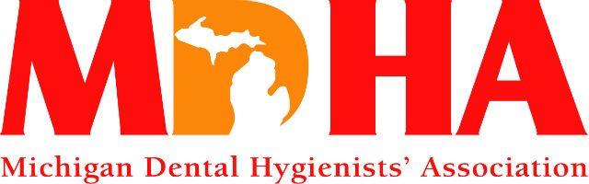
Eat, Stay & Play….
Design Your Own Getaway!
Win! Win! Win!
$900 gift card valid at the following Zehnder’s properties:
- Zehnder’s Restaurant
- Zehnder’s Gift Shop
- Zehnder’s Marketplace
- Z Chef’s Café
- Zehnder’s Splash Village Hotel & Waterpark
- The Fortress Golf Course
Raffle tickets are only $10 each. Tickets are on sale from
December until they are gone.
Only 400 tickets printed so get yours today!!

Drawing will take place on April 25, 2015 at the
Spirit of Michigan Meeting in Lansing MI

Need not be present to win

LEGISLATIVE NEWS
On behalf of Oral Health America (OHA), thank you for participating in the White House Conference on Aging sign-on letter. We are thrilled to announce that a total of 286 national, state, and local organizations and individuals signed on to this letter! Attached you will find a final copy for your records.
Additionally, we would like to encourage all of you to visit Toothwisdom.org, a first-of-its-kind online tool that connects older adults and caregivers to dental care where they live and educates them about the importance of oral health. The site also includes expert content for health professionals about the unique oral health needs of older adults. Health professionals are invited to contribute content for toothwisdom.org to share with other health professionals and for older adults and caregivers.
Best,
Bianca Rogers, Advocacy Coordinator Oral Health America
180 N. Michigan Ave., Ste 1150 | Chicago, IL 60601

Thank you letter from OHA

ADHA, FTC Submit Final Comments to Commission on Dental Accreditation (CODA) on Proposed Standards for Dental Therapy Education Programs

The deadline to submit comments to the Commission on Dental Accreditation (CODA) regarding the proposed dental therapy education standards was Dec. 1, 2014. The American Dental Hygienists’ Association (ADHA) very much appreciates all of the dental hygienists and state associations that provided written and oral comments to CODA. By sharing your expertise and experience you are helping to move the profession forward and open up additional opportunities for oral health access. On your behalf, ADHA also submitted a letter of comment. ADHA thanks the Council on Education for their assistance in addressing the technical matters concerning the proposed standards.
The ADHA was very pleased to see that the U.S. Federal Trade Commission (FTC) once again submitted a letter of comment to CODA. Further, the FTC comments echoed many of the same points that were included in the ADHA’s remarks, and in which the FTC urged CODA to expeditiously adopt accreditation standards for dental therapy education programs. The ADHA also has distributed a press release on the comments sent to CODA, which can be found at http://www.adha.org/resources-docs/ADHA_CODA_Comments_Press_Release_12-3-14.pdf, and the topic is also covered in the Dec 3, 2014, issue of ADHA Update.

Summary of FTC Comments
The FTC acknowledged that the timely adoption of standards has the potential to enhance competition by supporting state legislative initiatives to create dental therapists, and that national standards will help facilitate the mobility of dental therapists from state to state to meet consumer demand for services. The FTC asserted that further delay in the adoption of accreditation standards could discourage and delay the development of education programs, and reduce the availability of dental therapists.
The FTC noted that categorical statements regarding a supervising dentist’s responsibility for diagnosis and treatment planning could limit the competitive benefits of the new provider. Further noting that these statements might discourage state policymakers from allowing dental therapists to conduct evaluation and formulate treatment plans in the absence of an on-site dentist, and might also hinder the development of education programs that would educate dental therapists to perform those functions.
The FTC reiterated that provisions for advanced standing and career laddering for students licensed in other dental professions, such as dental hygiene and dental assisting, could enhance competition by increasing the number of providers entering the field. Further, creating dental therapy education programs and expanding the supply of dental therapists is likely to increase the availability of oral health services, enhance competition, reduce costs, and expand access to dental care.

Background
CODA has been accepting public comments on the proposed dental therapy education standards. From its inception the Commission noted that the draft standards were presented as a non-dental hygiene track but could be modified to support a dental hygiene program track. The ADHA has been working diligently on this effort.
In March 2013, the ADHA met with the FTC and our conversations with them have continued. The FTC works for consumers to prevent fraudulent, deceptive and unfair business practices, and to provide information to help stop and avoid them. The FTC’s charge to promote competition for the benefit of consumers underlies the FTC’s interest in commenting on CODA’s proposed dental therapy education standards.
The FTC supports CODA’s efforts to facilitate the creation of new dental therapy education standards and to expand the supply of dental therapists. As noted previously, the FTC stated that they believe this will likely increase oral health service delivery, enhance competition, reduce costs, and expand access to dental care.
Next Steps
CODA will meet on Feb. 6, 2014, when it is expected to have further deliberations on the proposed standards for dental therapy education programs. The ADHA will be there and will keep you apprised of further developments.
The ADHA is committed to increasing organized dental hygiene’s involvement in the development of new workforce models. As such, the ADHA Governmental Affairs team will be following up individually with the states of Washington, New Hampshire, New Mexico, Connecticut, Kansas, Vermont and Massachusetts in the coming weeks to discuss how to leverage the FTC letter of comment to complement the workforce efforts underway in those states. In addition, we will be further briefing Minnesota and Maine as the two states where dental therapy is law.
For all other states, we encourage you to share the ADHA and FTC letters with your members and interested stakeholders. Together, we are making a difference.
MEMBERSHIP NEWS
Visit http://www.adha.org/annual-session for all the details
Registration and Housing opens January 7th.
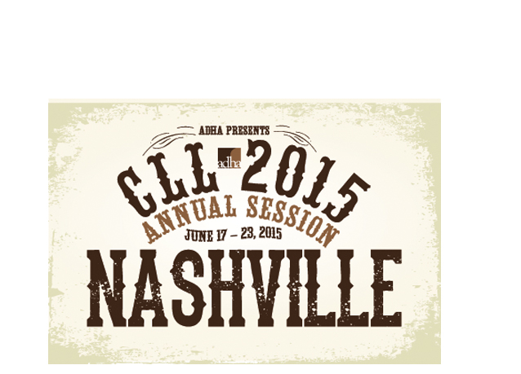

Communication Council News
visit
www.mdhatoday.org

Please remember, if you have information regarding seminars, newsletters, or anything you feel it is pertinent for your members and students, please post it on the MDHA website, www.mdhatoday.org!!

If you have any questions, please contact our webmaster, jsuminski6@gmail.com.

CONTINUING EDUCATION
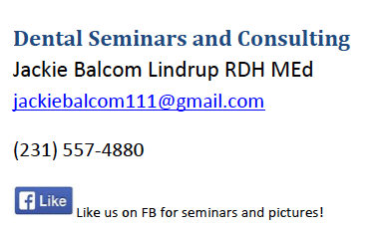

Ferris State University Dental Hygiene Workshops
The link to all of our dental offerings is: http://www.ferris.edu/HTMLS/administration/academicaffairs/extendedinternational/cps/pages/dentalhygiene/index.htm

JOB OPPORTUNITIES
Did you know that you can find great job opportunities on the MDHA website? Check it out today, visit http://www.mdhatoday.org/members/Employment%20Opportunities.html
Become familiar with www.mdhatoday.org and learn to navigate MDHA’s website!! There is an easy link for a membership application, and many opportunities for continuing education credits through various components.
Advertisers: This Newswire is being sent bimonthly to approx. 1000 registered dental hygienists throughout the state. It reaches these RDH’s and then some! If you would like to have your logo appear in this publication, please visit our website www.mdhatoday.org and click on the “advertisers” link. To our readers, you are encouraged to patronize our sponsors! Thank you!

