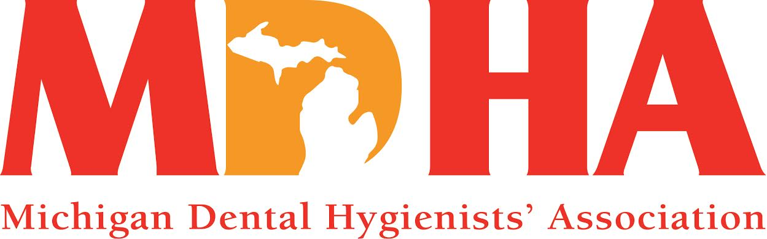

**March 2015 Newswire**

Description: Description: C:\Documents and Settings\HP_Administrator.HPBARRYMAIN\Local Settings\Temporary Internet Files\Content.IE5\ALVPQZNL\MC900072691[1].gif

Stay in contact with MDHA visit our website

<http://www.mdhatoday.org>

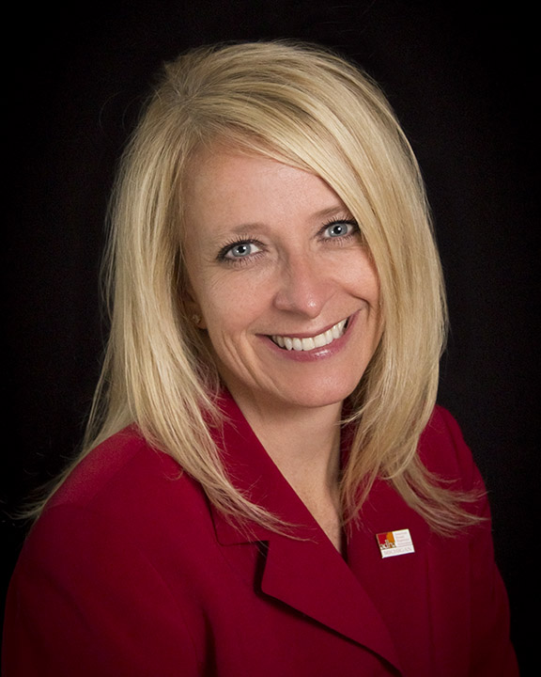

Well, we are almost to the first day of Spring, so we all deserve the title of *survivor*! We made it!! Soon, the days will be longer, the weather warmer and nature will be blossoming into beautiful colors! As we “spring ahead” this time of year, it is a perfect opportunity to “spring” into your professional association and become involved with others that truly care about Registered Dental Hygienists. It is common to hear “what does my dental hygiene association do for me?” and I tell you, we are blossoming, too!

In the last two months, we have been collaborating with other professional organizations to expand outreach and promote oral health and wellness. We are teaming up with Oral Health America (Chicago) to host a community-based health education workshop for older adults. We will be connecting with the Altarum Institute to learn about an opportunity to reduce the burden of childhood disease in Michigan through the Michigan Caries Prevention Program. We also have partnered with the Michigan Department of Community Health to be involved with the Count Your Smiles program, which will begin this Fall. Check our website under Resources, Volunteer Opportunities to find many ways you can “blossom” and make a difference as an RDH!

We have been strengthening our advocacy efforts through our support of the Healthy Kids Dental expansion, as well as educating almost 50 new Legislators and their staff about Registered Dental Hygienists and our value to the healthcare profession (be sure to review the upcoming Legislative Alert)!

Your Constituent is becoming more fluid with technology as we have added Paypal to our website, and we are excited to announce that we now have a Twitter account, #MIdentalhygiene, which is also linked to our website! We are making progress with redistricting of our Components to be more effective and efficient as we transform the profession of dental hygiene. And, we have numerous CE events throughout the State – just view the Events Calendar on our website for details.

Now, grab your calendars and mark these important dates so that you can take advantage of a small portion of what MDHA offers!

* April 22nd-25th ~ Spirit of Michigan meeting, Lansing Center, Lansing
* May 2nd ~ Board of Trustees meeting, Okemos
* May 13th ~ Legislative Luncheon, House Office Building, Lansing

Embrace the opportunity to be involved in something bigger than yourself and truly appreciate the value of your professional association! We are a “blooming” business and we look forward to continued growth with YOU!

In harmony…

KATHY MIELKE, BS, RDH

MDHA President

Description: Description: C:\Documents and Settings\HP_Administrator.HPBARRYMAIN\Local Settings\Temporary Internet Files\Content.IE5\ALVPQZNL\MC900072691[1].gif

Eat, Stay & Play….

Design Your Own Getaway!

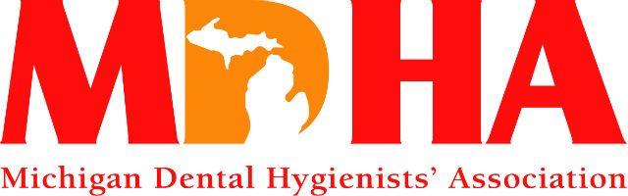

*Win! Win! Win!*



$900 gift card valid at the following Zehnder’s properties:

Zehnder’s Restaurant, Zehnder’s Gift Shop, Zehnder’s Marketplace, Z Chef’s Café, Zehnder’s Splash Village Hotel & Waterpark, The Fortress Golf Course

Raffle tickets are only $10 each. Tickets are on sale from

December until they are gone.

Only 400 tickets printed so get yours today!!

Drawing will take place on **April 25, 2015** at the

Spirit of Michigan Meeting in Lansing MI

Need not be present to win

Description: Description: C:\Documents and Settings\HP_Administrator.HPBARRYMAIN\Local Settings\Temporary Internet Files\Content.IE5\ALVPQZNL\MC900072691[1].gif

**LEGISLATIVE NEWS**



Legislative Alert

March 2015

**\*Leadership in Lansing\***

~ MDHA officers, along with members Marge Buehner, Melanie Colbert, Karen Lawson and our lobbying firm (Acuitas), spent a very cold Wednesday in February, visiting new legislators and introducing them to the profession of dental hygiene. Each legislator received an MDHA folder with fact sheets, as well as an oral health goodie bag. Almost 50 legislators were informed about who we are and what we do, along with our educational backgrounds, licensure requirements and our legislative priorities. We were well received and look forward to working with these new elected officials!

~ MDHA President, Kathy Mielke, BS, RDH, and our lobbyist, Sarah Hubbard, attended a reception honoring Appropriations Chairman, Senator Dave Hildenbrand, who is a long time supporter of MDHA. It was a wonderful networking experience!

~ On behalf of MDHA, your President-Elect, Allison Restauri, RDH, BSDH, MA, provided testimony to the Department of Community Health, House Appropriations Sub-Committee, regarding support of Governor Snyder’s proposed funding increase to the Healthy Kids Dental program. MDHA is in favor of expanding this benefit to children ages 0-8 in Oakland, Wayne and Kent counties.

~ Later this month, Allison will also provide testimony to the House Health Policy Committee per request of the Chair, Representative Mike Callton, who is interested in having a dental day presentation for his committee.

Thank you, Allison for representing our profession and ensuring we are recognized as a valuable asset to the healthcare team!

Also later this month, Cheryl will be in Lansing attending a fundraiser along with our lobbyist, Sarah Hubbard, for Representative Rob VerHeulen, who is a member of the health policy committee.

**\*ADA presents another workforce model\***

You might remember back in 2006 when the ADA launched a pilot project to produce community health workers whose training focuses on oral health. These Community Dental Health Coordinators (CDHCs) are to work in underserved rural, urban and Native American communities. The MDHA, and many others, pushed back on the creation of this new workforce model, voicing that Registered Dental Hygienists are already trained and the most qualified to focus on oral health!

This pilot program did not happen in Michigan, but as of Fall 2014, the CDHC project has graduated 34 students who are now serving in 26 communities in 8 states: Arizona, California, Montana, Minnesota, Oklahoma, Pennsylvania, Texas, and Wisconsin. (www.ada.org)

Introducing, the **Oral Preventive Assistant (OPA)** – another ADA workforce model.

Duties assigned to the OPA may vary from state to state but are *expected to build on the* *dental assistant scope* to include collection of diagnostic data such as medical histories, vital signs, and charting; radiographs; preventive services for all types of patients, including preventive and oral hygiene instruction, application of fluoride and sealants, coronal polishing for all patients, scaling for plaque induced gingivitis patients; application of topical anesthetic and general office duties including facilitating basic legal and regulatory compliance, e.g., HIPAA compliance, maintaining patient treatment records, and managing a recall system. States will determine eligibility, training, and certification and/or licensure requirements. The OPA services may be provided by the creation of a new category of allied dental personnel or added to an existing certification/licensure category (dental assistants). The ADA had a link on their website under education/careers > careers > dental team careers, but to date when clicking on it, it states “page not found.”

Stay tuned for more information as MDHA receives it.

**\* Commission on Dental Accreditation (CODA) adopts Dental Therapist (DT) accreditation standards\***

At its February 6, 2015 meeting, the Commission on Dental Accreditation adopted the Accreditation Standards for Dental Therapy Education Programs. The Commission notified the communities of interest that there will be no implementation date until further documentation has been provided which shows that criteria #2 and #5 of the "Principles and Criteria Eligibility of Allied Dental Programs for Accreditation by the Commission on Dental Accreditation" are fully satisfied. The Commission will accept written documentation until June 1, 2015, which shows that criteria #2 and #5 are fully satisfied, for consideration at the August 7, 2015 meeting of the Commission.

The Accreditation Standards and Principles and Criteria Eligibility are found on the Commission's Accreditation News Webpage: <http://www.ada.org/en/coda/accreditation/accreditation-news/>

Below are highlights from the approved dental therapy standards:

* **Advanced Standing:** The program may grant credit for prior coursework toward completion of the dental therapy program. This credit may be given to dental assistants, expanded function dental assistants and dental hygienists who are moving into a dental therapy program. Programs prerequisites and other allied dental program course work are a part of the years of full-time study.
* **Program Length:** The educational program must include at least three academic years of full-time instruction or its equivalent at the postsecondary level. This is considered the minimum amount of time required to educate a dental therapist. A specific academic degree is not identified.
* **Supervision:** The dental therapist provides care with supervision at a level specified by state practice act.
* **Scope of Practice:** Dental therapy’s minimal scope of practice is outlined in the standards by listing the competencies required within the dental therapy curriculum. Some of the *assessment skills* such as evaluation, charting, patient referral and radiographs are listed. *Preventative functions* include, but are not limited to, sub-gingival scaling and dental prophylaxis, application of preventive agents, dispensing and administration of non-narcotic medications via oral or topical routes as prescribe by a licensed health care provider based on state laws. *Restorative/surgical procedures* such as simple extractions of primary teeth, fabrication of temporary crowns, pulp capping, preparation and placement of direct restorations.

**\*Professional Liability Insurance \***

Due to a recent inquiry by an RDH about license renewal, we wanted to clarify that Michigan law does not require licensed professionals to have malpractice insurance, but it is highly recommended (per LARA official, Perry Bell). We also received confirmation from Debra Gagliardi, Assistant Attorney General, Licensing and Regulation Division, that “there is no current requirement under Michigan law that hygienists and assistants obtain their own professional malpractice insurance. In fact, there is no statutory requirement that dentists carry malpractice insurance, although most do. It may be prudent for a hygienist to get malpractice insurance if an individual works in multiple offices or volunteers professional services. To my knowledge there is no pending statutory or regulatory proposal to require dental hygienists and assistants to carry liability insurance.”

**\*CE credits for Volunteering \***

Many of us will volunteer throughout the year and may assume that we will receive CE credit for that service, but remember, regular CE approved sponsors or components are not allowed to give volunteer CE credit without additional approval. Volunteer CE credits are for services provided to the *underserved* and *must be non-profit*.

2 hours of clinical service = 1 CE and there is a maximum of 12 volunteer CE credits per renewal period.

Records must be kept on all volunteers.

Anyone seeking approval can attach a letter with all relevant information to the current CE program approval application found at this link:  <https://www.michigan.gov/documents/lara/Dentistry_CE_Sponsorship_Program_455685_7.pdf?20141216101528>Description: Description: C:\Documents and Settings\HP_Administrator.HPBARRYMAIN\Local Settings\Temporary Internet Files\Content.IE5\ALVPQZNL\MC900072691[1].gif 

Description: Description: C:\Documents and Settings\HP_Administrator.HPBARRYMAIN\Local Settings\Temporary Internet Files\Content.IE5\ALVPQZNL\MC900072691[1].gif

**COMMUNICATION NEWS**

Are you interested in keeping updated with MDHA? Want to know what is happening legislatively? I'm pleased to announce that we now have a twitter account. Please make sure that you follow us at #midentalhygiene on twitter.

If you haven't liked us on Facebook, head on over now and like our page to get current information: Michigan Dental Hygienist's Association.

Don't forget to check out the website. You will learn about upcoming CE's, job postings, and be able to network with other hygienists here in Michigan. Make sure that you set the website in your favorites and visit often: [www.mdhatoday.org](http://www.mdhatoday.org/)

Stay Connected,

Melissa Rosochacki, RDH, BSDH

Communications Council Chair

Description: Description: C:\Documents and Settings\HP_Administrator.HPBARRYMAIN\Local Settings\Temporary Internet Files\Content.IE5\ALVPQZNL\MC900072691[1].gif

**CONTINUING EDUCATION**

[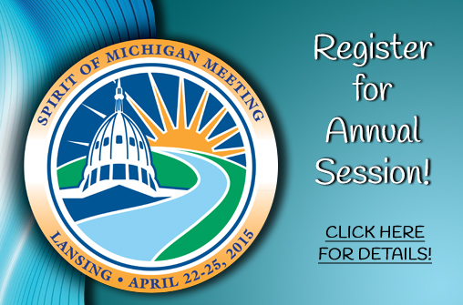](http://www.smilemichigan.com/pro/CE-Courses/Annual-Session)

<http://www.smilemichigan.com/pro/CE-Courses/Annual-Session/MDHA-Program>

# Dental Seminars and Consulting PLLC

**Jackie Balcom Lindrup RDH MEd**

jackiebalcom111@gmail.com (231) 557-4880

Email for registration form or pay by credit card

Like us on FB for seminars and pictures!

FRIDAY April 24, 2015 **“Medical Histories and Medical Emergencies in the Dental Office: Vital Signs for the Dental Team”**Cindy Kleiman RDH, BS

Earlybird: $60 (by 4/4) General Registration: $80 (4/4-4/22)

4 CE, GVSU Michigan Alternative and Renewable Energy Center, Muskegon MI; 8:30-12:30 PM- space limited!!! Credit cards welcome

Description: Description: C:\Documents and Settings\HP_Administrator.HPBARRYMAIN\Local Settings\Temporary Internet Files\Content.IE5\ALVPQZNL\MC900072691[1].gif

**PUBLIC HEALTH NEWS**

**Check out this article: Fluoride program supports students' dental health**

<http://www.uppermichiganssource.com/news/story.aspx?id=1154666>

Description: Description: C:\Documents and Settings\HP_Administrator.HPBARRYMAIN\Local Settings\Temporary Internet Files\Content.IE5\ALVPQZNL\MC900072691[1].gif

**JOB OPPORTUNITIES**

Did you know that you can find great job opportunities on the MDHA website? Check it out today, visit http://www.mdhatoday.org/members/Employment%20Opportunities.html

Description: Description: C:\Documents and Settings\HP_Administrator.HPBARRYMAIN\Local Settings\Temporary Internet Files\Content.IE5\ALVPQZNL\MC900072691[1].gif



Description: Description: C:\Documents and Settings\HP_Administrator.HPBARRYMAIN\Local Settings\Temporary Internet Files\Content.IE5\ALVPQZNL\MC900072691[1].gif

Become familiar with [www.mdhatoday.org](http://www.mdhatoday.org) and learn to navigate MDHA’s website!! There is an easy link for a membership application, and many opportunities for continuing education credits through various components. Description: Description: C:\Documents and Settings\HP_Administrator.HPBARRYMAIN\Local Settings\Temporary Internet Files\Content.IE5\ALVPQZNL\MC900072691[1].gif

**Advertisers**: This Newswire is being sent bimonthly to approx. 1000 registered dental hygienists throughout the state. It reaches these RDH’s and then some! If you would like to have your logo appear in this publication, please visit our website [**www.mdhatoday.org**](http://www.mdhatoday.org) and click on the “advertisers” link. To our readers, you are encouraged to patronize our sponsors! Thank you!

