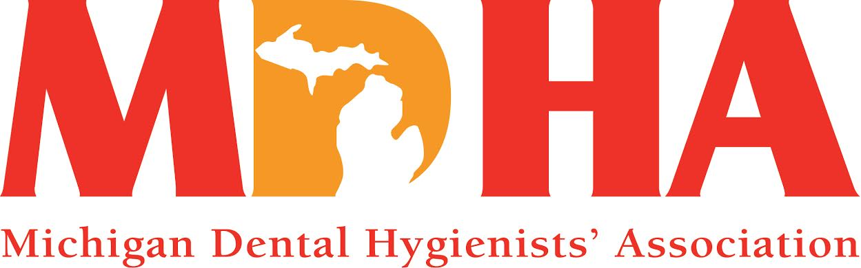

**May 2015 Newswire**

Description: Description: C:\Documents and Settings\HP_Administrator.HPBARRYMAIN\Local Settings\Temporary Internet Files\Content.IE5\ALVPQZNL\MC900072691[1].gif

Stay in contact with MDHA visit our website

<http://www.mdhatoday.org>

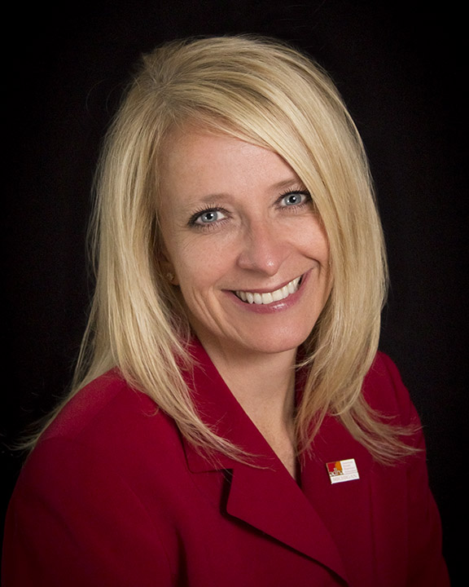

April showers bring May flowers, right? Well, at least that’s how the saying goes! Regardless of when the rains come, it is always pleasant to see trees budding and flowers blooming! The season is changing, the scenery is changing, and we embrace the warmth of the sun and the smell of the flowers! The same is happening with your professional association. We are embracing *change*, and making *change* happen, one day at a time.

Most recently, MDHA hosted over 40 dental hygienists for a training workshop, provided by Oral Health America (OHA), titled “Tooth Wisdom: Get Smart About Your Mouth.” With this training, these RDHs will connect community-dwelling older adults with oral health resources and education. Michigan is the 1st state to take on this project and we are proud to partner with OHA, the Area Agencies on Aging Association and the Coalition for Oral Health for the Aging (COHA) to empower older adults to care for their oral health. Stay tuned for opportunities to assist with these workshops locally and *change* the way people think about their oral health, especially in our older-adult population.

The MDHA is also hosting our annual Legislative Luncheon where RDHs can *change* the way legislators think and speak about the dental hygiene profession. This is our opportunity to “shine” and educate the legislators, and their staff, with exactly who we are, what we do, our educational background, licensure and value that we bring to healthcare as an essential primary care provider. This event happens every year, and the legislators want to hear from YOU, their constituent. So, if you have never attended or have come every year, this is a great opportunity to network with those working for us at the State level. We want to thank our sponsor, Delta Dental, for their support and for collaborating with us on this wonderful event!

Soon, your MDHA delegation will be heading to Indianapolis to meet with District V delegates from Kentucky, Ohio and Indiana to review proposed Bylaws and Resolutions for ADHA Annual Session, and to elect our new District V Trustee. *Change* will be happening as we streamline our policies and improve the foundation of our profession.

We have several hundred students whose lives are about to *change* as they celebrate their success at pinning ceremonies and graduations. I was honored to be invited to attend the UDM Commencement ceremony, as well as several pinning ceremonies! What a wonderful opportunity to showcase our profession and support our colleagues and friends! **Congratulations to all dental hygiene graduates!** We look forward to you joining and/or maintaining membership in your professional association so that we can transform our profession together!

Don’t forget to “like” us on Facebook and connect with us on Twitter at #MIdentalhygiene.

The time is now to get on the “*change*” train and take advantage of all that your professional association does for you. Make the future of dental hygiene something more than what it is now, or what it would be, if we just left it alone.

We are all *change* agents, so I know you have it in you to “be the *change* you wish to see in the world.”

In harmony…

KATHY MIELKE, BS, RDH

MDHA President

Description: Description: C:\Documents and Settings\HP_Administrator.HPBARRYMAIN\Local Settings\Temporary Internet Files\Content.IE5\ALVPQZNL\MC900072691[1].gif



Description: Description: C:\Documents and Settings\HP_Administrator.HPBARRYMAIN\Local Settings\Temporary Internet Files\Content.IE5\ALVPQZNL\MC900072691[1].gif

**FINANCE COUNCIL NEWS**

MDHA's "Getaway" raffle winner was AJ Jarabek.  She is an RDH and clinical representative for Young Dental who will receive a $900 gift card to create her Frankenmuth getaway!  Congratulations, AJ and thank you to all who purchased a ticket!  Stay tuned for our next raffle adventure!!

We have new fundraising items for sale!  Check out the MDHA luggage/bag tag and our first aid kit!  These items are $5.00 each, and will sell out fast!!

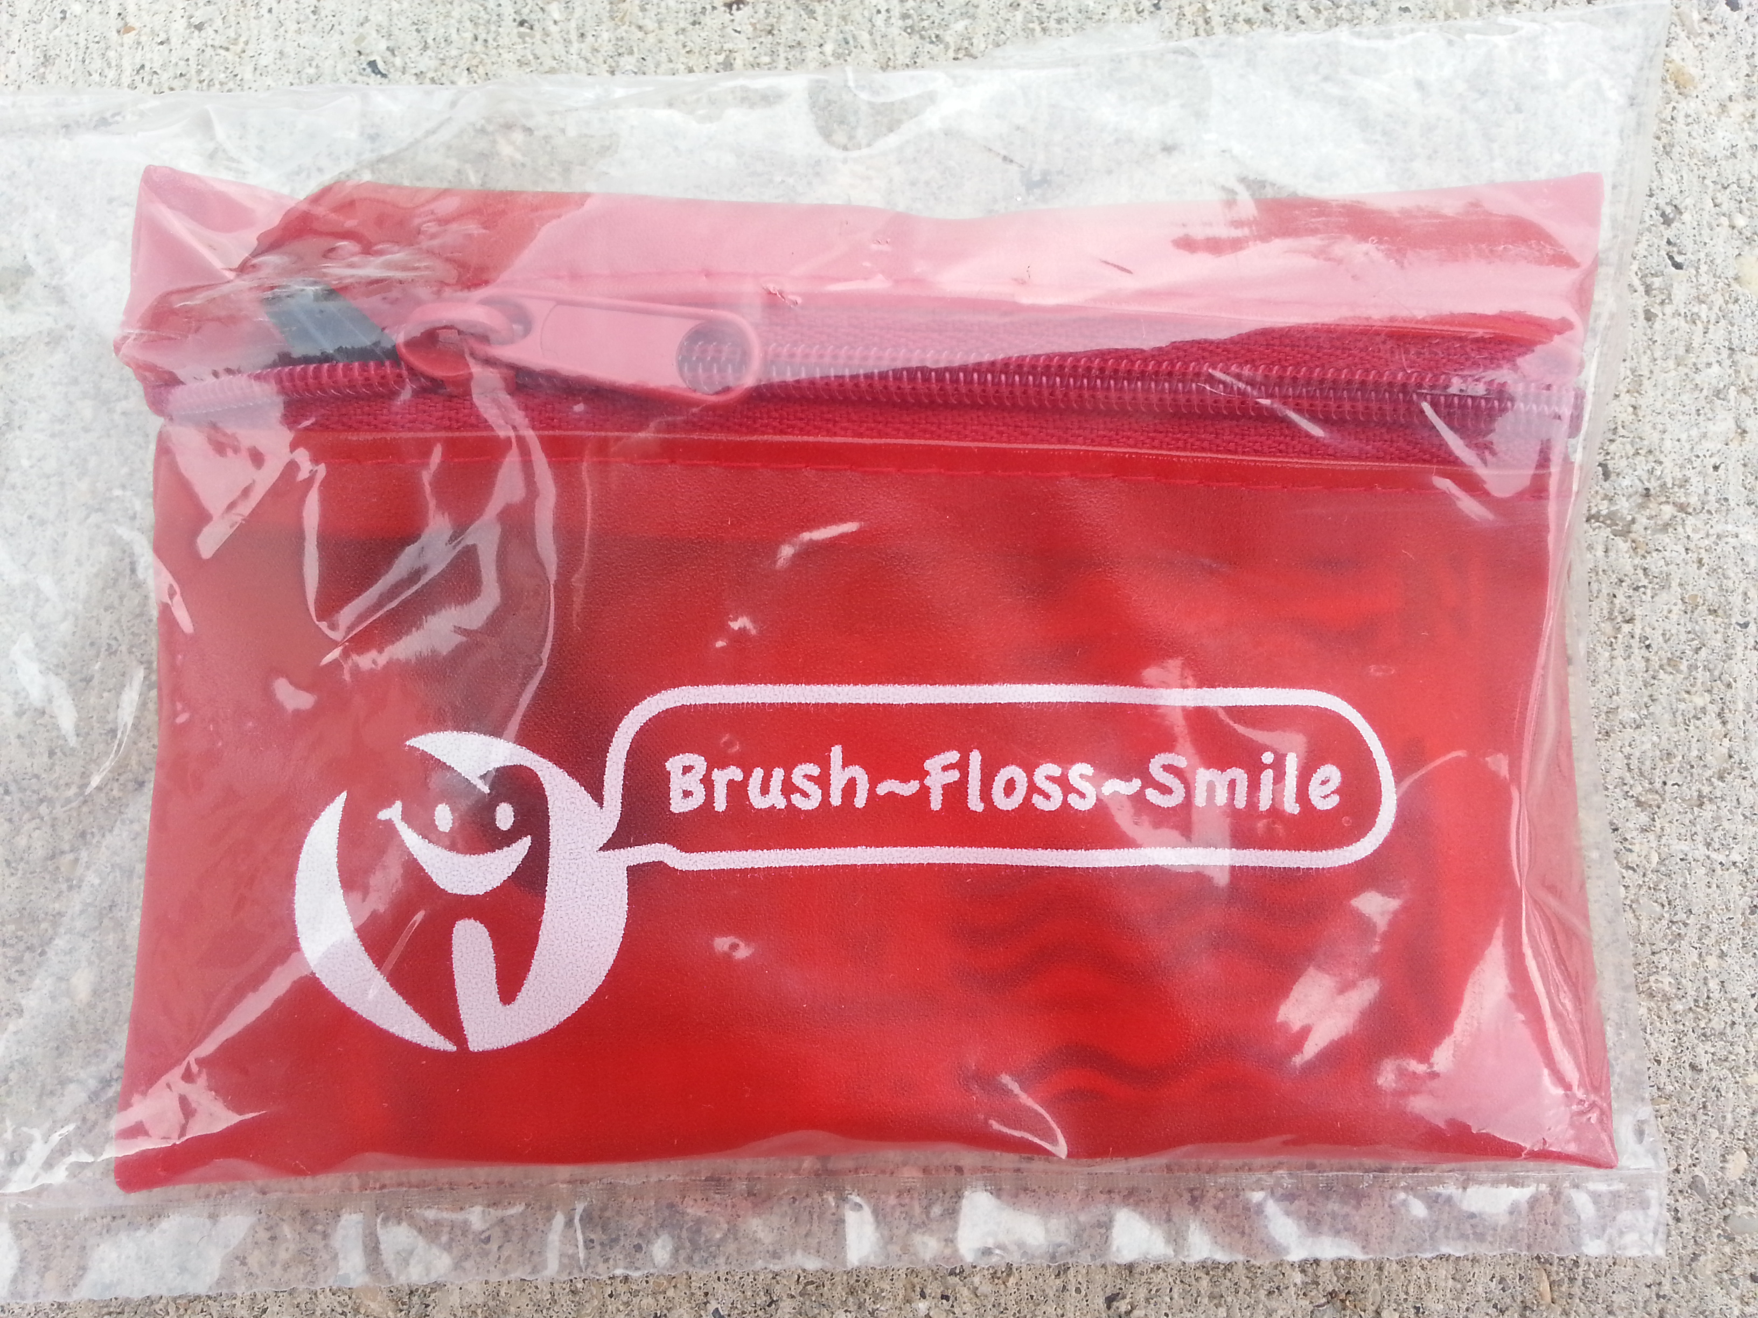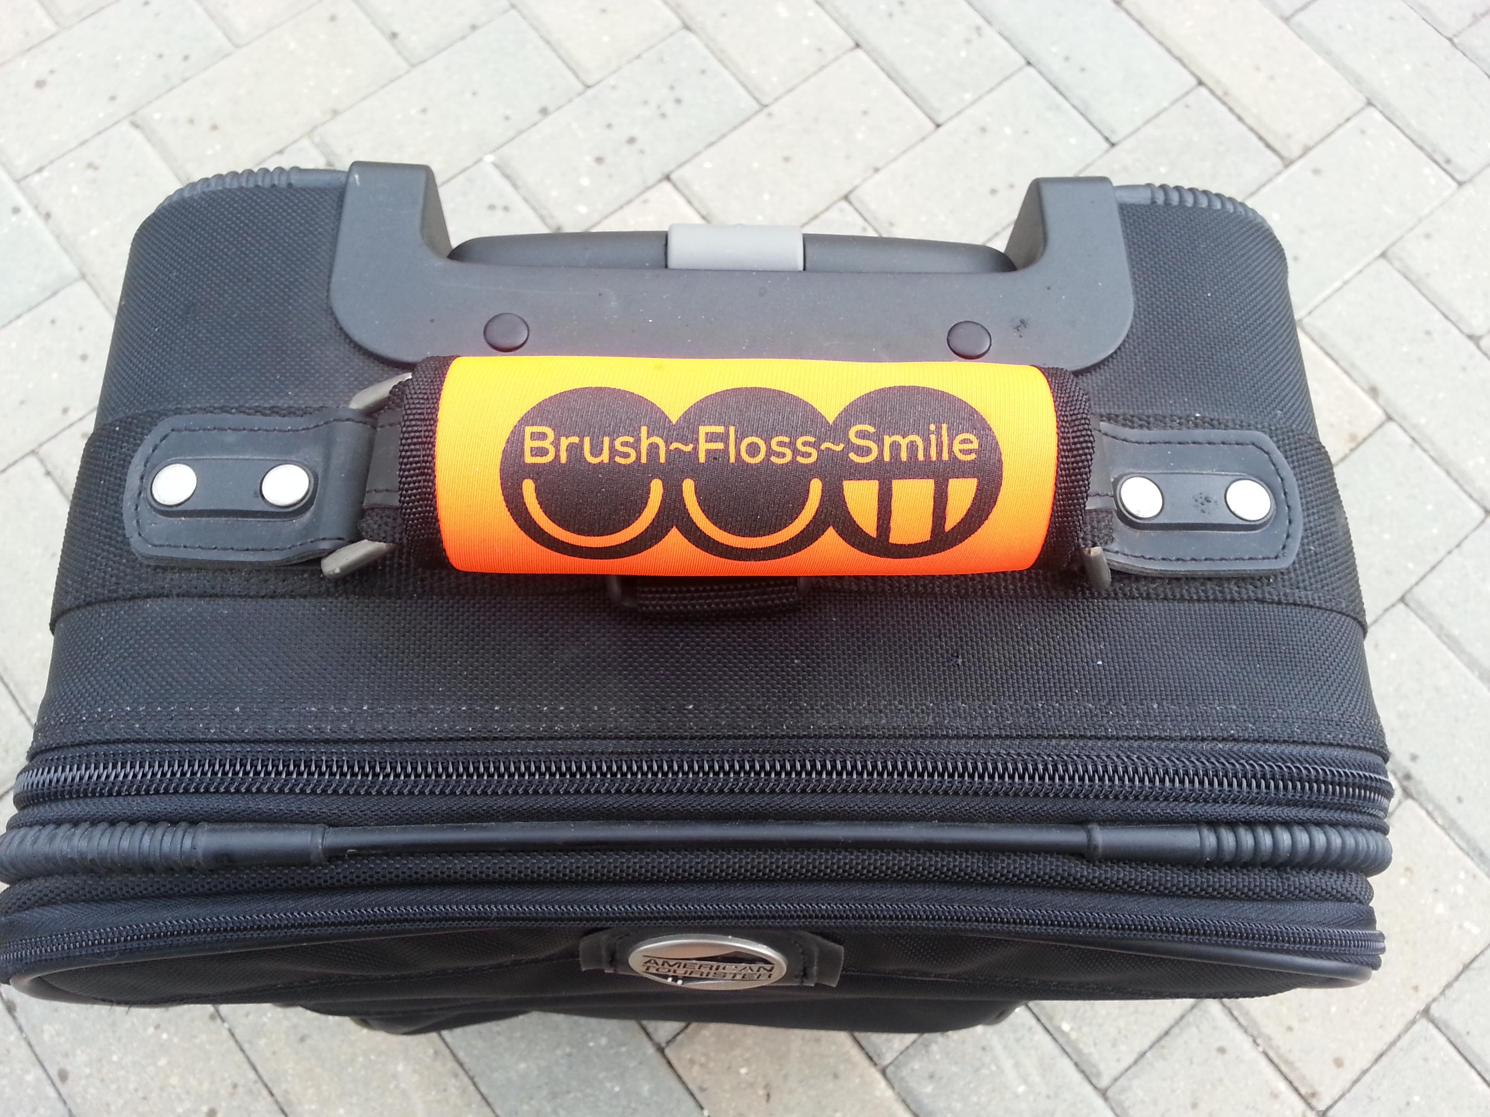

Description: Description: C:\Documents and Settings\HP_Administrator.HPBARRYMAIN\Local Settings\Temporary Internet Files\Content.IE5\ALVPQZNL\MC900072691[1].gif

**COMMUNICATION NEWS**

Congratulations, Dental Hygiene Graduates!

Welcome to the profession

Description: Description: C:\Documents and Settings\HP_Administrator.HPBARRYMAIN\Local Settings\Temporary Internet Files\Content.IE5\ALVPQZNL\MC900072691[1].gif

**CONTINUING EDUCATION**

If you were unable to attend any of our Component's last CE seminars, there is still time to register for the Center for Lifelong Learning classes taking place in June in Nashville, TN.  Grab some friends and head South for networking, motivation, and FUN!!  More details can be found by visiting [www.adha.org](http://www.adha.org/) and clicking on this icon on the home page.

[](http://www.adha.org/annual-session)

Description: Description: C:\Documents and Settings\HP_Administrator.HPBARRYMAIN\Local Settings\Temporary Internet Files\Content.IE5\ALVPQZNL\MC900072691[1].gif

**PUBLIC HEALTH NEWS**

If you are not already aware, please go to the link below and read about the new fluoride recommendations from the Public Health Service.

[**http://www.publichealthreports.org/documents/PHS\_2015\_Fluoride\_Guidelines.pdf**](http://www.publichealthreports.org/documents/PHS_2015_Fluoride_Guidelines.pdf)

Description: Description: C:\Documents and Settings\HP_Administrator.HPBARRYMAIN\Local Settings\Temporary Internet Files\Content.IE5\ALVPQZNL\MC900072691[1].gif

**MEMORIAM**

MDHA Joins ADHA in Remembering Irene Woodall, RDH, BS, MA, PhD

April 15, 1946 – April 22, 2015

The Michigan Connection

Irene Zimmerman Woodall is remembered by friends and colleagues throughout the country as an innovative advocate for dental hygienists and the profession of dental hygiene. She is recognized as having a profound influence on the growth of the dental hygiene profession during the 1970’s and 1980’s. Her vision for the future of the profession of Dental Hygiene began in 1965 as a graduate of the University of Detroit School of Dentistry. She became a clinical dental hygiene instructor there in 1966. She was the editor of the MDHA Bulletin from 1966 through 1969 contributing inspirational thought provoking editorials that challenged the current expectations for a dental hygienist. She became MDHA President from 1969 to 1970. Irene was the second program director for Kalamazoo Valley Community College (KVCC) in Michigan from 1971 to 1976 where she developed innovative programs some of which are still in place today. While at KVCC she added the use of ultrasonic scalers to the dental hygiene armamentarium and made it possible to have one at each hygienist’s station. She moved to the University of Pennsylvania in 1976 and later moved to Colorado.

Dr. Woodall’s passion for dental hygiene as a clinician, author, educator and researcher continued to evolve throughout her career. While at KVCC she developed a standard for Competencies in their program which later became the Competencies for ADHA at that time. She developed the idea for a magazine that contained quick-read articles on new research, clinical advances, and that advocated for dental hygienists to expand their vision of the future of Dental Hygiene. That idea developed into RDH Magazine which is still published today. She was the founding and first editor of RDH Magazine and served in that capacity from 1981 until 1993. She authored numerous articles and books including Comprehensive Dental Hygiene Care. Another of her contributions was to Develop and Chair the program for the Third International Symposium on Dental Hygiene. She was actively involved in researching and teaching the use of the ultrasonic scaler in addition to the use of hand instrumentation as a beneficial part of the prophylaxis. She was also involved in research for an anti-inflammatory agent for oral use. These are standard protocol today but not in the 1970”s when she was an innovator of the ideas.

Irene Woodall was a visionary of the late twentieth century whose inspiration to always ask questions and to explore new ideas about where dental hygienists could make a difference has led the profession to many of the advances we have achieved and will achieve. This small tribute is intended to share the vision and accomplishments of a special person who made a difference for all hygienists in Michigan and throughout the country. She was included in the article in the MDHA 90th Anniversary Bulletin as one of the Pioneers in Dental Hygiene in Michigan. Irene Woodall suffered an aneurysm followed by a stroke in 1993 while in Colorado and later developed Parkinson’s Disease.

More information about Irene may be found in the most recent ADHA Update titled ADHA Supports New Community Water Fluoridation Recommendation. Also use a Google search for Irene Woodall and read the Dentistry IQ articles with the links to her columns and quotes from her work. It will remind us of her forward thinking.

Description: Description: C:\Documents and Settings\HP_Administrator.HPBARRYMAIN\Local Settings\Temporary Internet Files\Content.IE5\ALVPQZNL\MC900072691[1].gif

**JOB OPPORTUNITIES**

Did you know that you can find great job opportunities on the MDHA website? Check it out today, visit http://www.mdhatoday.org/members/Employment%20Opportunities.html

Description: Description: C:\Documents and Settings\HP_Administrator.HPBARRYMAIN\Local Settings\Temporary Internet Files\Content.IE5\ALVPQZNL\MC900072691[1].gif



Description: Description: C:\Documents and Settings\HP_Administrator.HPBARRYMAIN\Local Settings\Temporary Internet Files\Content.IE5\ALVPQZNL\MC900072691[1].gif

Become familiar with [www.mdhatoday.org](http://www.mdhatoday.org) and learn to navigate MDHA’s website!! There is an easy link for a membership application, and many opportunities for continuing education credits through various components. Description: Description: C:\Documents and Settings\HP_Administrator.HPBARRYMAIN\Local Settings\Temporary Internet Files\Content.IE5\ALVPQZNL\MC900072691[1].gif

**Advertisers**: This Newswire is being sent bimonthly to approx. 1000 registered dental hygienists throughout the state. It reaches these RDH’s and then some! If you would like to have your logo appear in this publication, please visit our website [**www.mdhatoday.org**](http://www.mdhatoday.org) and click on the “advertisers” link. To our readers, you are encouraged to patronize our sponsors! Thank you!

