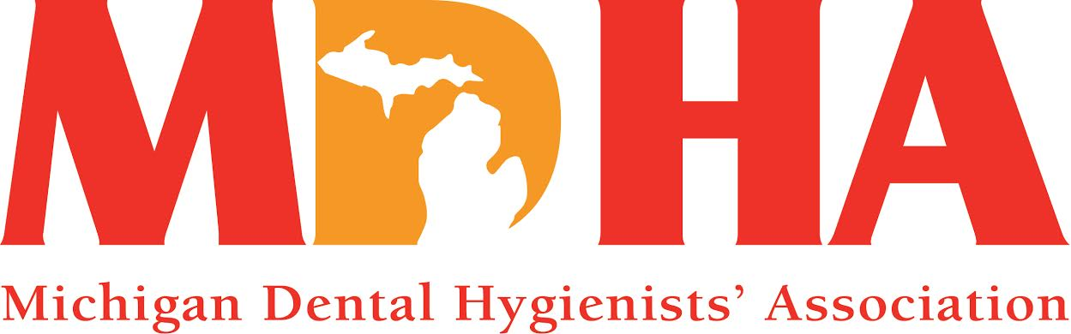
July 2015 Newswire
Stay in contact with MDHA visit our website
http://www.mdhatoday.org
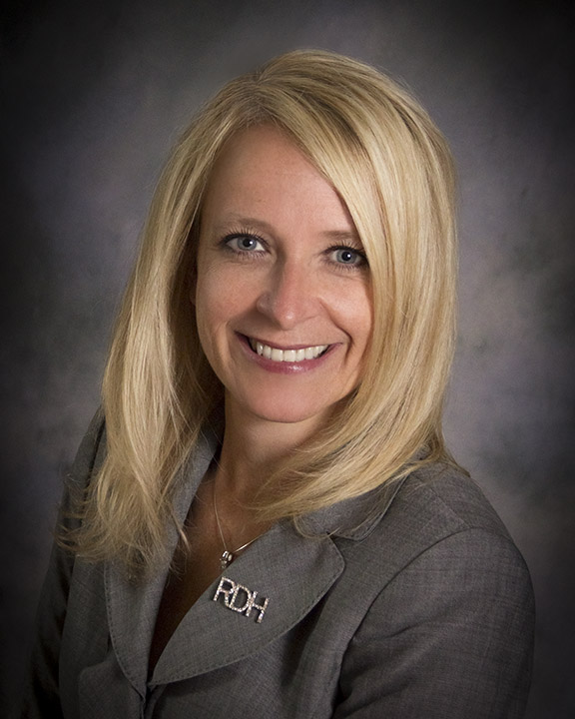

What an exciting few months we have had within MDHA! Fireworks are definitely going off as we move the profession of dental hygiene forward…and upward!!
May and June proved to be exceptional with many graduations and pinning ceremonies being held, celebrating the success of our new RDH colleagues!
Congratulations again to all new Registered Dental Hygienists and welcome to your profession!!

Many of you may already know, but we are pleased to share the news that Governor Snyder passed the budget for 2015-16 to include expansion of Healthy Kids Dental (HKD) to all counties. Children from ages 0-12 will now benefit from this program in Oakland, Wayne and Kent counties, providing all 88 counties in Michigan with the HKD program. We thanked the Governor through our Twitter account (#MIdentalhygiene), and he re-tweeted, along with one of his staff! So exciting!!!!
Your MDHA leadership has held meetings with leaders from the Michigan Osteopathic Association, the Michigan Dental Association, and coming soon, Trinity Health, along with many others. These meetings open the door for opportunities to mutually benefit each organization and help us collaborate on initiatives involving oral and overall health. This will strengthen our network and build upon our goal of bringing harmony to the dental hygiene profession.
Be sure to check out the Membership Council section for details on the Inaugural Oral Cancer Foundation Walk/Run for Awareness on August 2nd in Birmingham, Michigan!! This is a great opportunity to involve your colleagues, family and friends to get some exercise and support the campaign for early detection of oral cancer!
Speaking of opportunity, your Delegates and Alternate Delegates had a great experience during Annual Session in Nashville! Be sure to read the special section titled ADHA Annual Session 2015 for updates and photos. If you have not been to ADHA’s Annual Session, it’s a must!!
So, mark your calendars for next year in Pittsburgh, June 8-14, 2016!!
In other ADHA news, we will welcome a new Chief Operating Officer in July. His name is Bob Moore, CAE and he brings a wealth of association management experience with him. You can read more in this press release. He will be a great addition to our team in Chicago!
Finally, we know the summer months are a break for many, but your MDHA leaders have been busy moving our profession forward, not only with outside initiatives, but also focusing internally on our Component restructuring, our annual budget, working with our lobbying firm on legislative priorities, planning for House of Delegates in October, and the list goes on.
It is important that you understand that we do all of this for you and the profession of dental hygiene! So, stay connected, get involved, and participate in making a difference locally, at the State level and even nationally! The only way to go is “upward!”
In harmony…

Kathy Mielke, BS, RDH
MDHA President

ADHA Annual Session 2015

There is so much to see and do during our ADHA Annual Session, and this year in Nashville was spectacular! We were kept busy by attending award presentations, plenary sessions, exhibits, CE courses, poster sessions, the IOH Benefit/President’s reception, and of course, the business meetings and workshops.

Our new ADHA leaders for 2015-16 are:

President ~ Jill Rethman, RDH, BA from Arizona
President-Elect ~ Betty Kabel, RDH, BS from Florida
Vice President ~ Tammy Filipiak, RDH, MS from Wisconsin
Treasurer ~ Donnella Miller, RDH, BS from Tennessee
Immediate Past President ~ Kelli Swanson-Jaecks, MA, RDH from Oregon
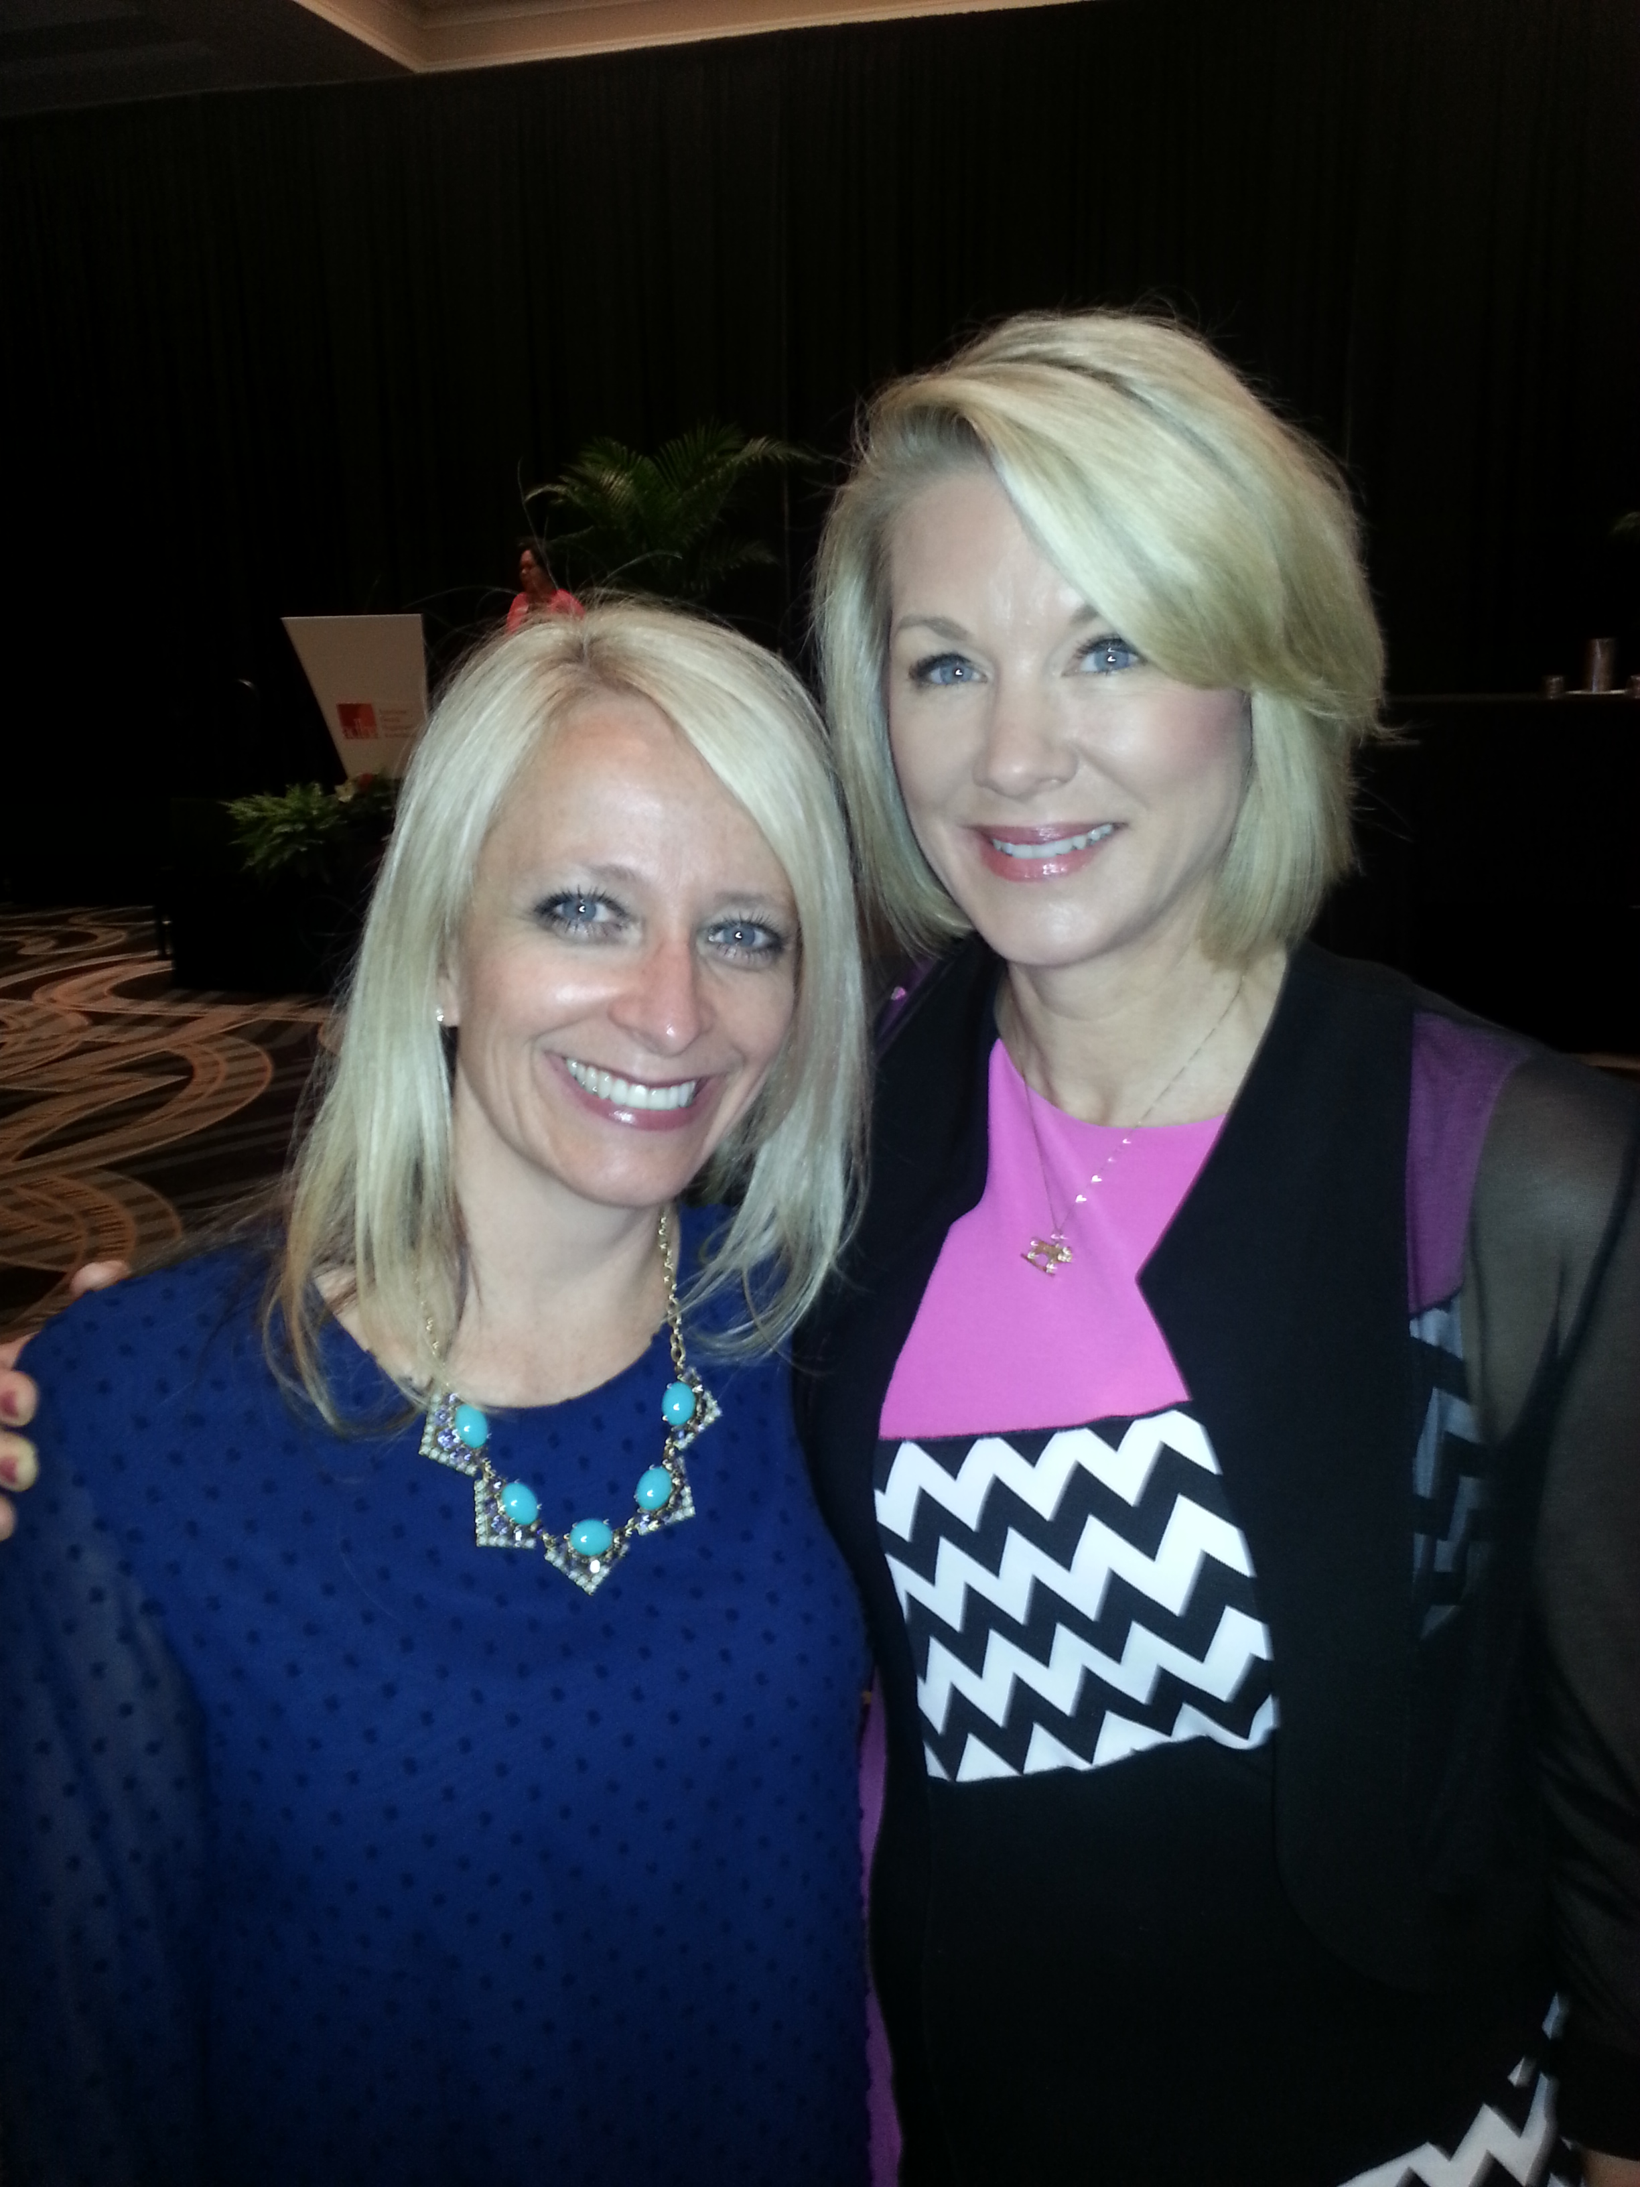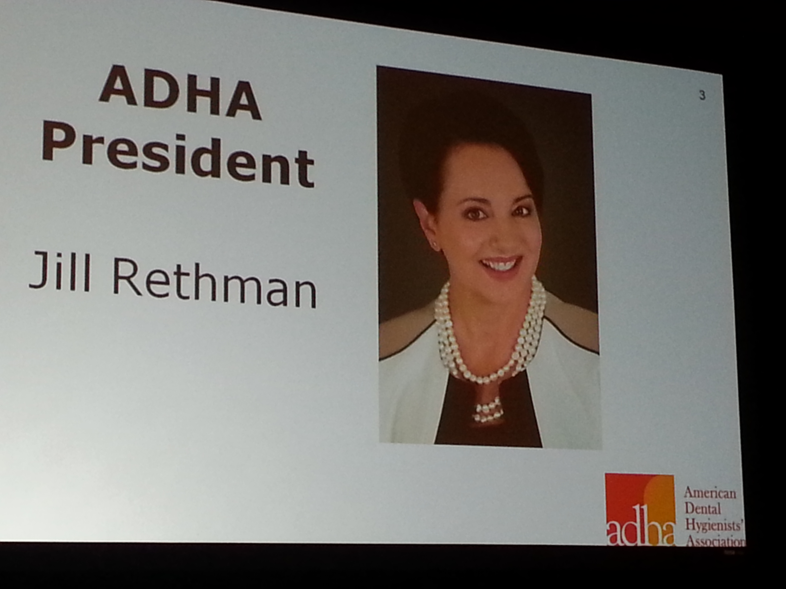
New ADHA President, Jill Rethman, RDH, BA
President Mielke with ADHA Immediate Past President,
Kelli Swanson-Jaecks

Our new ADHA District V Trustee is Sharlee Burch, RDH, BS, MPH, EdS, EdD from Kentucky. She represents Indiana, Ohio, Kentucky and Michigan at the national level. Her email is sharleeb@adha.net if you need to connect with her.

Our MDHA President, Kathy Mielke, BS, RDH, was elected to the ADHA Ethics Committee, representing Region B, which includes 12 states from Districts IV, V and VI.

Also, we are proud to have Heather Beavers, RDH, BAS and Chris Farrell, RDH, BSDH, MPA continuing on as Chairs for the ADHA Council on Member Services and Council on Public Health, respectively.

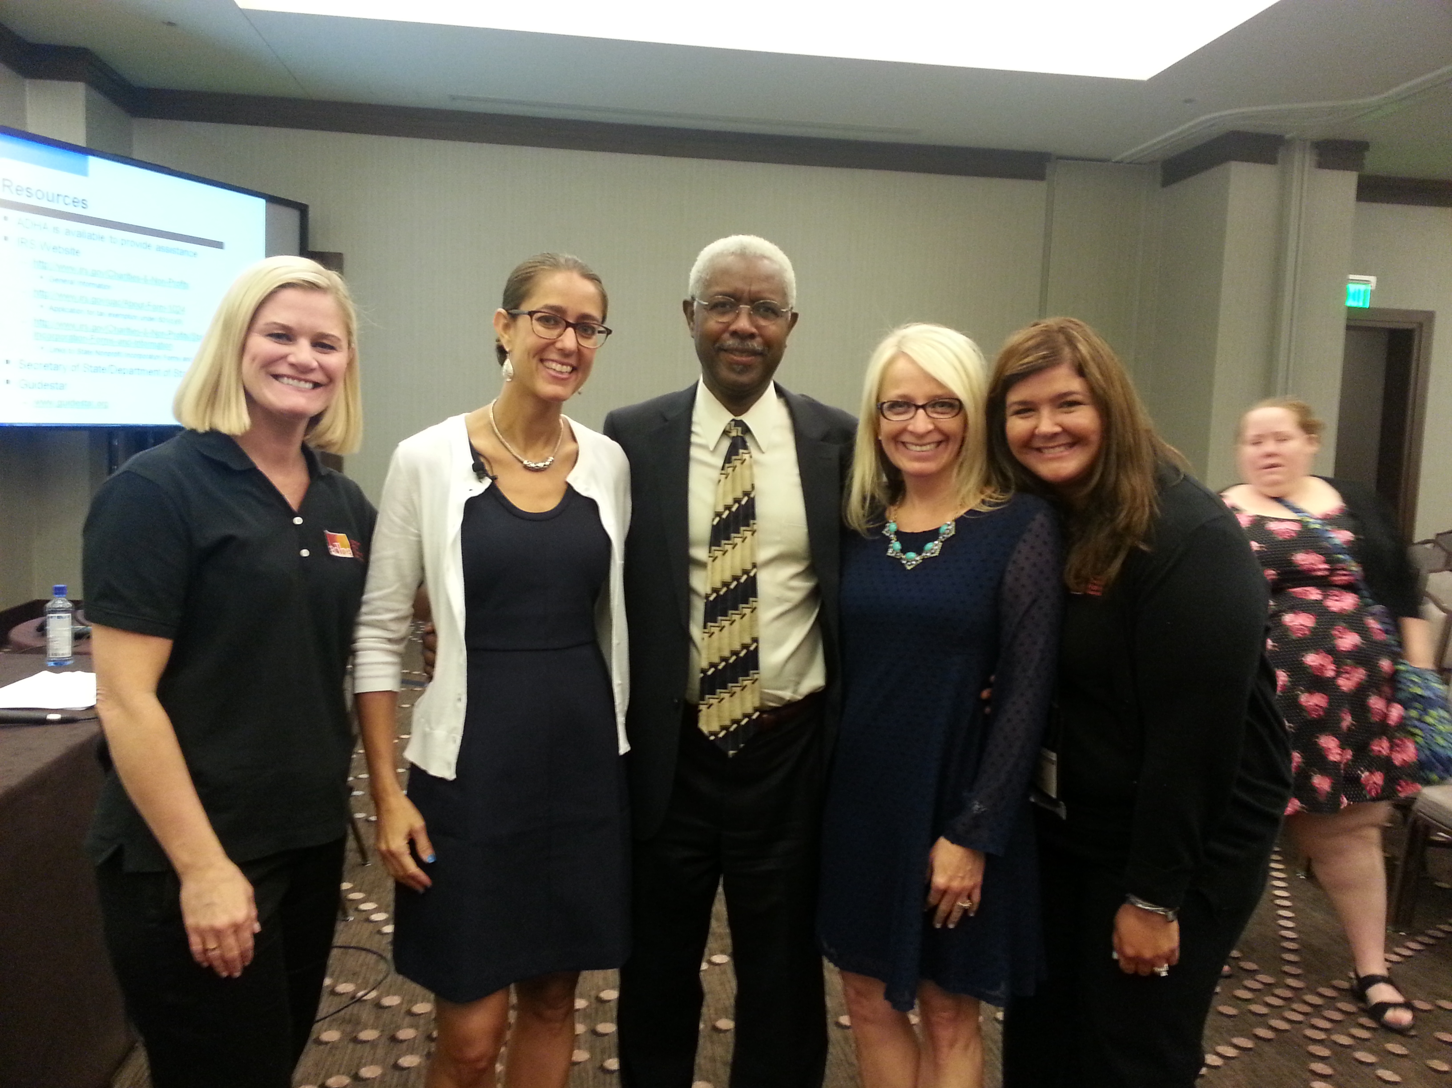
Left to Right > Katie Powell, ADHA Director of Member Services; Kimberly Pendo, COO, Chicago Law Partners, LLC; Isaac Carpenter, ADHA Chief Financial Officer; Kathy Mielke, MDHA President; Jennifer Hill, ADHA Senior Manager, Constituent and Component Relations

The Institute of Health (IOH) is our philanthropic foundation that provides thousands of dollars each year to support the charitable educational, research and scientific endeavors of ADHA. Michigan donated a Coach purse this year for the IOH Silent Auction and the winning bid was $160! And, District V came in 2nd place for the IOH challenge, raising $1750.00 during ADHA Annual Session. Donations for the week totaled over $12,000 and all money raised will fund Scholarships, as well as Community Service and Research grants. So, please consider going online and “give now to help fund the future of dental hygiene!”

And, don’t forget about our HYPAC ~ dental hygiene’s Political Action Committee! HYPAC enables dental hygienists to collectively support candidates for congress who share our interests. This joint effort provides a stronger voice for oral health care concerns. The combined amount raised at ADHA Annual Session was $13,553.54! What a great success to support our “upward-thinking spirit!”

As previously mentioned, SAVE-THE-DATE for the ADHA’s 93rd Annual Session in Pittsburgh, Pennsylvania, June 8-14, 2016!! Hope to see you there…

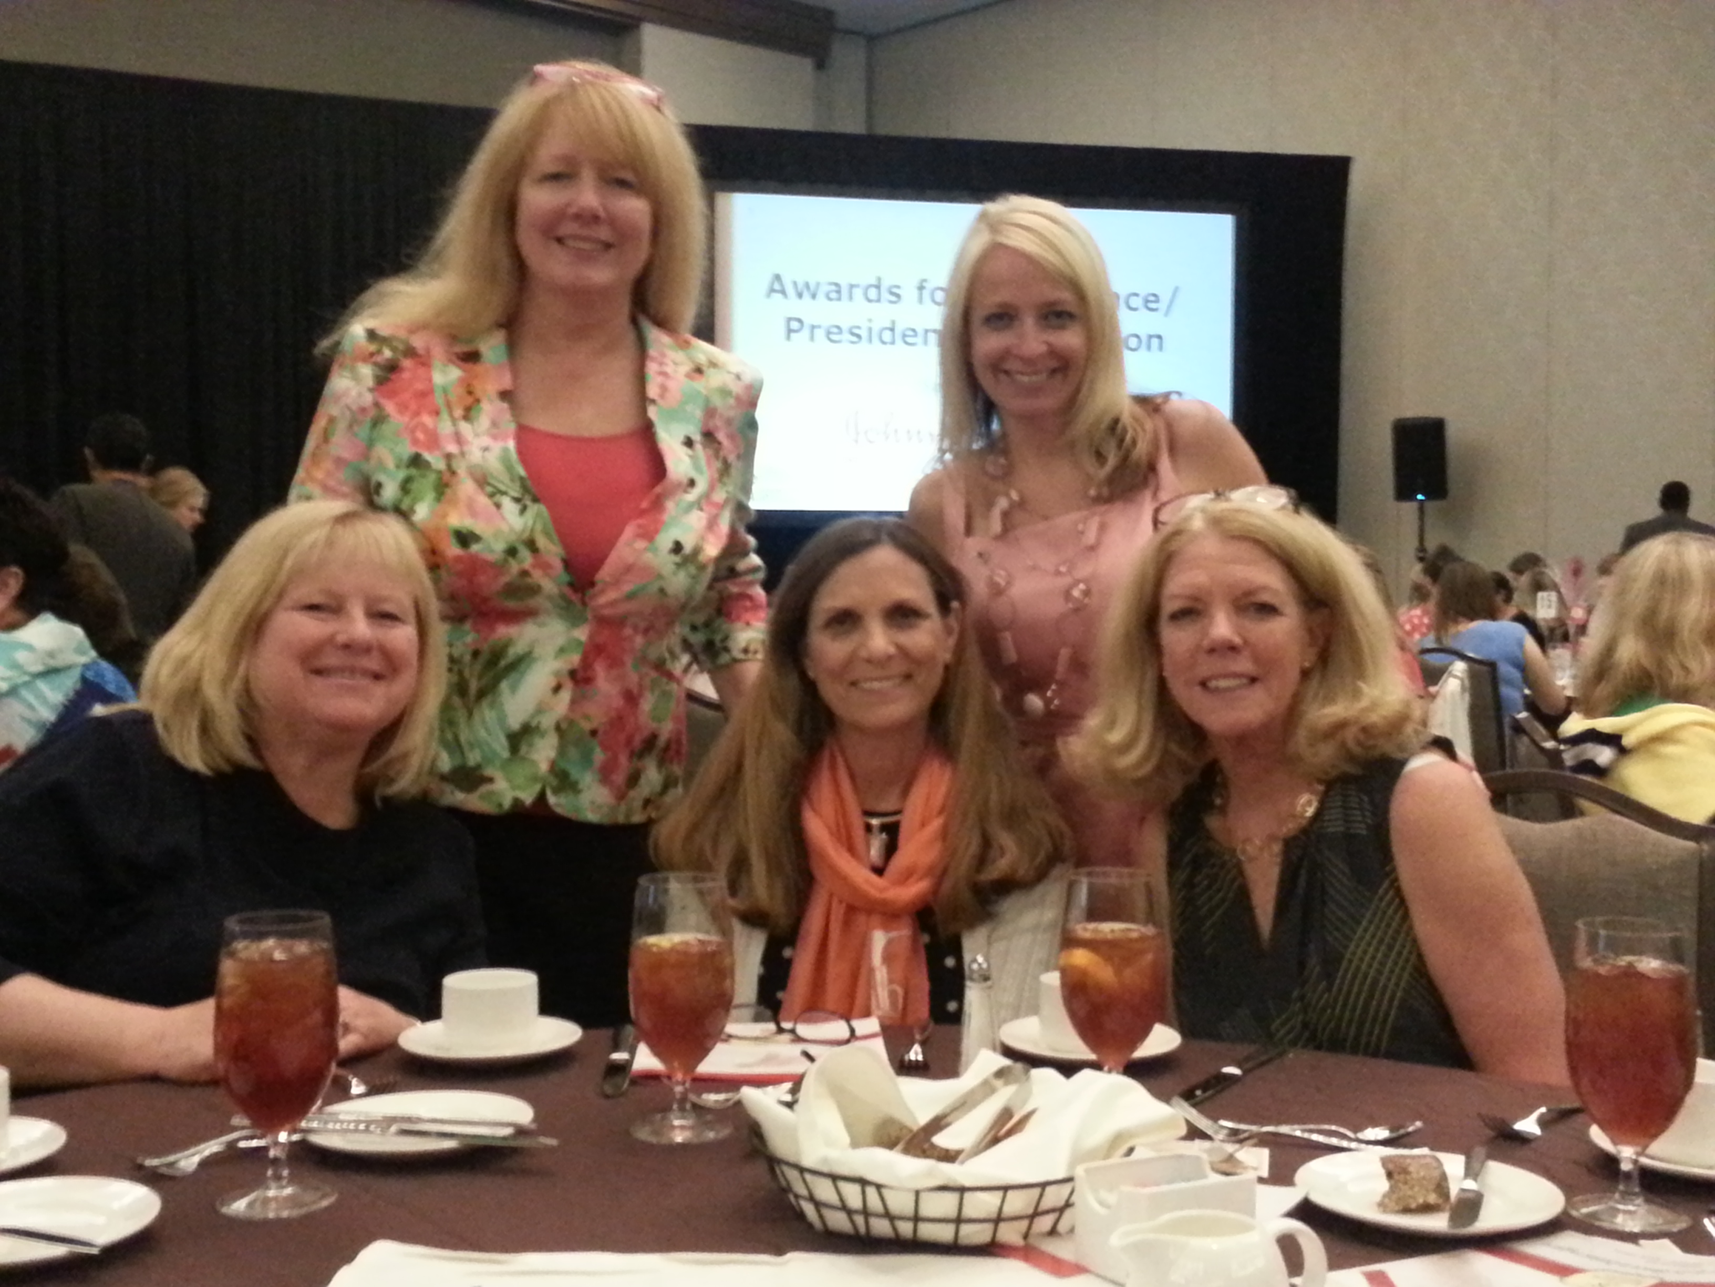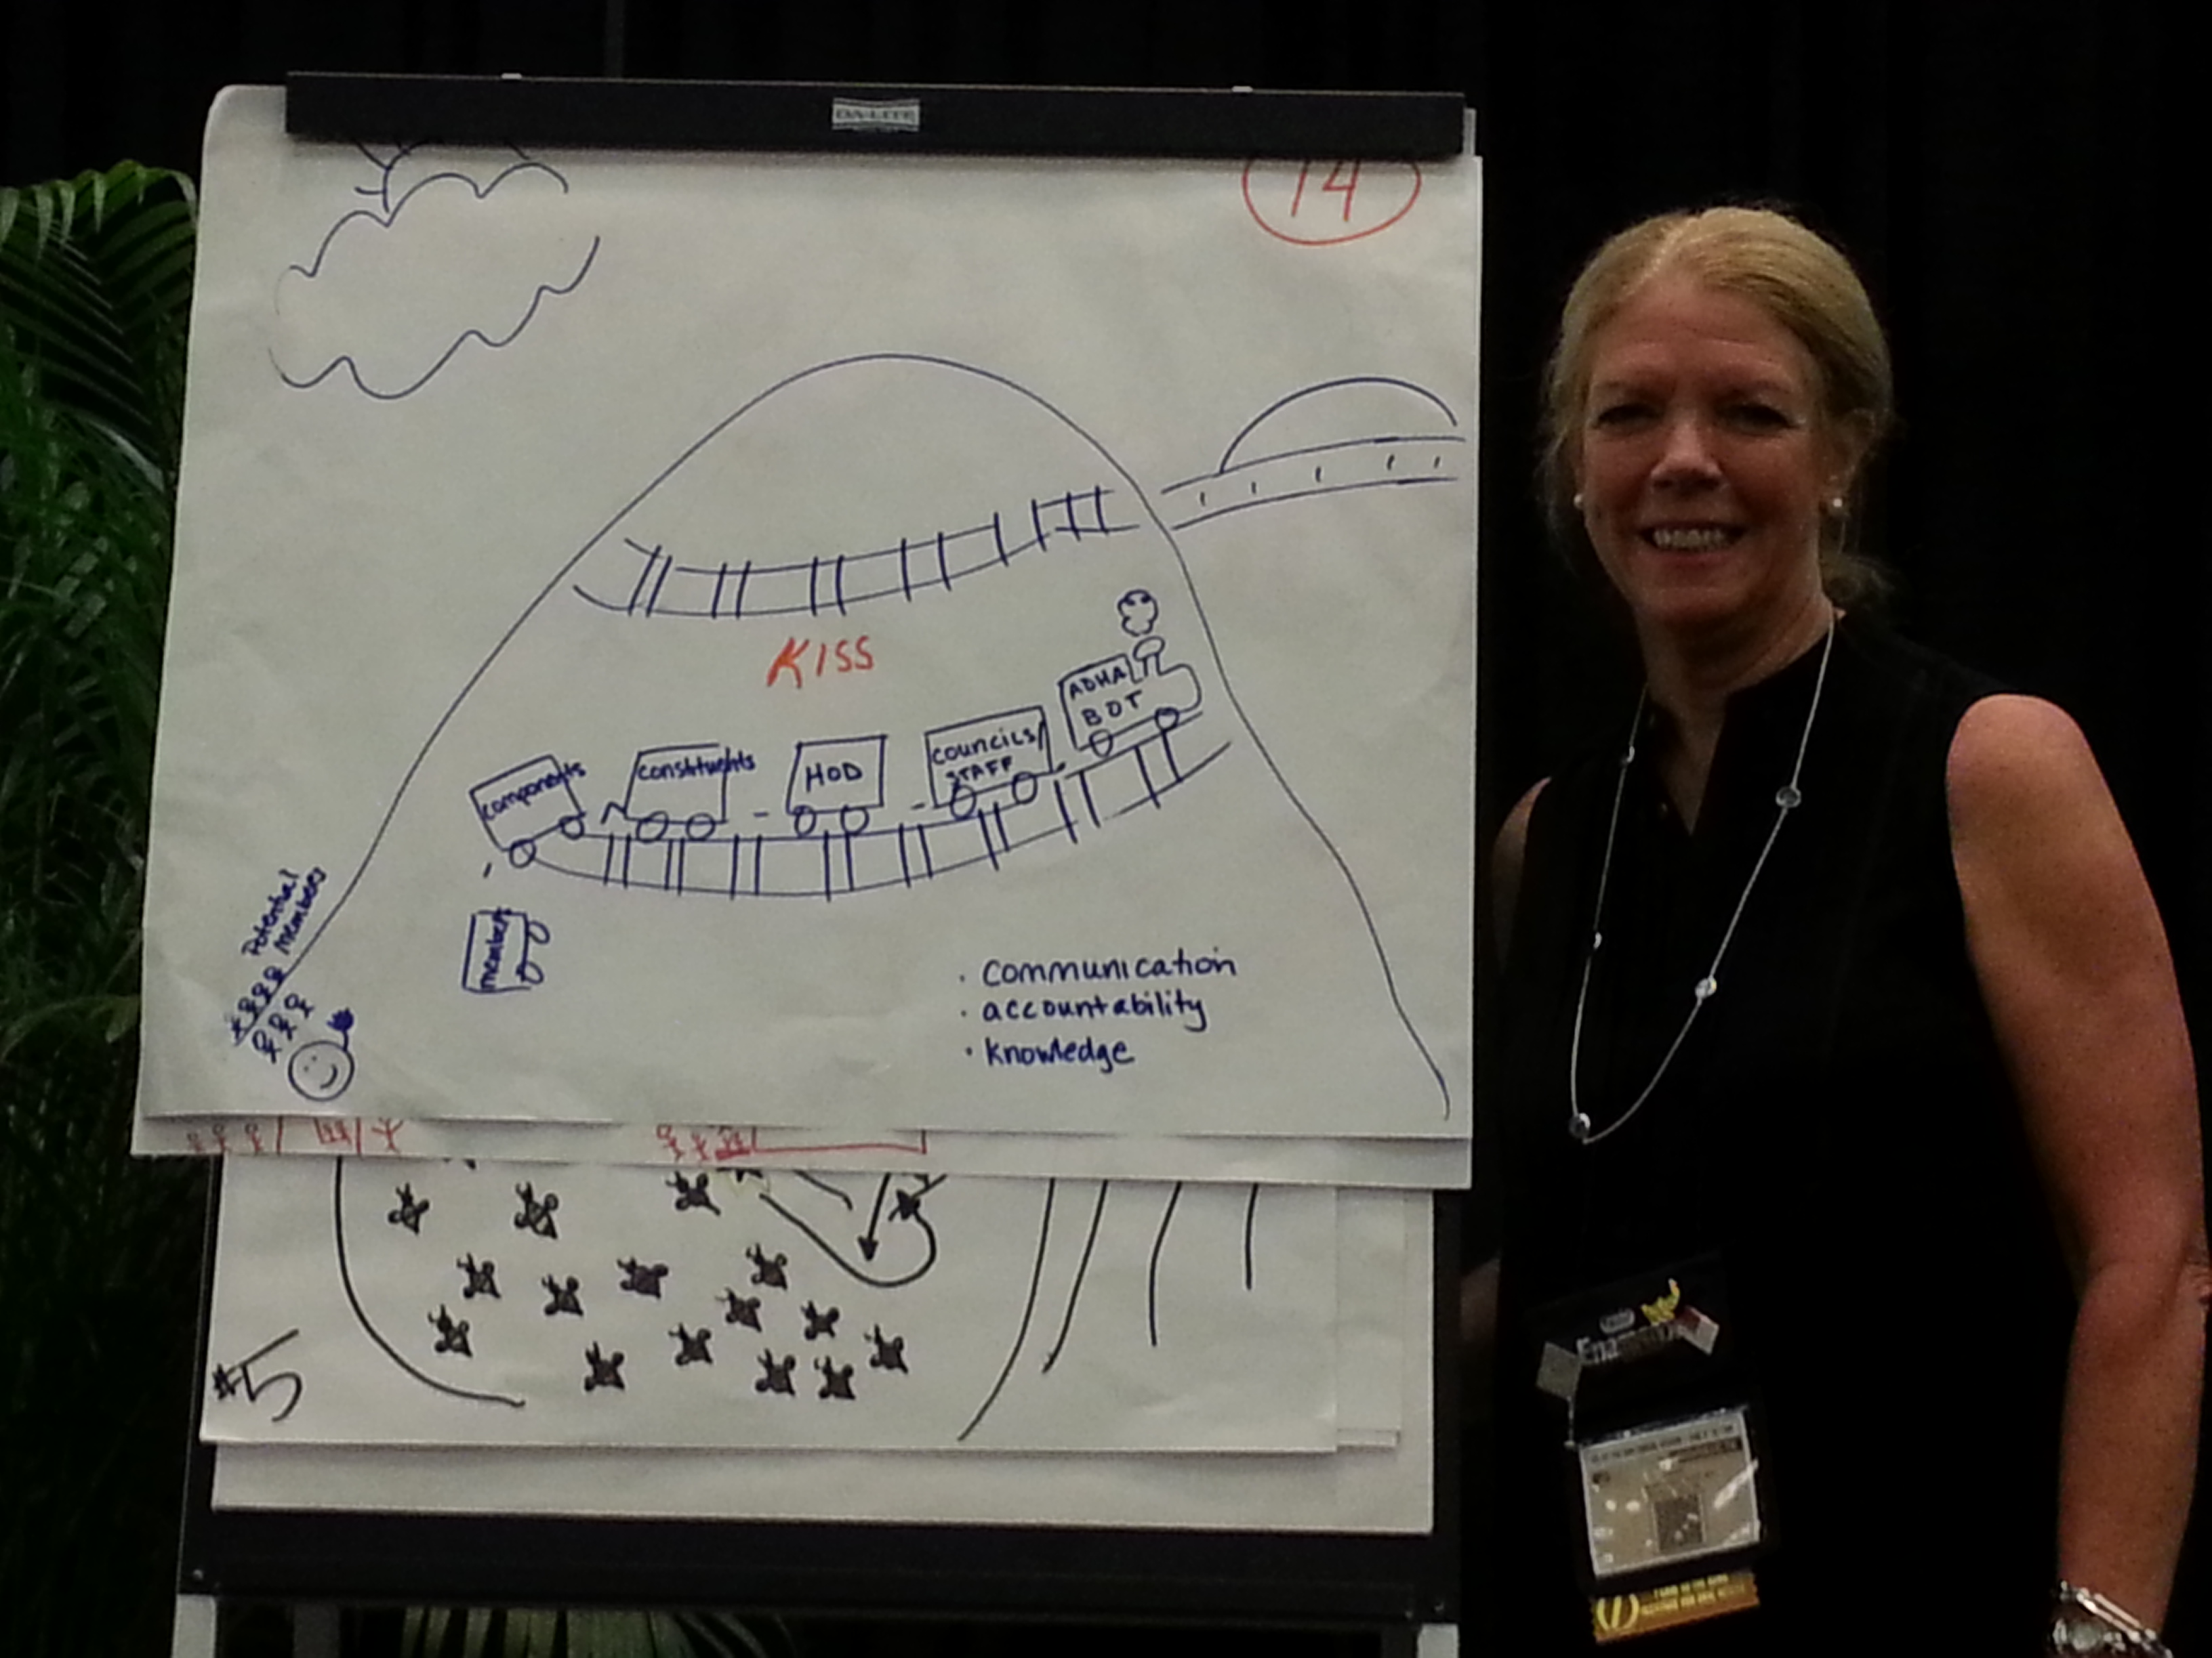
MDHA Delegates attending the Award's for Excellence/President's Luncheon
Delegate Miller during the business meeting, speaking at the Governance Design Session.

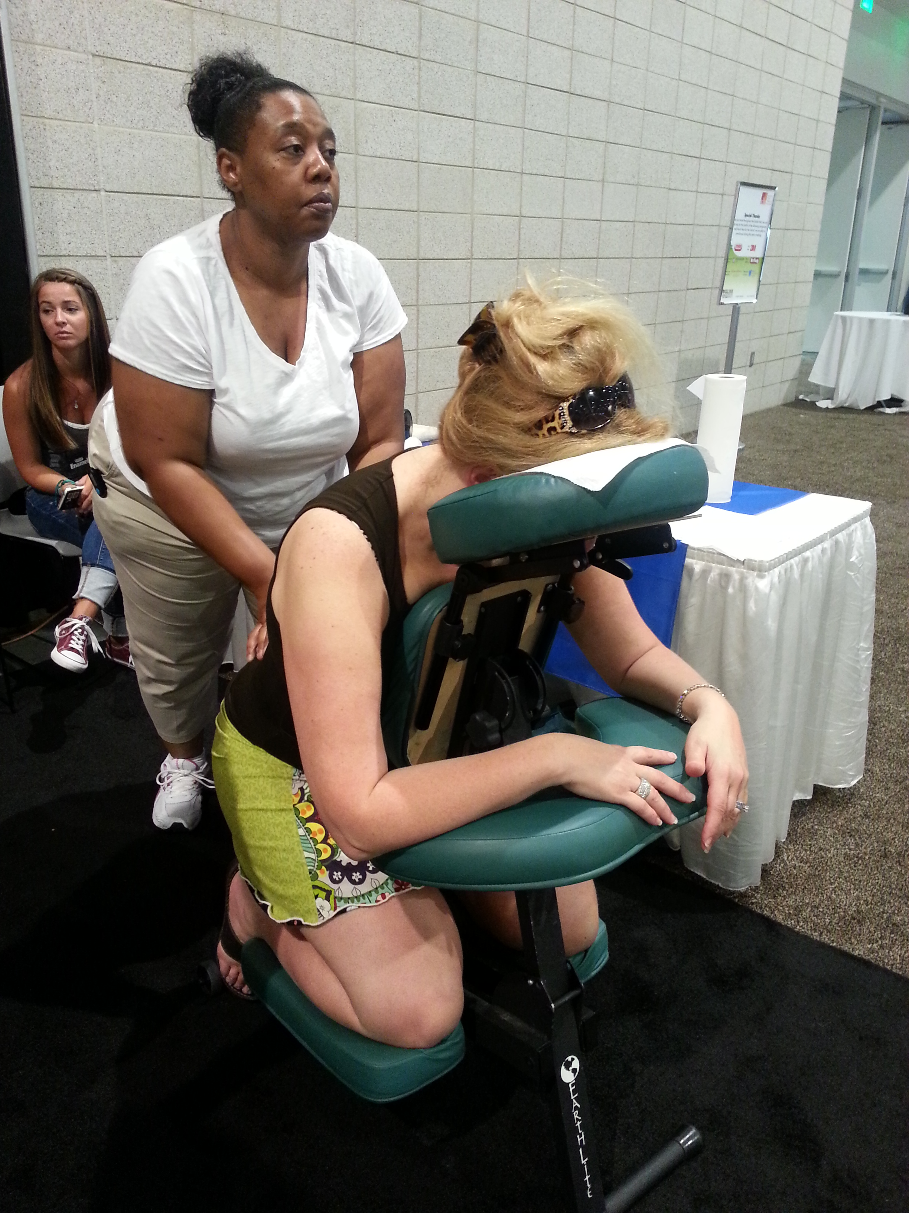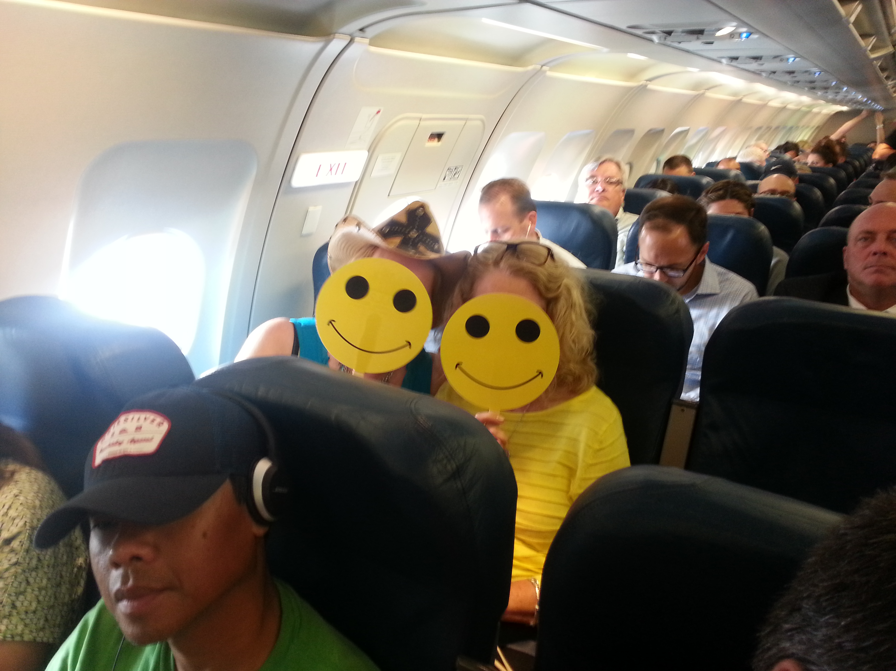
President-Elect Restauri being pampered after walking the Exhibit Hall and collecting numerous bags of goodies!!

"Happy" Michigan Delegates ? and ?

I was asked by President Mielke to provide a testimonial on my experience as a delegate to the ADHA Nashville meeting, one word, invigorating. There is nothing more powerful than over 2,000 registered dental hygienists gathered together to make policies that influence our profession. We are the change agents. Not only that, you also get the opportunity to meet dental hygienists from all over the country and learn from them what works in their state, that is networking as its best.
We had round table discussions on governance, which was engaging, enlightening, and entertaining. This session was run like the previous mega issue questions. One enters the room and chooses a number from a basket and you then proceed to that assigned table. There is a facilitator who then asks for a time keeper, a record keeper and a presenter. Oh yea, and a drawer. We were asked to describe our current form of governance using three attributes and draw the tripartite structure using a mode of transportation. Hygienists are cleaver and imaginative. We had rockets, sailboats, ships, synapses, roller coasters, a stage coach, trucks and several trains. The ADHA staff will gather all this information, analyze it, and draw a conclusion based on the member’s desires.
We attended a workshop on advocacy. We learned what and what not to do when attending a state lobby day. This workshop reinforced my belief that we do a great job presenting ourselves in Lansing as professionals.
The officers were invited to a membership workshop detailing our new charter agreements, our responsibilities as leaders within the constituent, as well as our component’s responsibilities. All of these changes are necessary to protect the volunteers who work so hard on behalf of our profession, as well as our branding. The agreements will ensure that all entities are in compliance with state and federal laws regarding not for profit associations. Michigan is ahead of the game. We took the lead in the fall of 2013 creating a task force to review our current component makeup. We knew that several components were not in compliance with federal tax laws, putting our leaders at great risk. The Michigan delegation has always been a respected influence nationally. We will get through this process with grace and dignity. Together we are better.

Thank you for allowing me the opportunity to serve Michigan as a delegate to the ADHA.
Respectfully submitted
Cheryl Bentley, RDH
Immediate Past President DHA
ADHA Delegation Chair

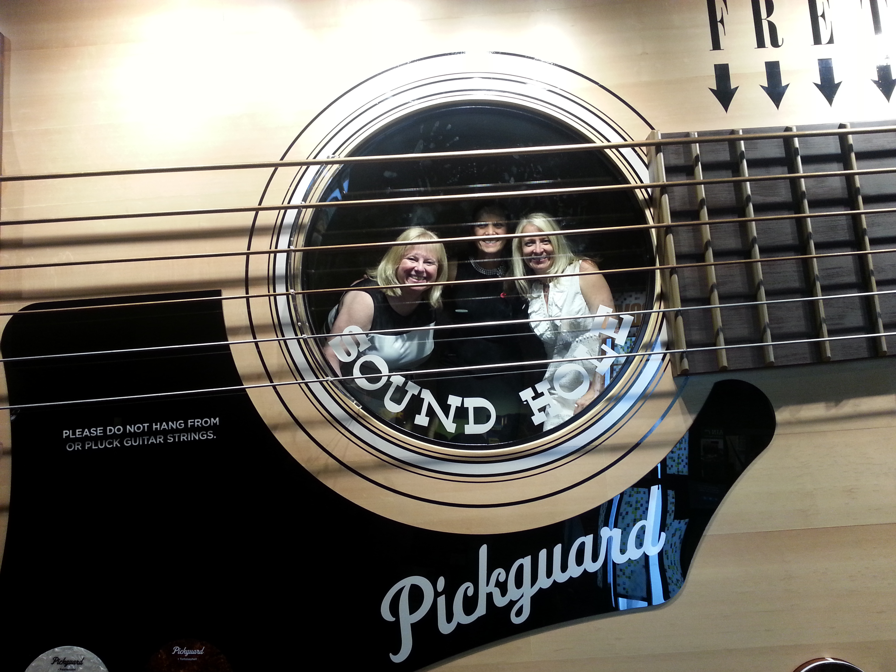
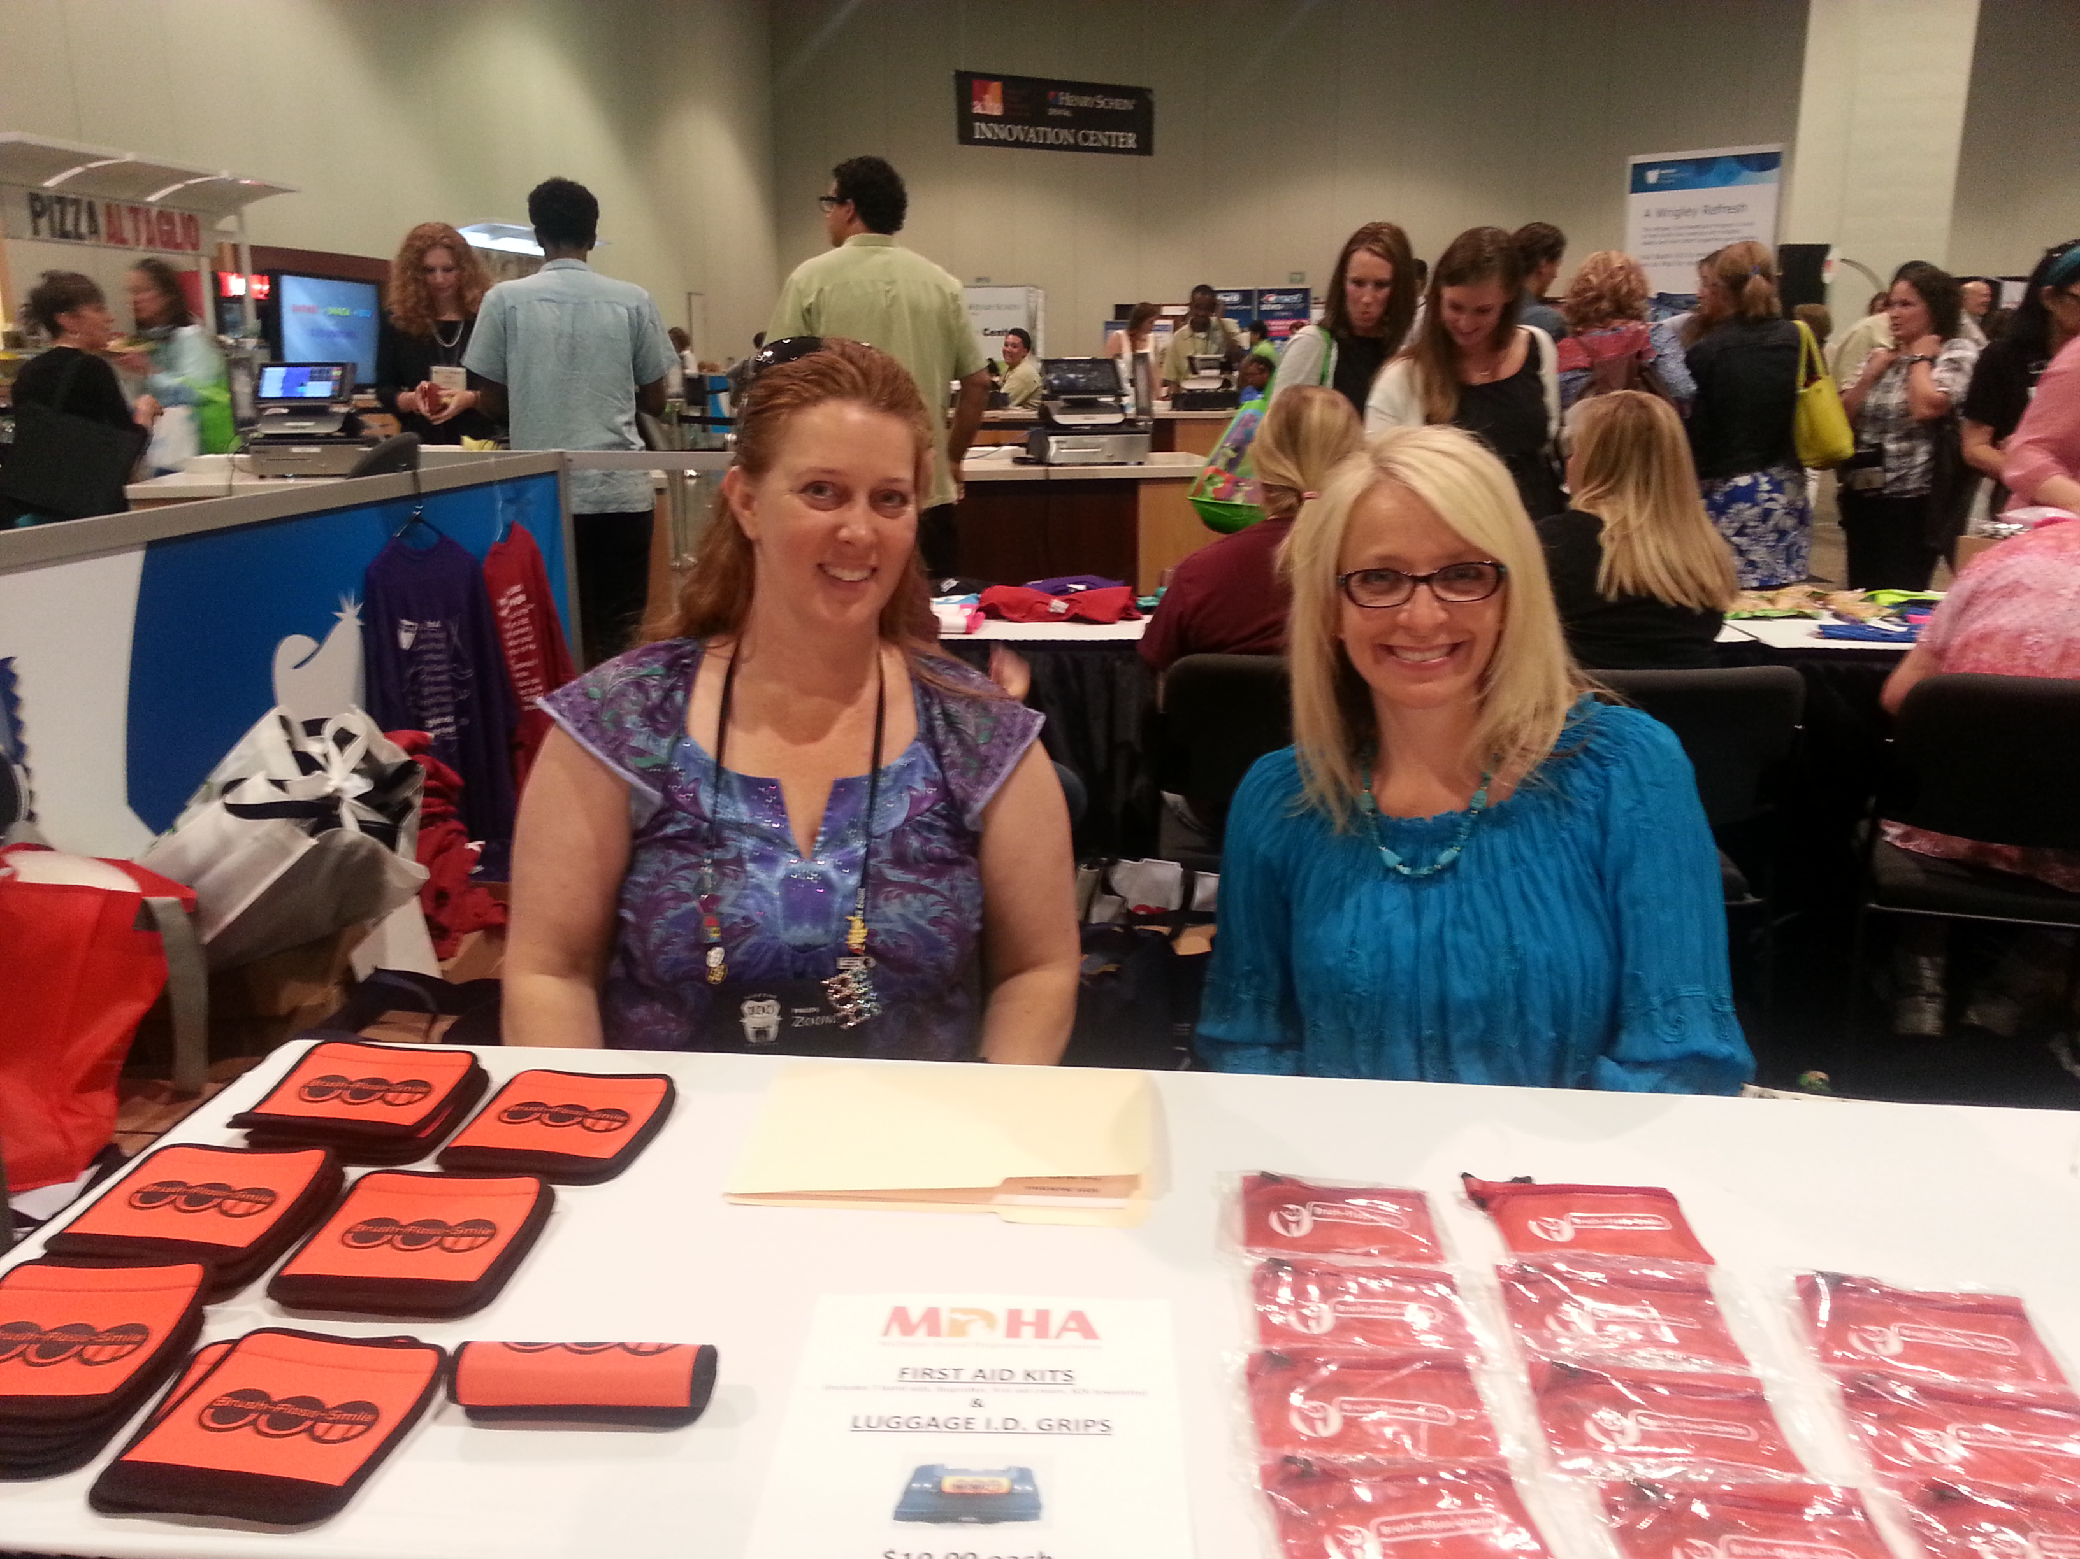
VP Yahn, IPP Bentley and President Mielke during the Country Music Hall of Fame tour as part of the IOH Benefit/President's Reception.
Delegates Mielke and Dennings selling MDHA fundraisers during the ADHA Marketplace.
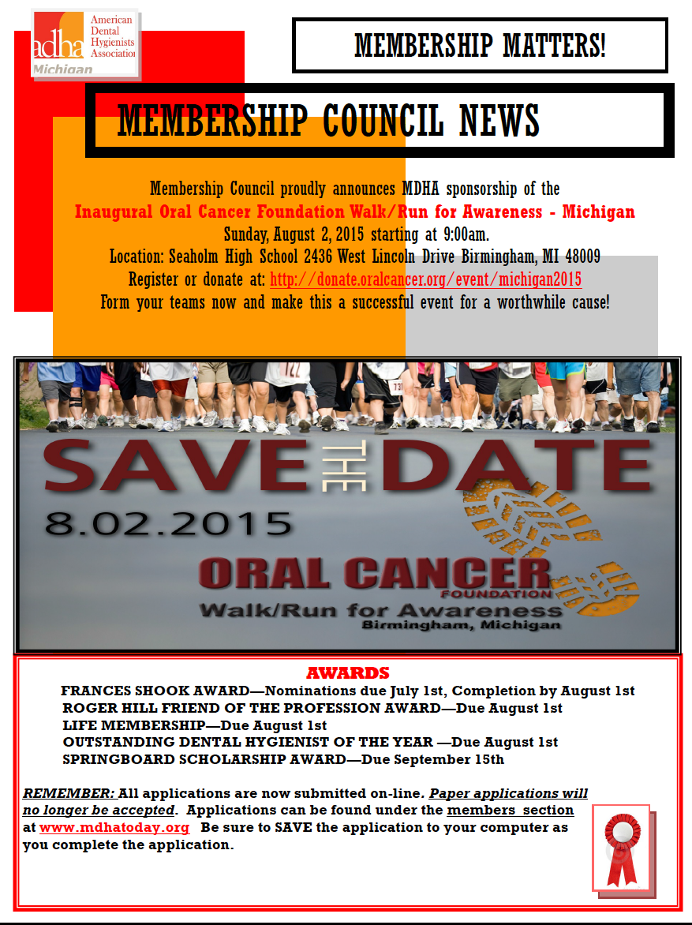
LEGISLATIVE COUNCIL NEWS

Since we live our lives in 3-, 4- or 6-month increments, please SAVE-THE-DATE for our annual
MDHA Legislative Luncheon ~ March 2, 2016.

FINANCE COUNCIL NEWS

Be on the lookout for new fundraisers coming your way!! Not only do we have our First Aid Kits and Luggage I.D. tags, but we will soon begin our annual Coffee Sale!! Additionally, we have another new fundraiser that we will highlight in September and will continue with our MDHA Getaway Raffle ~ where will it take you in 2016!?!?
These fundraisers are simple ways to support your professional association and enhance our bottom line.

Speaking of bottom line, the Finance Council hosted the annual budget meeting in July and will present a balanced budget for 2015-16 to the Board of Trustees in September for approval. A HUGE thank you to our MDHA Treasurer, Tamara Fisher, and our Association Administrator, Joyce Losen, for their time and efforts in preparation for what was a very successful meeting! Thank you, thank you, thank you!!

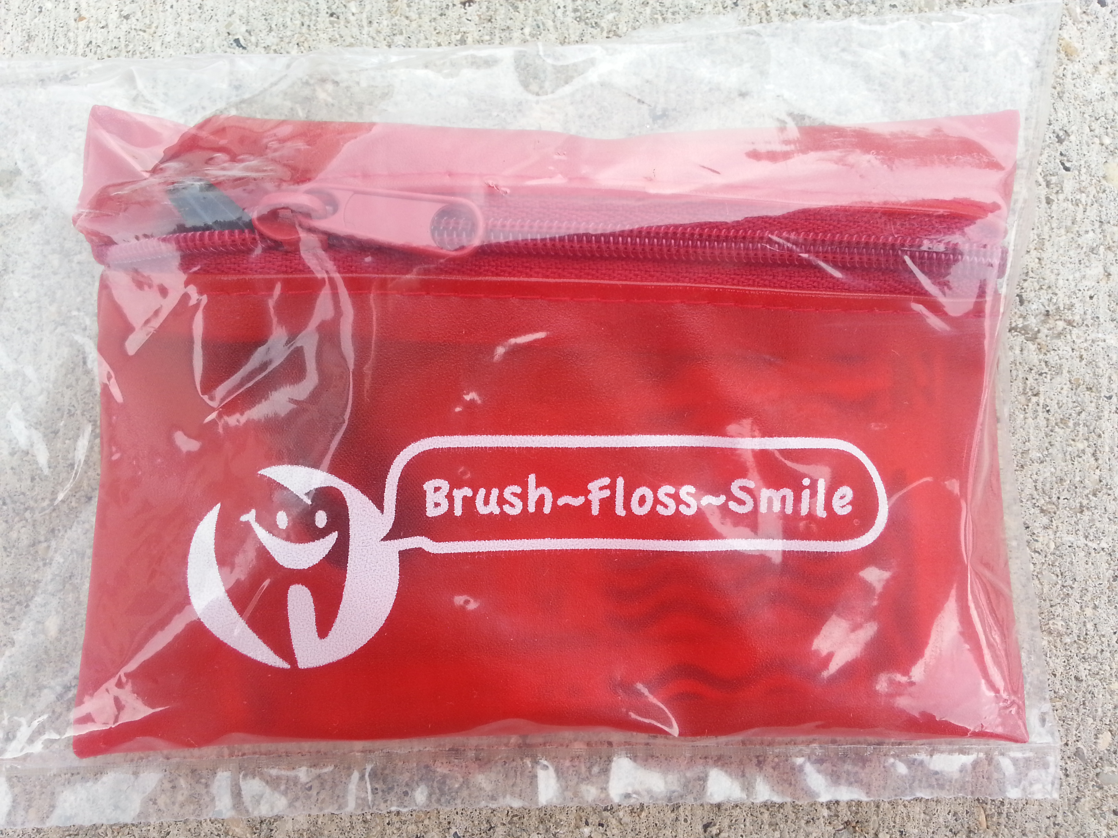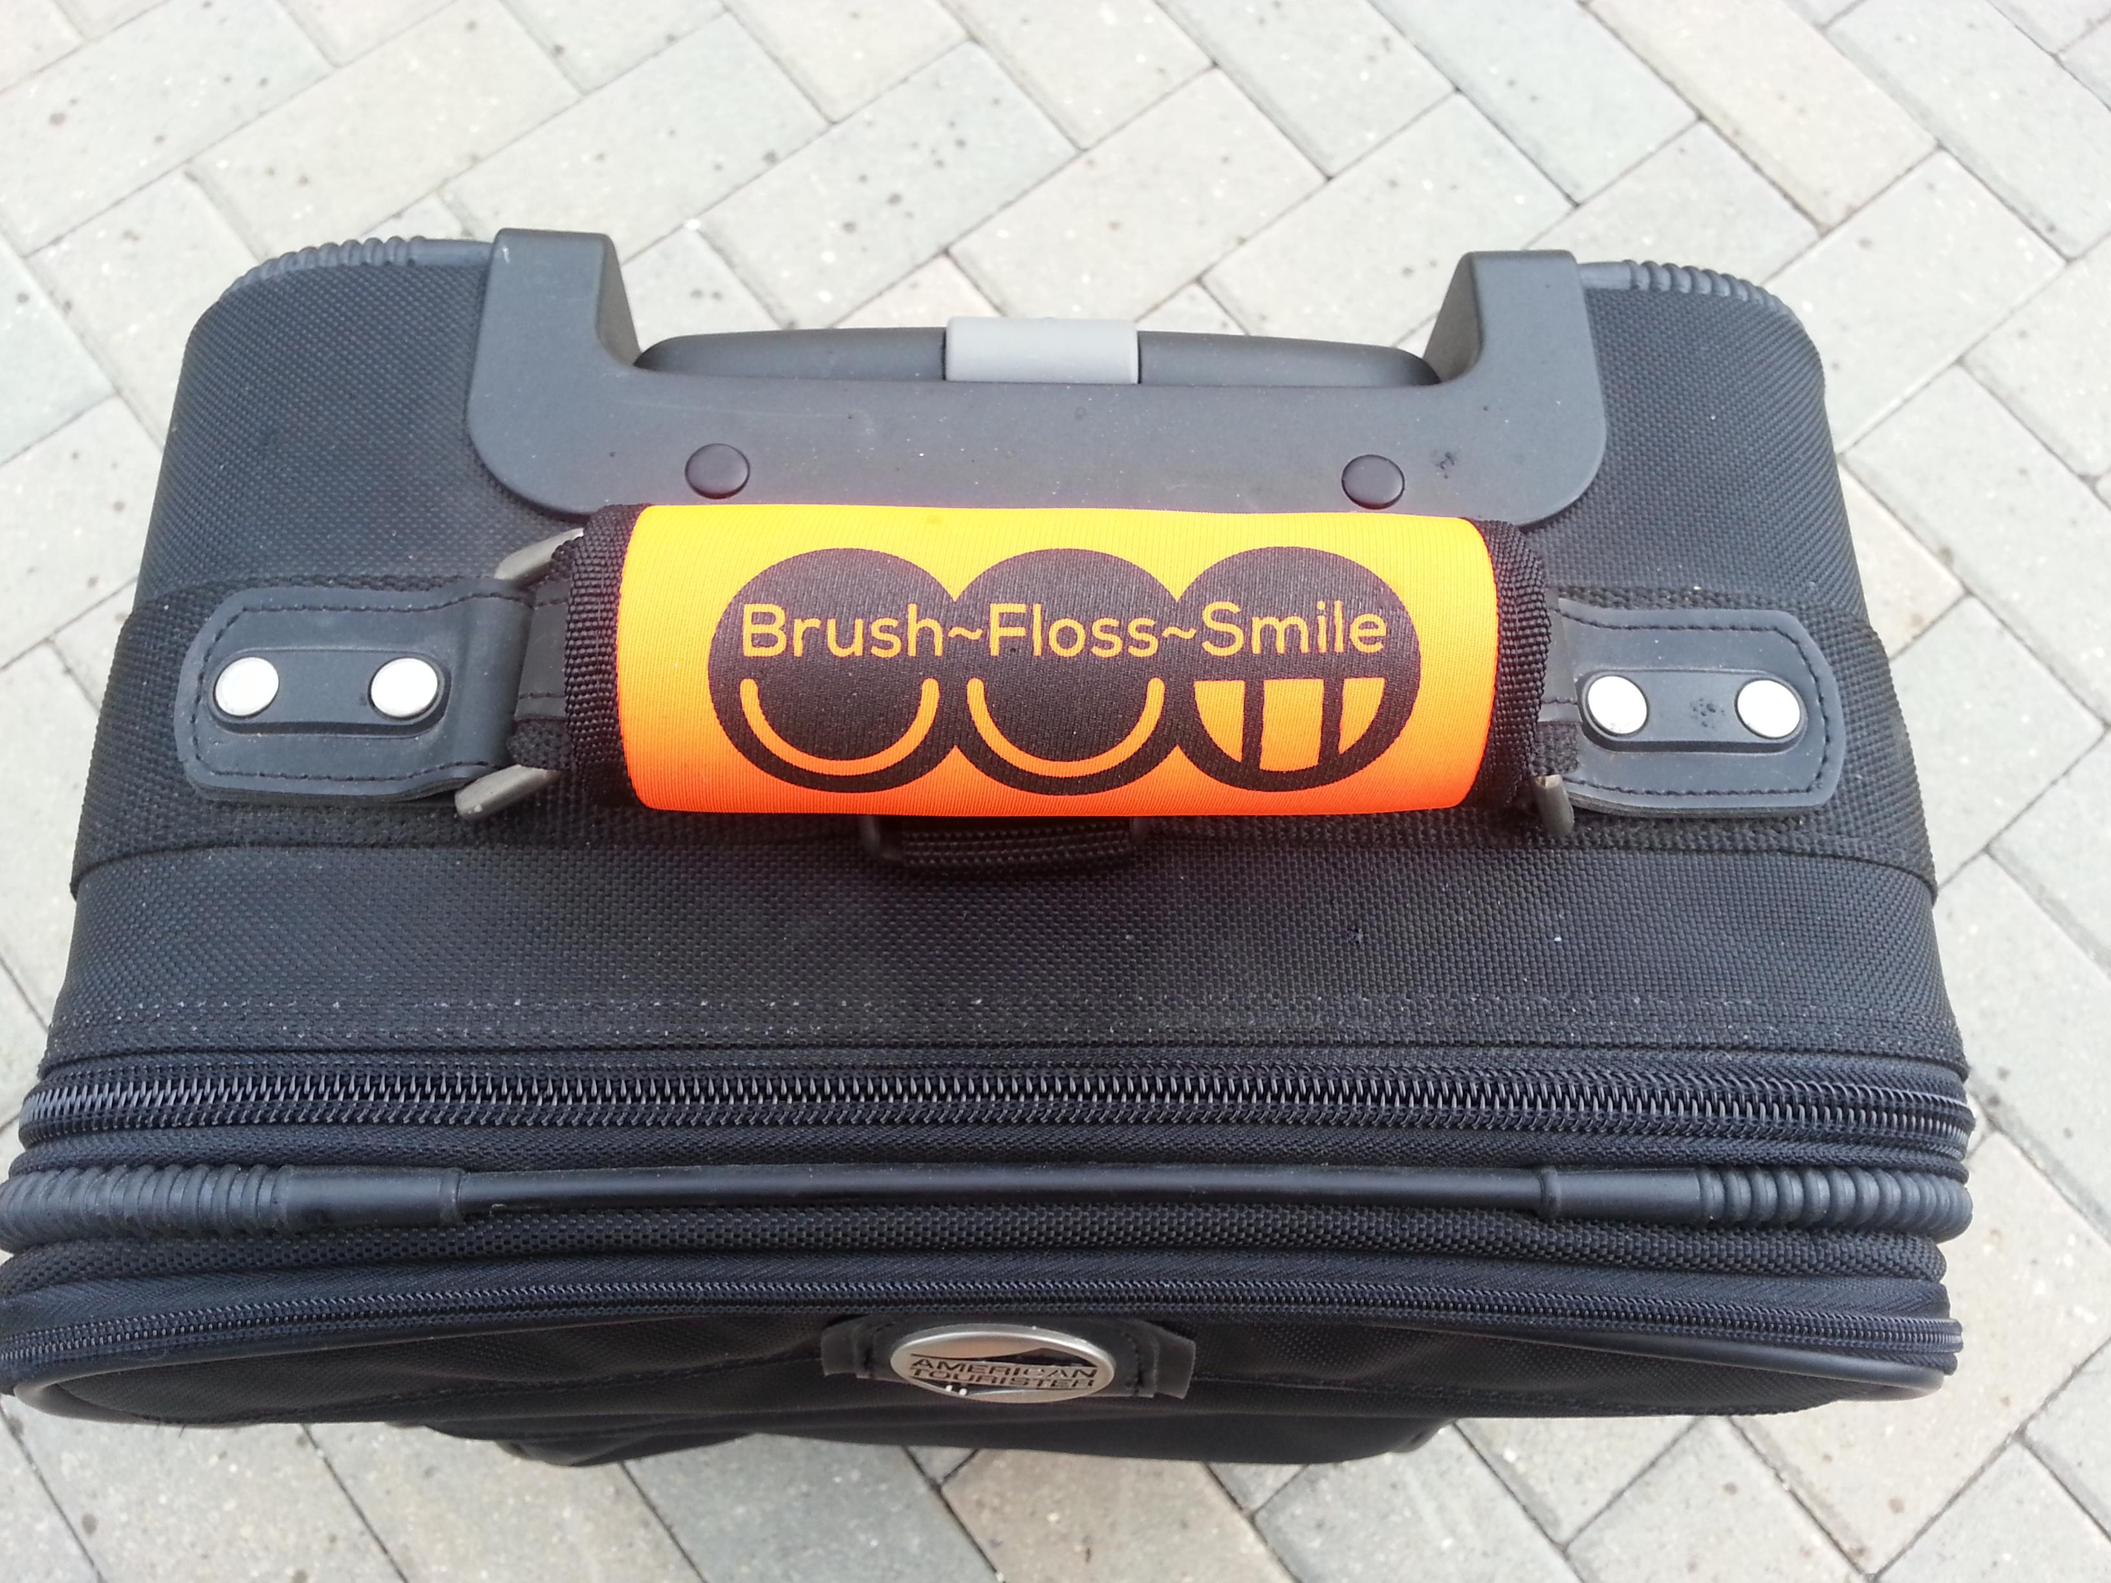

CONTINUING EDUCATION
Looking for CEs this Fall? Save the date for Friday, October 23, 2015 when MDHA will be in Northern Michigan providing 6 CE to kickoff our annual House of Delegates meeting. Stay tuned on our website for more details.

Another great opportunity for CE is the Center for Lifelong Learning (CLL) in Pittsburgh 2016.
Mark off your calendars now to attend this awesome event – June will be here before you know it!!
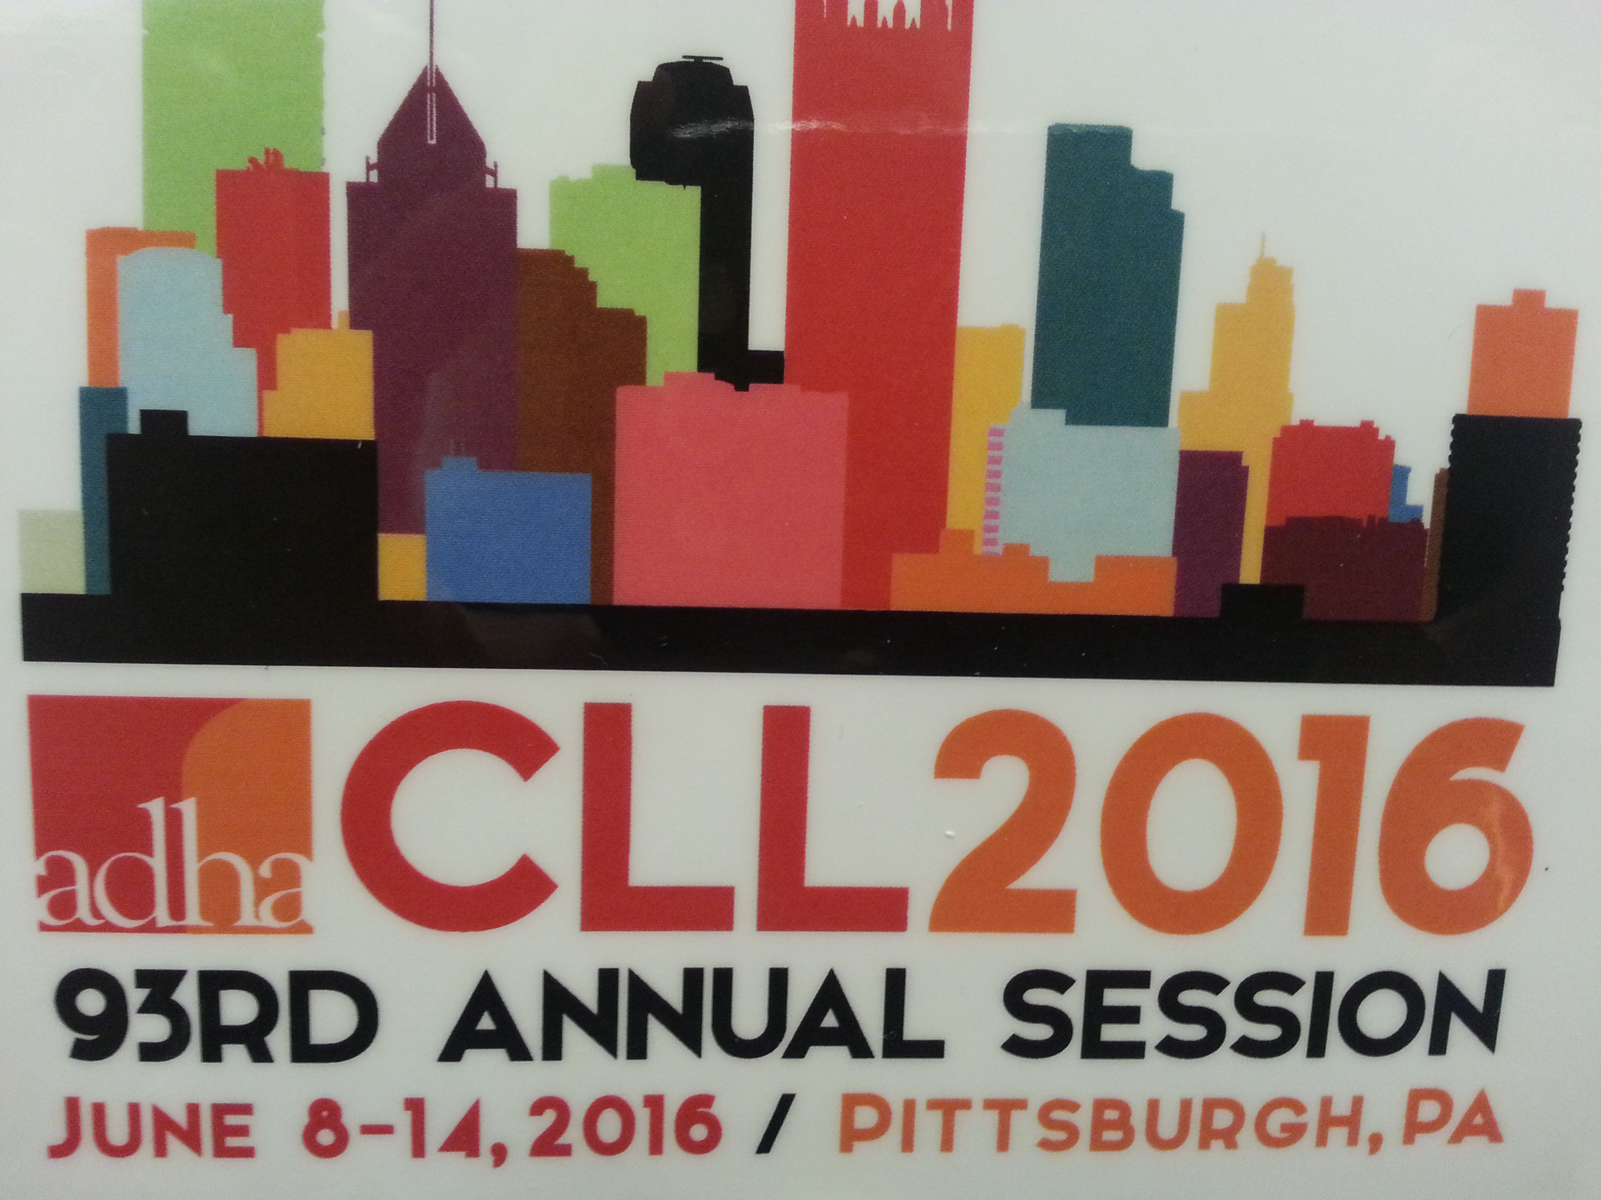
PUBLIC HEALTH NEWS
Congratulations to the University of Detroit-Mercy and children of Wayne County for this amazing opportunity for access to care afforded by Delta Dental!
Click on this link for more details.
http://www.crainsdetroit.com/article/20150615/NEWS/150619948/delta-dental-grant-to-help-udm-offer-wayne-county-kids-mobile-dental
JOB OPPORTUNITIES
Did you know that you can find great job opportunities on the MDHA website? Check it out today, visit http://www.mdhatoday.org/members/Employment%20Opportunities.html
Become familiar with www.mdhatoday.org and learn to navigate MDHA’s website!! There is an easy link for a membership application, and many opportunities for continuing education credits through various components.
Advertisers: This Newswire is being sent bimonthly to approx. 1000 registered dental hygienists throughout the state. It reaches these RDH’s and then some! If you would like to have your logo appear in this publication, please visit our website www.mdhatoday.org and click on the “advertisers” link. To our readers, you are encouraged to patronize our sponsors! Thank you!
