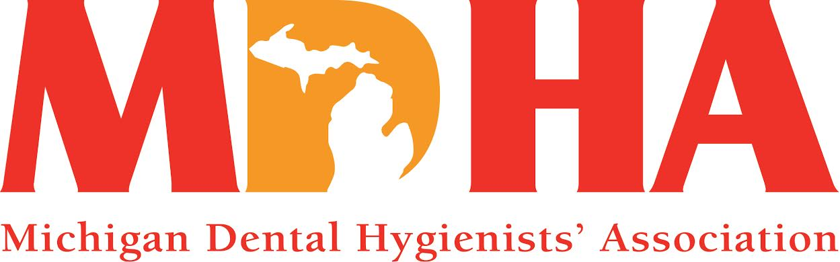
Fall 2015 Newswire
Stay in contact with MDHA visit our website
http://www.mdhatoday.org
It is October, and that means it is NATIONAL DENTAL HYGIENE MONTH!! This month is dedicated to our profession and is a great time to showcase our education, licensure and specialty in prevention. Visit the ADHA website at www.adha.org and look under the Events tab for NDHM materials. Here, you can also find a complimentary CE course provided by ADHA and the Wrigley Oral Healthcare Program. Post something on your Facebook page, write an article for a local newspaper or church bulletin, or hang the posters available at ADHA in every operatory at your office (one was also included with your most recent Access magazine)! Give credit where credit is due and be proud of what you do! You make a difference in people’s health and for that you should be celebrated!!

Since Fall is upon us, it is time to get back to the basics: reading, homework and routines ~ carpools, games and meetings! Maybe not in that order, or that literal, but the MDHA has definitely been doing their homework and we are ready to take on the new year!
As I write this last article as President, it is almost like the last day of school. I am saddened that my term will come to an end this month, yet I am so excited for the direction that MDHA is going and the amazing leaders that will drive the “change train” to new stations!

Speaking of change, grab your calendars as we have announced a different location for our annual House of Delegates (it will be held at Boyne Mountain Resort, October 23-25, 2015) and our annual Legislative Luncheon will be Wednesday, March 2, 2016 in Lansing. These are two excellent opportunities to see what we are doing at MDHA to move our profession upward!

Some other dates worth noting are the deadlines for scholarships (February 1st) and research grants (February 28th) available through your ADHA Institute for Oral Health (IOH). The IOH is the philanthropic foundation to advance professional excellence in dental hygiene education and research. Go to the ADHA website for further details, and spread the word to others that you know that may benefit from this type of funding.

By now, you should have received a letter from me detailing the background and progression of the restructuring taking place within our state. My hope is that you have a better understanding of the process and why change was desperately needed. I believe in this change and I want you to feel confident that your MDHA leadership is taking it seriously and will be with you every step of the way. The value of a sound and business-savvy organization is priceless! Our Component restructuring will be effective on October 25th and is a solid foundation for the future of MDHA. What a wonderful opportunity to support our colleagues and strengthen our association!

My theme of harmony fit perfectly with the idea of change this year and my hope is that we can all embrace what change is about: to make or become different. We experience change throughout our daily lives, both personally and professionally, and have seen leaps and bounds of change in the dental world. Change is good, just like harmony in a song. Every part in harmony enhances the other and it is imperative that they listen to each other so they are able to produce such beautiful music together.
I know the MDHA, with your help, will continue to work hard as the voice of all RDHs in Michigan.

And, as this President’s term is almost complete, know that my song has not ended as I will continue to change and grow, supporting this Association and our profession for many years to come. It has been an honor to serve you this past year and I look forward to making more music with MDHA!

Harmony will prevail…
KATHY MIELKE, BS, RDH
MDHA President

COMMUNICATIONS COUNCIL NEWS

Anything happening in your area that you would like to share??
Please contact our Communications Council Chair, Melissa Rosochacki at melissarosochacki@yahoo.com, so we can get your information on our website.
Don’t forget to like us on Facebook and follow us on Twitter (#MIdentalhygiene)!

EDUCATION COUNCIL NEWS
Click the link and see the attached flyer http://www.mdhatoday.org/wp-content/uploads/2014/02/MDHA-Continuing-Education-Programs-and-Registration.pdf for details on our 6 CE program offered this month at Boyne Mountain Resort on Friday, October 23rd.
Stay tuned for more information on another 6 CEs being offered by MDHA and your Northland Component on March 12, 2016.

FINANCE COUNCIL NEWS

Our annual coffee sale is going on now through November 15th!! Get your stocking stuffers or office exchange gift before the deadline! Makes a great gift basket!
See the attached flyer for details at the end of the newswire.

Also, get ready to purchase your Boyne Stay & Play Getaway Raffle! You can golf, you can ski – with your spouse or the whole family!! Tickets are $10.00 and will be available at our House of Delegates, so connect with your Component Trustee to purchase your ticket(s)!

LEGISLATIVE COUNCIL NEWS

Since we live our lives in 3-, 4- or 6-month increments, please SAVE-THE-DATE for our annual
MDHA Legislative Luncheon ~ March 2, 2016.

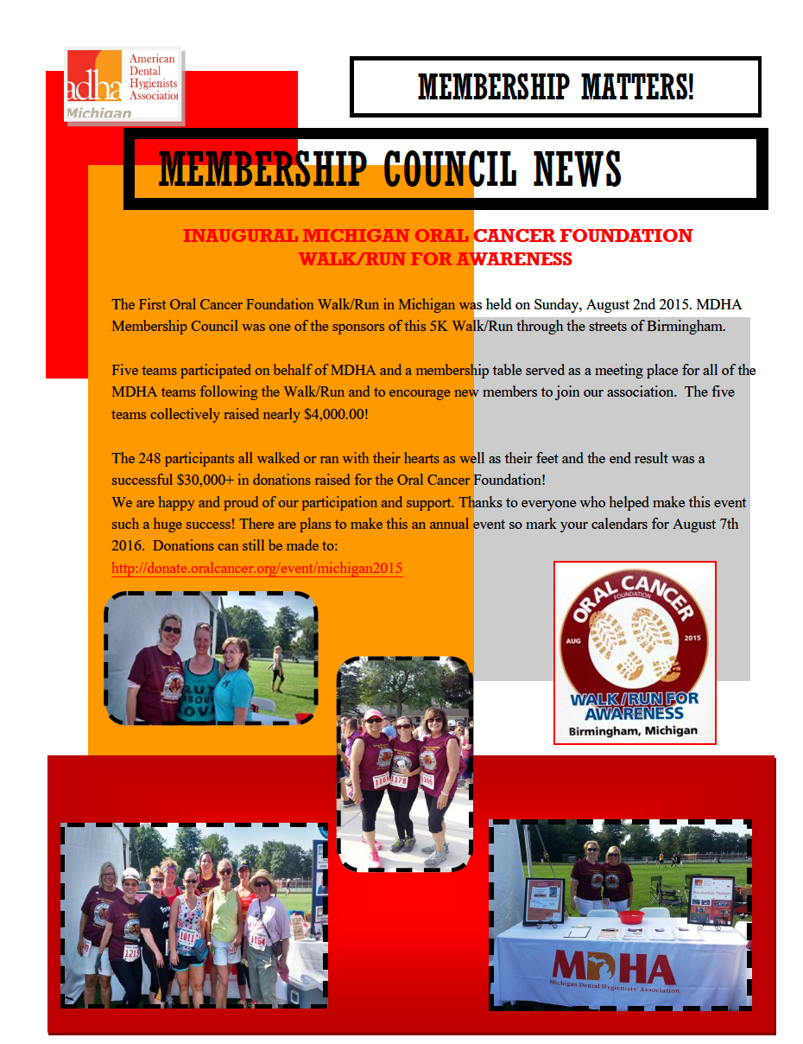

PUBLIC HEALTH NEWS
Mark your calendars to support the Mission of Mercy coming to Macomb Community College, June 9-12, 2016. Registration details will be available after the first of the year.

The MDHA encourages you to stay on top of the fluoridation issues in your communities! You know the facts and that there is evidence-based science to back it up, so be sure to utilize the U.S. Public Health Service report and recommendation as a reference. Click here http://www.publichealthreports.org/documents/PHS_2015_Fluoride_Guidelines.pdf and contact MDHA for any support needed!!

JOB OPPORTUNITIES
Did you know that you can find great job opportunities on the MDHA website? Check it out today, visit http://www.mdhatoday.org/members/Employment%20Opportunities.html
Become familiar with www.mdhatoday.org and learn to navigate MDHA’s website!! There is an easy link for a membership application, and many opportunities for continuing education credits through various components.
Advertisers: This Newswire is being sent bimonthly to approx. 1000 registered dental hygienists throughout the state. It reaches these RDH’s and then some! If you would like to have your logo appear in this publication, please visit our website www.mdhatoday.org and click on the “advertisers” link. To our readers, you are encouraged to patronize our sponsors! Thank you!
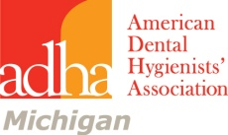

MDHA/ADHA STUDENT CHAPTER
Gourmet Coffee Sale
Fall 2015
This year, 14 ounce vacuum sealed bags of ground or whole bean coffee will be available at $16.00 each for regular and $18.00 each for decaf. Our flavors are:
1. Breakfast Blend 2. Decaf Breakfast Blend 3. Bunches
4. Decaf Bunches 5. Winter’s Blend 6. Columbian Supremo
7. Christmas Spice 8. Pumpkin Spice 9. Coffee Cake
10. Jamaican Me Crazy 11 Decaf Jamaican Me Crazy 12. Cookie Doodle
13. Decaf Cookie Doodle
PLEASE NOTE THAT THIS YEAR, ONLY ONE COFFEE SALE WILL BE HELD SO LET’S RALLY TO MAKE IT A HUGE SUCCESS! COFFEE WILL BE AVAILABLE FOR PICK ON DECEMBER 10, 2015 AT CENTRAL OFFICE. COMPONENTS CAN COORDINATE PICK UP. REMEMBER THAT OUR COFFEE WILL MAKE A GREAT CHRISTMAS GIFT FOR FAMILY AND FRIENDS. ORDERS ARE DUE TO JAN POPOWICH BY NOVEMBER 15.
Eve Sidney, RDH sidneyej@gmail.com Jan Popowich, RDH janp2@wowway.com
MDHA Coffee Sale Co-Chairmen 586-468-9561 (Jan)
ORDERING GUIDELINES
- Designate a Component/Student Chapter coffee sale chairman who will place the component order with the Jan Popowich. Plan your component order deadline to allow you enough time to place your order with the MDHA coffee chair before the November 15 deadline. Be sure to collect payment with orders. Order forms are included in this packet.
- ORDER DEADLINE TO JAN POPOWICH IS Sunday, November 15.
Call Jan with your final order on or before November 15. You can call evenings or weekends, contact me by email, or leave a message on my voice mail. I will return your call or email. I will need your name, phone number, component name and coffee order. PLEASE REMEMBER THAT ALL MONEY IS DUE TO MDHA IMMEDIATELY AFTER PLACING YOUR ORDER. THIS YEAR THE COMPONENT CHECK SHOULD BE MAILED TO JAN POPOWICH’S HOME ADDRESS. AFTER I DOCUMENT THAT IT HAS BEEN RECEIVED I WILL FORWARD IT TO CENTRAL OFFICE.
- Payment to MDHA is made with ONE component check.

DELIVERY GUIDELINES
- The coffee will be available for pick up by components and Student Chapter groups on December 10 at Central Office. Components can coordinate pick up.
- For questions regarding delivery, please contact Eve Sidney at sidneyej@gmail.com
PAYMENT GUIDELINES
- Components/Student Chapters should collect payment with the orders. Coffee purchasers should make checks to the component or student chapter, not to MDHA.
- Payment is due to Jan Popowich immediately after placing your order. I’ll give you the total amount to be sent. DO NOT SEND A CHECK PRIOR TO PLACING THE COFFEE ORDER.
- Payment to MDHA must be in the form of ONE check made payable to MDHA. Please write the name of your component on the check. Please use the enclosed form when mailing your component payment to Jan Popowich.
- Payment to MDHA should equal the total number of bags sold x $14.00 for regular coffee and $16.00 for decaf coffee. Each component or Student Chapter group will keep $2.00 per bag sold.
- Payment is sent to MDHA Coffee Sale c/o Jan Popowich
38591 Thornwood Dr, Harrison Township, MI 48045

