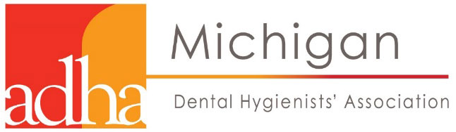

Legislative Alert
Let your voice be heard!

Support SB 1013; creation of the Dental Therapist (mid-level provider)

Show your support either by attending a hearing or writing a letter or both.
Two hearings are planned to be held in Lansing. September 6th will address the “access to care” issue. Speaking on Sept 6th will be dental hygienists working in the public health arena. Others in attendance would be wonderful as a show of support as well as an educational opportunity. The 2nd hearing is tentatively planned for September 20th where hygienists may provide oral and/or written testimony on the mid-level provider issue. If you are able to attend a hearing please contact the MDHA lobbyist, Sarah Hubbard, from Acuitas, at shubbard@acuitasllc.com or 517-881-7898 for more information, such as the exact location. If you are unable to attend please consider writing a letter to your senator. A thank you letter to the sponsors of the bill would also be helpful.

Thank you for your time and commitment to the underserved citizens of the state of Michigan. Below is a draft letter for you to copy and paste.
_____________________________________________________________________________________
Find Your Senator
Senate: http://www.senate.michigan.gov/fysbyaddress.html
_____________________________________________________________________________________

The Honorable ____________
Michigan State Senator
P.O. Box 30036
Lansing, MI 48909

Dear Senator ___________,
As a Registered Dental Hygienist practicing in Michigan, I support Senate Bill 1013 introduced recently by Sen. Mike Shirkey. SB 1013 creates a new dental provider known as a Dental Therapist (DT) who would be able to perform the most commonly needed preventative and restorative dental care tasks in areas experiencing a dental shortage.
The Dental Therapist would work under the supervision of a Dentist. Addition of a DT to a dental care team would be voluntary and directed by the Dentist. Dental Therapists are similar to physician assistants on medical teams, and are well trained to perform routine dental procedures currently only performed by dentists, such as filling cavities.
Senate Bill 1013 would give dentists the flexibility to modernize and expand their practices in a financially sustainable way, while also treating more patients who otherwise would not have access to dental care.
Access to dental care is limited or nonexistent for millions of Michigan residents, creating serious oral health care issues that can lead to tooth loss, pain and potential life-long ramifications.
• There is at least one dental shortage area in 77 of Michigan’s 83 counties.
• More than one-third of all Michigan seniors have lost six or more natural teeth due to tooth decay or gum disease. Low-income seniors are more than three times as likely to have lost six or more teeth due to tooth decay and/or gum disease.
• Almost 3 out of 4 new mothers in 2008 did not receive dental care during their most recent pregnancy. Research shows gum disease contributes to preterm birth.
• Nearly 60 percent of children on Medicaid did not see a dentist in 2014—placing Michigan in the bottom ten states in the nation.
• 66 percent of third-graders in the Upper Peninsula had a history of dental decay in their primary and/or permanent teeth, compared to 56 percent statewide.

Please support SB 1013 when this comes before you in the legislature. Thank you for your time.

Regards,
_______________, RDH

