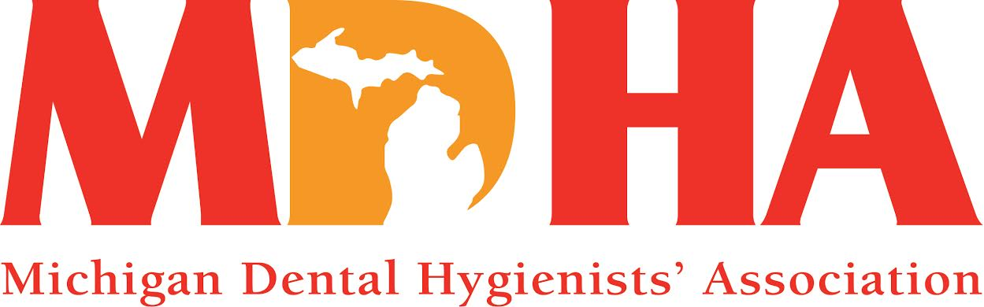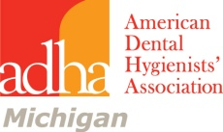
July 2014 Newswire
Stay in contact with MDHA visit our website
http://www.mdhatoday.org
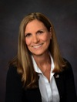
We have had a successful spring. Your officers have been busy with Spirit of Michigan (a joint meeting with the MDA, MDHA and MDAA), legislative luncheon, Mission of Mercy, District V meeting and the ADHA Annual House of Delegates.

I would like to thank all of those who participated in the Spirit of Michigan, either by attendance or volunteering. Your contribution makes a difference to the Association as well as your profession. We are already gearing up for next year, which is to be held in Lansing. Please inform MDHA officers if you have any suggestions for speakers or are interested in volunteering. Your input is always appreciated.
The MDHA Legislative luncheon was held in the House Office Building on May 7, 2014. It allows dental hygienists a one on one opportunity to speak to their elected officials in a non-threatening atmosphere. This year prior to the luncheon our lobbyist Sarah Hubbard presented a CE. It was informative and enjoyed by many. We had several students in attendance as well. I believe participating is a valuable experience. We are planning to continue the tradition. Mark your calendars for next year May, 13,2015.
A huge thank you to those who volunteered for the Mission of Mercy held on the campus of Ferris State University. The event was a success and was appreciated by the many people that were served. It is one small part of solving the access to care issue here in Michigan.
The District V meeting was held in Ft Wayne, IN on the same weekend as the Mission of Mercy. MDHA delegates met with the delegations from Indiana, Ohio, and Kentucky to discuss the proposed by-laws (Pby’s) and policies (Pr’s) to the ADHA HOD. District V is a voice to be heard on the national level. We Rock!

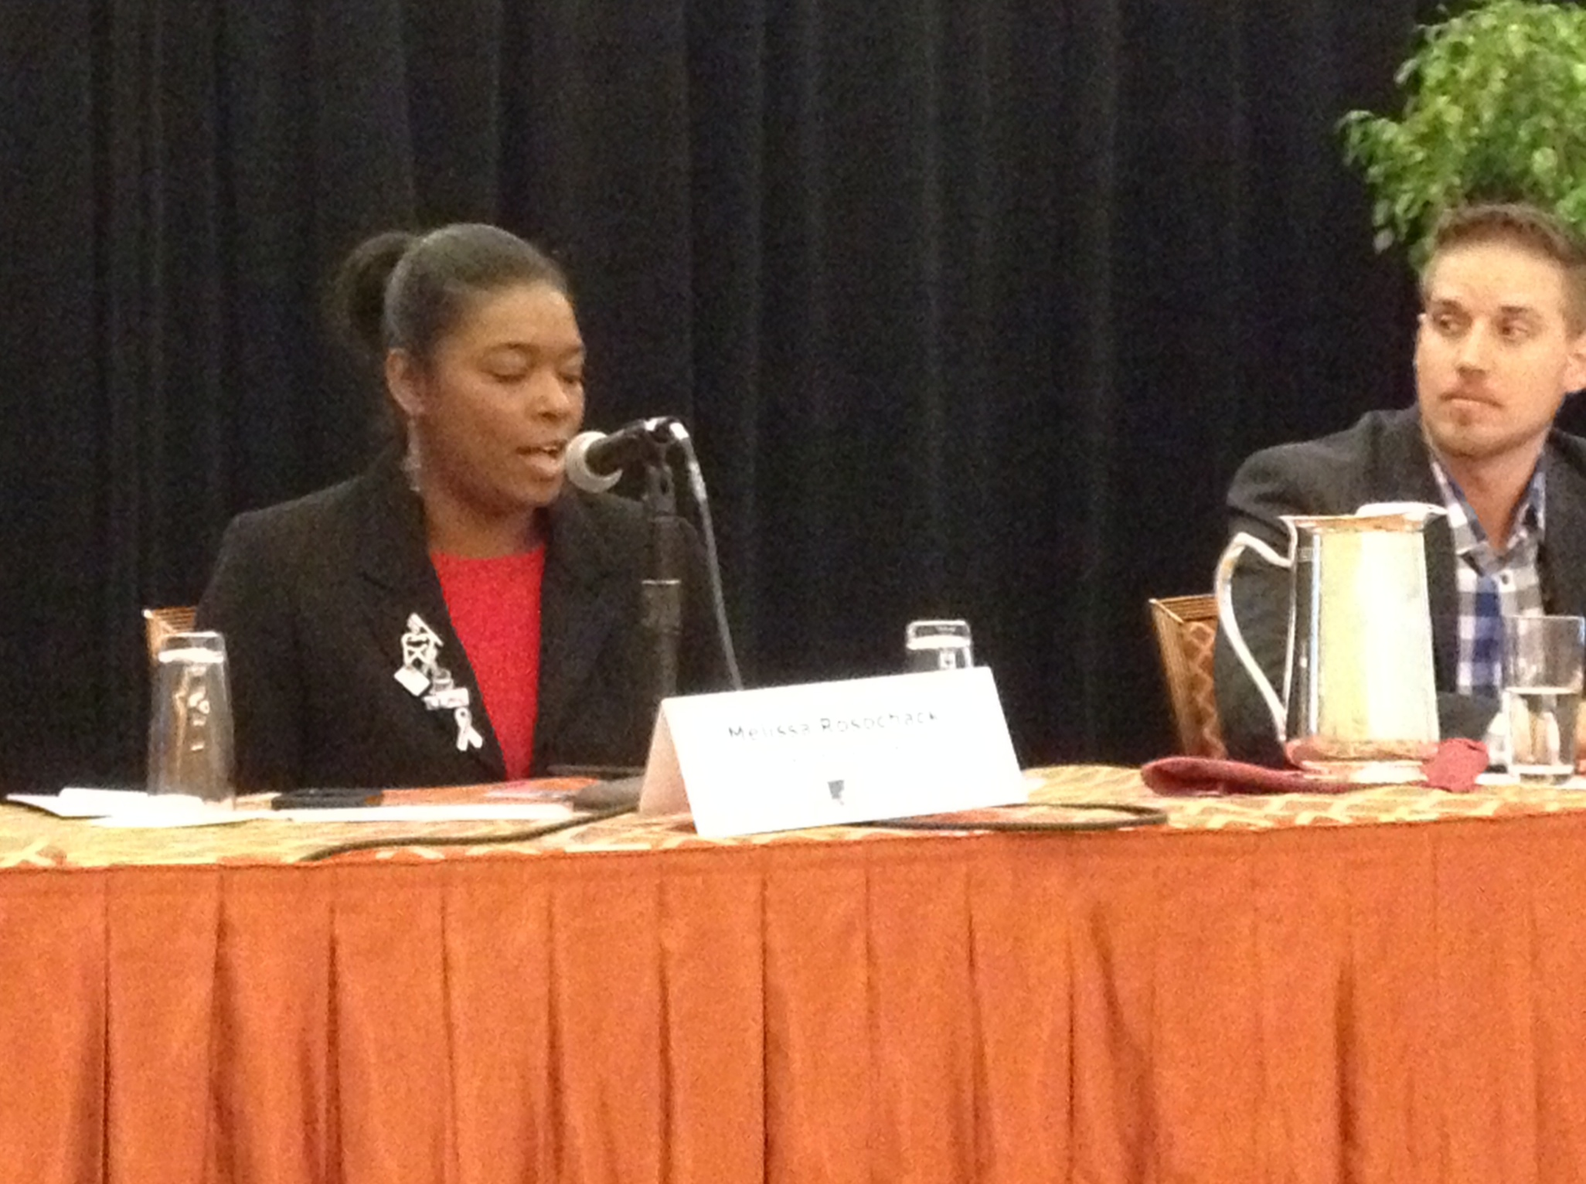
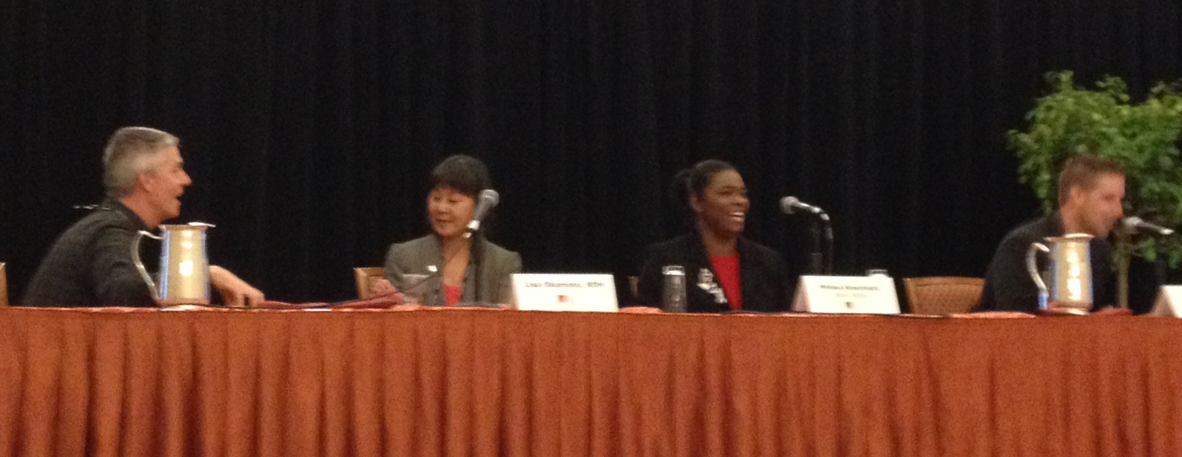
Lastly, the ADHA House of Delegates was held in Las Vegas. The first few days are filled with CE courses and opportunities for officers to meet with ADHA staff. We all participated in some capacity. We are proud of Melissa Rosochacki who served as a panelist at the Diversity workshop. She out shined the other panelist with her confidence and well thought out answers. On the house floor the Pby I was excited about, was to change the title of the voting members of the organization from Active to Professional. The data shows that potential members are resistant to join because they believe Active member means that you must do something more than pay your dues. Other policy changes were made that rewrote current policies written in the negative to a positive format, which we had done in Michigan a few years ago. The most significant change for ADHA took place this last year when the organization developed a new strategic plan.
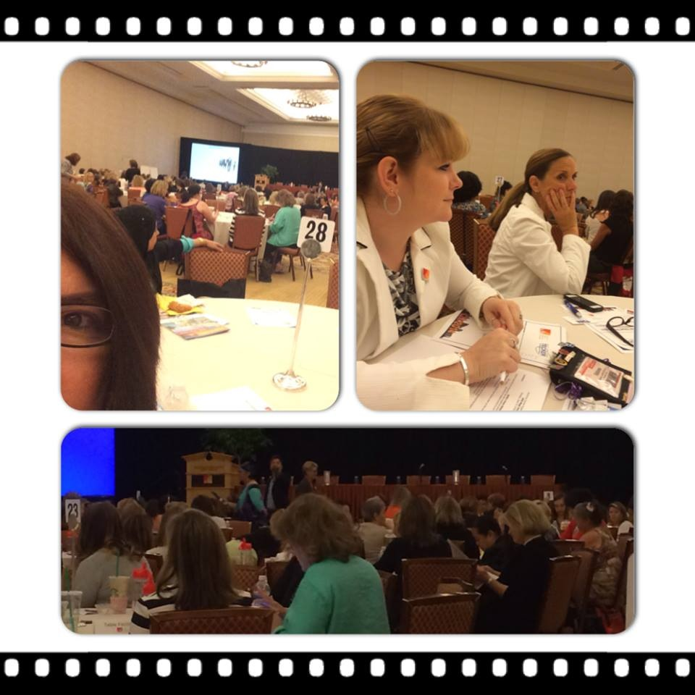
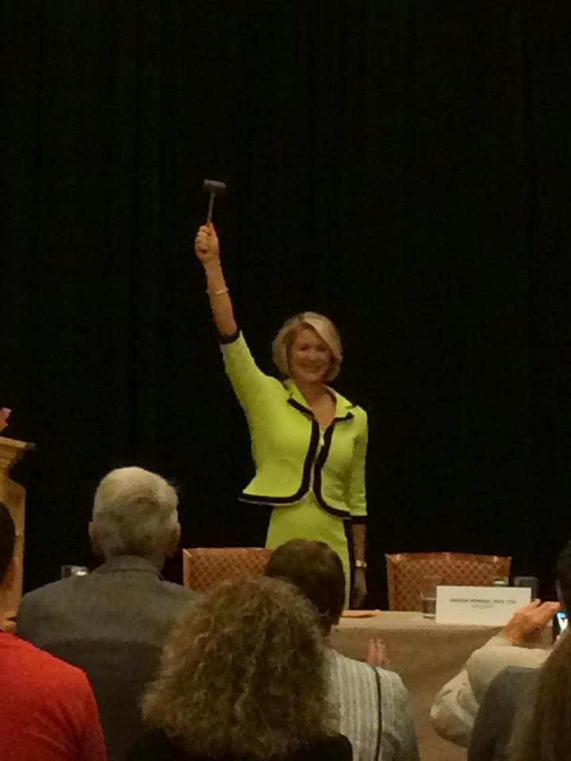
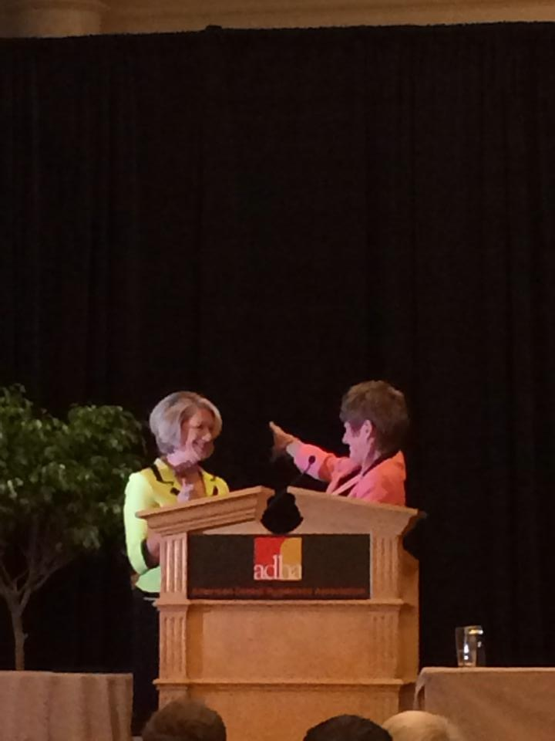
2015 ADHA Strategic Plan
Core Ideology
Lead the transformation of the dental hygiene profession to improve
the public’s oral and overall health.
Vision Statement
Dental hygienists are integrated into the healthcare delivery system as essential primary
care providers to expand access to oral health care.
Values
Service : Collaboration : Quality : Community : Lifelong Learning : Ethics

The plan to accomplish these goals is through Education, Alliances, and Advocacy. Newly installed ADHA President Kelli Swanson Jaecks is the perfect person to lead us through this transition. Our organization is a Tripartite organization, National, State and Local. There is power in numbers. Together we are stronger. If you are considering membership, this is your time, this is our time, and together we can make a difference. Help us Frame the Future of our profession.
Respectfully Submitted, Cheryl Bentley, RDH MDHA President

MEMBERSHIP COUNCIL NEWS
NEW THIS YEAR!
Scholarship applications have been converted to a fillable on-line form
The deadline for the MDHA Awards which are presented at the annual House of Delegates session is quickly approaching. Please note that all award applications are due by AUGUST 1st, 2014.
The award applications and descriptions can be found under the Members and Students section of the MDHA website and also can be accessed directly at: http://www.mdhatoday.org/awards/
When filling out the application forms, please type directly into the spaces provided, then save the document to your computer. Attach the document to an email and send to Kim Amico, RDH at:
kimamico_rdh@wowway.com

When filling out the application forms, please type directly into the spaces provided, then save the document to your computer. Attach the document to an email and send to Kim Amico, RDH at kimamico_rdh@wowway.comADHA’s call for award applications begins in the fall of 2013. Apply today for your chance to be recognized by your colleagues and receive funding to attend the ADHA’s CLL at the 91st Annual Session. See below for individual deadlines and entry details.
Be sure to check the ADHA Website for award applications: http://www.adha.org/awards-program

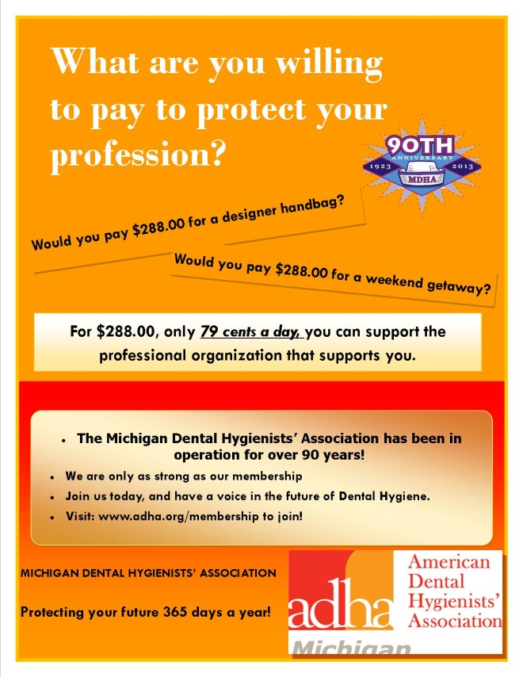
GRADUATION PACKET FOR THE CLASS OF 2014
A graduation packet of important information was designed and distributed by the Membership Council to all the Dental Hygiene Class of 2014 graduates.
This document will soon be available in the student section on the website with yearly updates.
Congratulations to our newest RDHs!
ATTENTION STUDENT MEMBERS!
Be sure to convert your student membership to active membership. Just follow one of these easy steps:
- Access your online profile at www.adha.org and login to your ADHA account and click the “Convert to Active Member link. OR
- By calling Member Services at 312-440-8900, press 1.
- Email: student.relations@adha.net Include your name, ADHA member ID number, license number and state of licensure.

Legislative Council News
Hello all,

The ADHA CLL this year was truly amazing! We had a great time in Las Vegas, while we learned to appreciate, once again, the value of our national leadership. The ADHA National House of Delegates is unlike anything else "we" may have experienced. While our Michigan House of Delegates is run similarly, being in the company of all Registered Dental Hygiene Delegates from around the country has a unique aura unto itself. It is this forum whereby we collectively determine the Policies and Bylaws that dictate the direction and guidance of our chosen career.
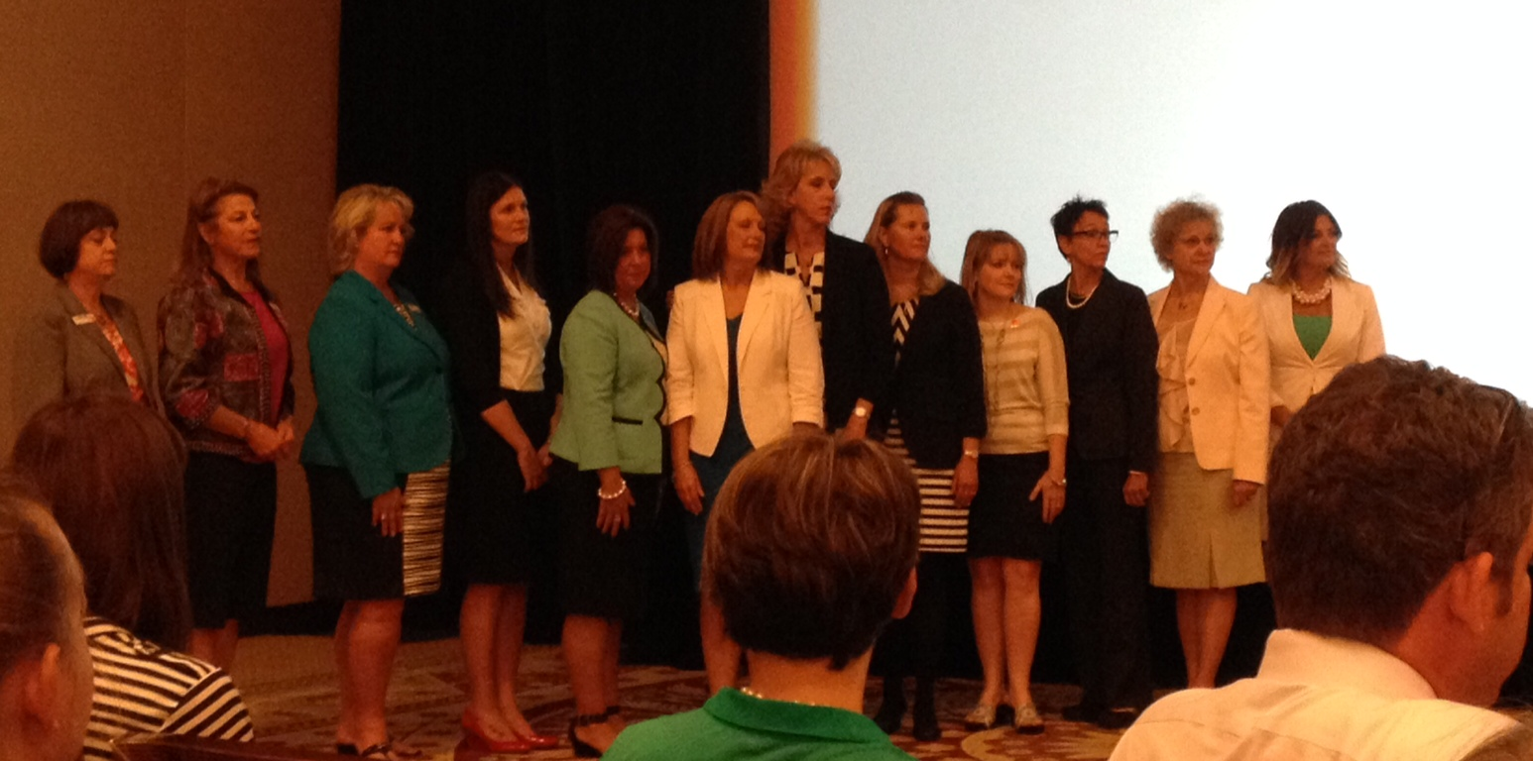

All twelve Districts conferred with the Executive Officers, and select staff of the American Dental Hygienists' Association directly. We voted on future leaders that will be accountable for the success and direction of our career. It is both a humbling and yet empowering opportunity that makes a difference for all of us. Your Michigan Leadership was well represented.

Feel free to contact the Legislative Council for specific details regarding the Policies and Bylaws. In the meantime, don't miss the next opportunity to join us. The ADHA/CLL will be held in Nashville Tennessee next year around the same time.
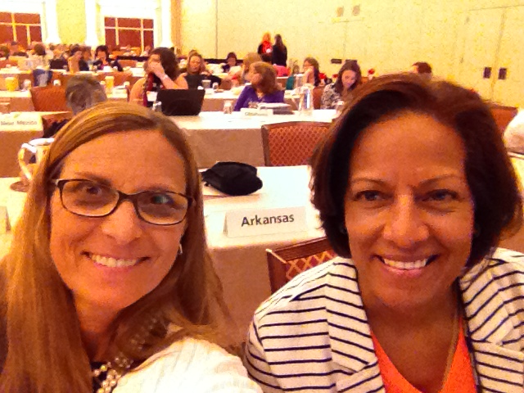

Respectfully submitted,

Melanie D. Colbert RDH BS
Legislative Co-Chair

Public Health News
Fluoridation in Michigan Update:
Many Michigan dental professionals have taken fluoridation for granted for too many years. We see the benefits on a daily basis. Our oral health has significantly improved since fluoridation was initiated in our own Grand Rapids in 1945. It is time to wake up and pay attention to what is happening in our state, to the efforts being made by opponents of fluoridation to get communities to stop one of the most successful public health measures of our time. The Centers for Disease Control and Prevention (CDC) still promotes community water fluoridation as one of the top ten public health measures of the 21st century and is one of the top evidenced-based preventive measures for dental decay, along with dental sealants.
There has recently been increased activity in our state by anti-fluoridation groups, especially in northern Michigan. In May, the Boyne City Council voted to discontinue the practice, even though there was a public vote to fluoridate in 1973. There are some dental professionals in the area trying to get it re-instated by bringing the issue to a public voice again but are facing strong opposition with members on the city council.
In Traverse City there recently was a vote by the city commissioners in June to maintain their fluoridation program, but not without a lot to time and combined community support to rally residents to show up and voice support for continuation. There is continued activity from the opposition to get this issue on the November ballot. Please stay tuned for continued news on where that goes.
I also just received notice from the East Jordan City Administrator that they will be discussing fluoridation as one citizen is raising concerns. They plan to discuss the current level used to fluoridate and are considering lowering the level to the proposed CDC recommendation of .7ppm from their current level of 1.0ppm at their July 15th city meeting. This normally brings out more opposition to fluoridation so we will rally support in that area for that evening.
Cassopolis, in the southwestern portion of the state has also recently had some opposition to fluoridation. Tom Kochheiser from the MDA was able to attend a planning meeting in that area last month and feels the issue should go no further but keep your ears peeled.
Below is a list of the fluoridation activity that has happened across the state since 2010:
- Mt. Pleasant: 2010 Voted to reduce to natural level of .4/ppm Population: 25,983
- Forsyth Township/Gwinn: 2010 Officially voted out by council but has not been fluoridating for years. Pop: 2370
- Newberry: 2010 Received word from DEQ Sept 8-2011 that Newberry had discontinued in Nov 2010. Pop: 2000
- Galesburg: May 2011 voted to discontinue; Pop: 1988
- Village of Marcellus: 2011 - Voted out Pop: 1157
- Mt. Clemens: June 2011 - Voted to discontinue Pop: 18,405
- Benton Harbor: October 2012- discontinued due to finances- fluoridation grant in 2013 so resumed
- Hartland Township: –Dec 20, 2011 Council voted to discontinue 5-2 Pop: 1500
- Leslie: 2011 Considered adding but city council voted not to.
- Hartford: 2012- Spoke with city council and decided to keep
- Howell: 2012- Mayor opposed but no action yet
- Kalamazoo: 2012 Some discussion- spoke with Environmental Concerns Comm and City Commissioners- no further action
- Marysville: 2012 No action yet
- Wayland: 2012- spoke to city council and voted to keep
- Port Huron: 2013- March on city capital; no further action
- Boyne City: Voted out May 13, 2014
Also of concern are those communities that consistently had sub-optimal levels in 2013 to prevent dental disease. We are currently looking into why this is the case for these communities and will address each community as quickly as possible:
- Marine City
- Rockford
- Sheridan
- South Lyon
- Quincy
- Tecumseh
- West Branch
- Wyandotte
- (Summit Township-overages)
If you live in any of the above areas I urge you to speak with your city officials and encourage them to initiate, maintain, and monitor the proper optimal fluoride levels in the community drinking water to reduce oral disease in our state! Please contact me for more information or to learn how to advocate for community water fluoridation for your community.
Susan Deming, RDH, RDA, BS
Education/Fluoridation Coordinator
Michigan Department of Community Health
Oral Health Unit
demings@michigan.gov
517 373-3624
ADHA UPDATE
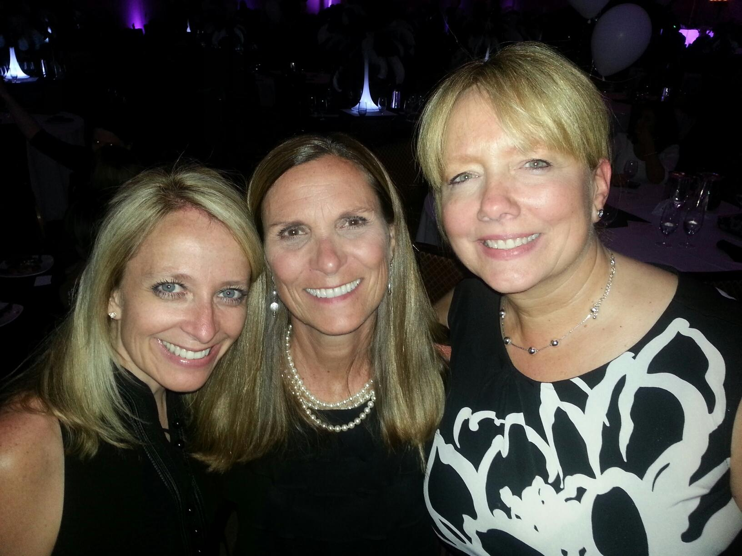
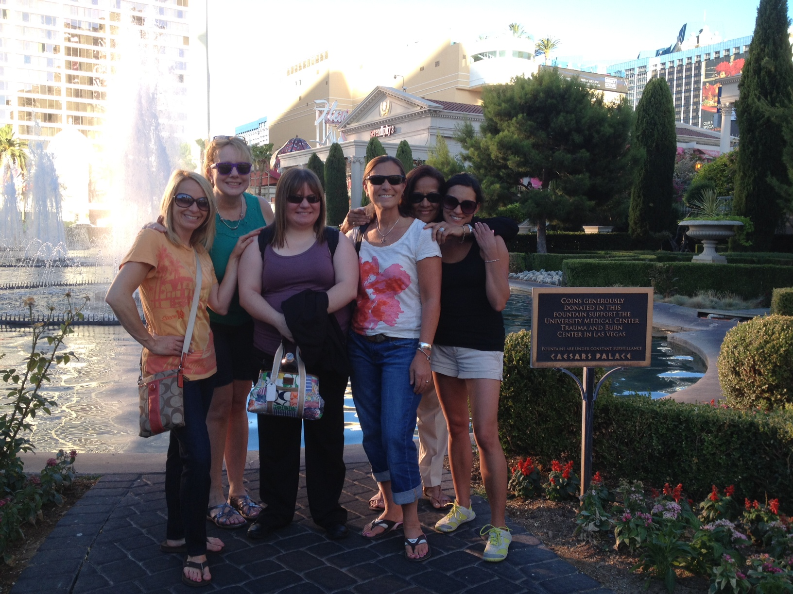
A Delegate’s Perspective: Transforming the profession of Dental Hygiene
As always the ADHA Center for Life Long Learning and the ADHA House of Delegates is inspiring and educational. This year was no exception. I am sitting at the gate in the airport contemplating the last week of activities. There were several CE courses to choose from, something for everyone. The friendships made are priceless and the empowering message that “we are stronger together” lights a spark in all of us. The ADHA developed a new strategic plan, to lead the transformation of the dental hygiene profession to improve the public’s oral and overall health and that dental hygienists are integrated into the health care delivery system as essential primary care providers to expand access to oral health care.
As a delegate we participated on the house floor but almost as important are the Mega Issue question: What are the implications of ADHA’s new future vision on the constituents (state) and component (local) associations? As we entered the room we chose a number from a basket and went to the assigned table. Seated at each table were ten dental hygienists from random states. We introduced ourselves and appointed a time keeper, scribe, and a presenter. Each table already had an appointed facilitator. We discussed what unique roles do the constituents and components play in ensuring that dental hygienists are integrated into the healthcare delivery system and are considered essential primary care providers and what three things should we focus on to contribute to ADHA’s vision. The outcome of these discussions will be shared on the ADHA’s website soon. I believe one of the most important ideas for us to leave with is that, there is power in numbers, so even if you as an individual are speaking to an elected official remember that you are a part of a national association and have their backing. That is huge. We need to think nationally. Together we are better and stronger. Together we will ensure that we are known as essential primary health care providers and we will make a difference in the access to healthcare issue.
Thank you for allowing me to represent Michigan as a delegate. I truly appreciate the opportunity.
Respectfully submitted by: Cheryl Bentley, RDH, MDHA President, ADHA Delegate
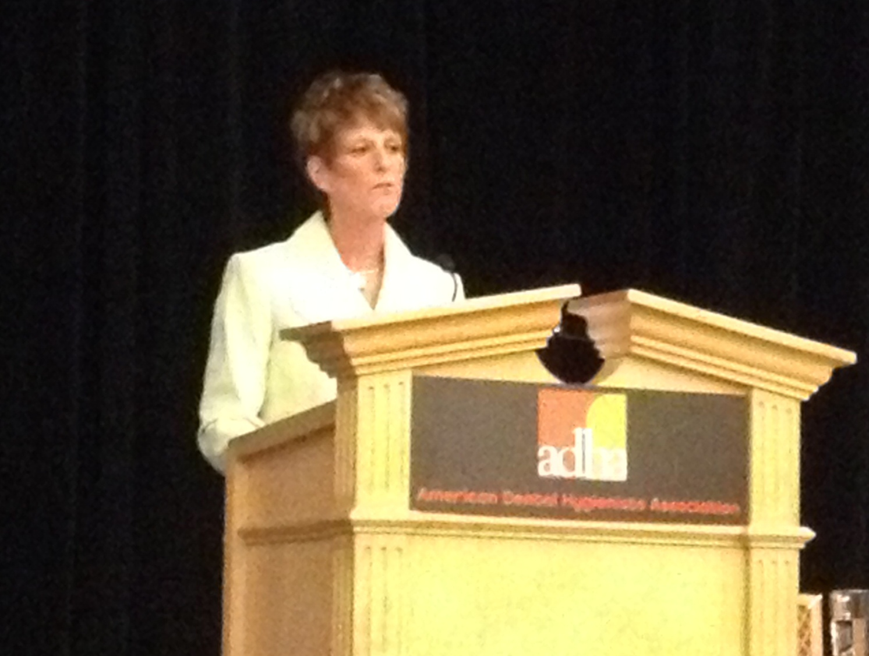
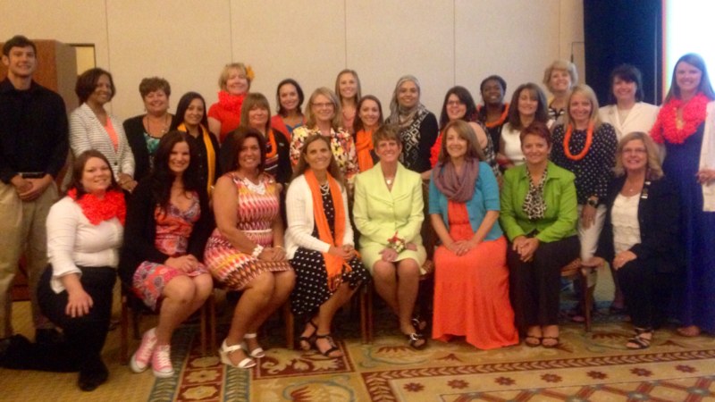
Communication Council News

THE NEW WEBSITE HAS LAUNCHED
visit
www.mdhatoday.org

Please remember, if you have information regarding seminars, newsletters, or anything you feel it is pertinent for your members and students, please post it on the MDHA website, www.mdhatoday.org!!

If you have any questions, please contact our webmaster, Jen Suminski, jen_suminski@yahoo.com.

JOB OPPORTUNITIES
Did you know that you can find great job opportunities on the MDHA website? Check it out today, visit http://www.mdhatoday.org/members/Employment%20Opportunities.html

CONTINUING EDUCATION

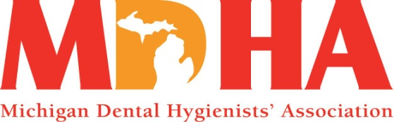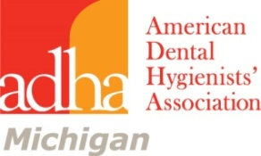
Continuing Education Seminar
Featuring Amanda Slawter
Presenting Motivational Interviewing
Where and When Fairfield in Okemos September 13
4-6pm following the Saturday Meeting of the BOT
Everyone welcome
6-7pm Wine and cheese Tasting
$20 for 2 CE Course __________
Wine and Cheese tasting $15 __________
each attendee will receive a RDH wineglass
Register for both and save! Total $30 __________
Name______________________________________
Address____________________________________
____________________________________
Phone______________________
Mail to: Joyce Losen 2310 Jolly Oak Rd Okemos, MI 48864
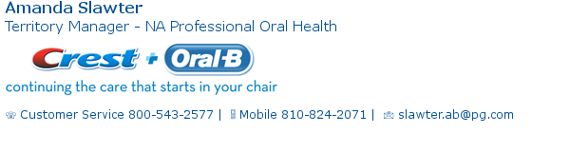

Friday, September 12, 2014 (8:30 – 12:30) 4 CE
“The DiGangi Code: Fact and Fiction for Clinicians” with Patti DiGangi.
Coding can seem cryptic and a conspiracy not to pay claims. Much of what we think we know about codes is fact….or is it fiction? Can D4341/2 and D1110 be used on the same day? The insurance carrier said to alternate D1110 and D4910. Is this correct? Why are there no codes for care for active gingival disease without bone loss? What the code for periodontal charting?
· Identify dental benefits fact from fiction
· Know the correct answers to eternal questions about periodontal care
· Classify the steps to accurate coding using case histories
· Create simple and effective narratives
· Learn what’s new in CDT 2014
· Increase your brain fitness
All attendees receive a FREE book titled Dentalcodeology – More than Pocket Change bite-size mini book for busy people. Patti holds a publishing license with the ADA for Current Dental Terminology and is an ADA Evidence Based Champion. Early bird Registration of $65 must be postmarked by August 15, 2014 for vendor supplies for goodie bags to reach us prior to seminar. General registration is $80.
All seminars are held at GVSU Marec Center, 200 Viridian Drive, Muskegon MI 49440. Registration and breakfast 8:00 AM, 8:30-12:30 seminar. Please call Jackie with any questions at (231) 557-4880 or email jackiebalcom111@gmail.com . Seminar fees and deadlines will vary with speaker and vendor requirements. Our goal is to keep seminars as economical as possible! MBOD#299130035

Russell W. Bunting Periodontal Society Seminars
Friday November 14, 2014 Speaker: Allan G. Farman, BDS, PhD Trends and Influences Affecting Dentistry through Multidimensional Imaging Location: Weber's Inn, Ann Arbor Registration 8:30 am Lecture 9-5 Visit Website, Russell W. Bunting Periodontal Society

Ferris State University Dental Hygiene Workshops
The link to all of our dental offerings is: http://www.ferris.edu/HTMLS/administration/academicaffairs/extendedinternational/cps/pages/dentalhygiene/index.htm

The link to the 2013-14 Brochure is: http://www.ferris.edu/htmls/administration/academicaffairs/extendedinternational/cps/pages/dentalhygiene/DentalWorkshopBrochure.pdf
FUNDRAISERS

MDHA Annual Coffee Sale
Do you need ideas for holiday gifts? Look no further. The annual MDHA coffee sale can help. The following coffees will be available for purchase during the fall sale. Coffee will be delivered at the November BOT meeting-just in time to enjoy during the November and December holidays. Regular coffee is $16.00 and decaf coffee is $18.00 a bag.
Check with your components for fall coffee order due dates and delivery! Help support MDHA with a cup of coffee a day!
The following coffees will be featured during the Fall 2014 sale.
Unflavored Coffee
Breakfast Blend: This mix of four beans roasted light and dark makes for a slightly stronger taste. Perfect for the morning commute or anytime. Caff or Decaf
Bunches: A blend of three beans from Central America, Africa and Indonesia, resulting in a mild but flavorful cup of coffee. Caff or Decaf
Winter’s Blend: A very popular blend of both light and dark roasted Costa Rican. This makes a smooth, full flavored and clean cup of coffee. Caffeinated only
Colombian Supremo: Rich, well balanced, and deep with a medium body. A very popular coffee around the world. Caffeinated only

Flavored Coffee
Coffee Cake: You can smell it baking in the oven! A hint of nuts, ginger, orange, cinnamon and spices. Caffeinated only
Cookie Doodle: Just like a popular old fashion cookie! Light cinnamon with hazelnut and vanilla. Caff or Decaf
Jamaican Me Crazy: A cool blend of Caramel, Kahlua, and Vanilla. A top seller! Caff or Decaf
Holiday Flavored Coffee
Christmas Spice: Egg nog with cinnamon and spices. A Favorite! Caffeinated only
Pumpkin Spice: Fresh baked pumpkin pie right from the oven. Just add whipped cream! Caffeinated only
If you have immediate questions, contact Eve Sidney at sidneyej@gmail.com
BONNIE NOTHOFF MEMORIAL FUNDRAISER FOR MDH-PAC
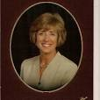
Bonnie Nothoff was President of the Michigan Dental Hygienists’ Association in 1998-99. She became MDHA’s Governmental Affairs Liaison in 2001, Director of Governmental Affairs in 2003 and was our Lobbyist from 2008 until her death in July, 2013. She worked tirelessly to organize, educate and inspire dental hygienists in Michigan to take an active role in pursuing many legislative initiatives. She helped us pass legislation that has greatly impacted the scope of practice of dental hygienists in Michigan and resulted in improved dental care for the public.
The legislation she helped MDHA pass was monumental: administration of local anesthetic and nitrous oxide analgesia by the dental hygienist with direct supervision by the dentist, our education in law not rule, impressions for mouth guards, bite splints, orthodontic appliances and bleaching trays, mandated one hour of pain management per license renewal period and the expansion of PA 58 to PA 161. This was her proudest achievement for it allowed expanded functions to underserved populations in specific sites such as schools, nursing homes and community health programs. The last legislation she was involved with was “second pair of hands” which allowed a dental hygienist to receive assistance by another individual.
Bonnie taught us the legislative process and encouraged each hygienist to contact his or her state senator and state representative and establish a working relationship with them. She would be the first to say our work is not done. This is an election year and the Michigan Dental Hygienists’ Political Action Committee needs your help.
The MDH-PAC is establishing an annual fundraiser in memory of Bonnie and all she did for dental hygienists in Michigan. The PAC uses its funds to support state senators and state representatives that support our legislative goals.
Please make a donation to the MDH-PAC in any amount in Bonnie’s memory. Help MDHA continue to pursue the legislative activity that she worked so hard to maintain.
Mail your check payable in ANY amount to MDH-PAC to Jackie Oliver, RDH 309 W. Saratoga Ferndale MI 48220 jacqoliver@gmail.com Employer information is required.
Name_______________________________________Evening phone__________________Email_____________________________
Address_____________________________________________City, ZIP__________________________________________________
Employer_______________________________Employer Address____________________________City,ZIP____________________
Paid for with regulated funds by MDH-PAC.
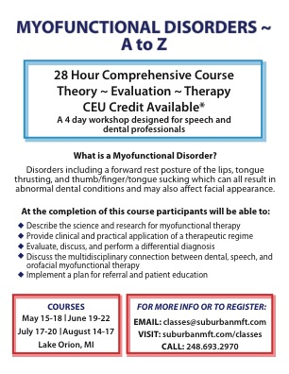

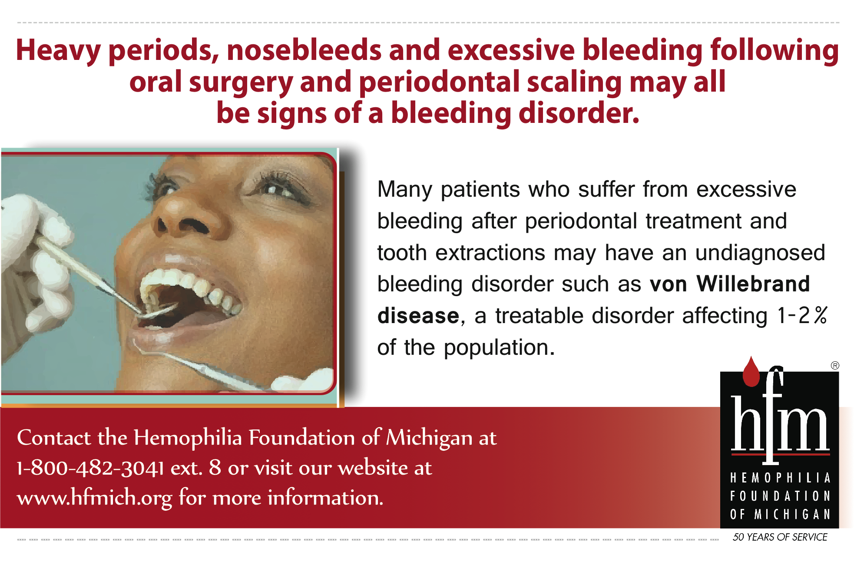
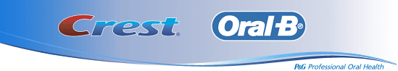

Become familiar with www.mdhatoday.org and learn to navigate MDHA’s website!! There is an easy link for a membership application, and many opportunities for continuing education credits through various components.
Advertisers: This Newswire is being sent bimonthly to approx. 1000 registered dental hygienists throughout the state. It reaches these RDH’s and then some! If you would like to have your logo appear in this publication, please visit our website www.mdhatoday.org and click on the “advertisers” link. To our readers, you are encouraged to patronize our sponsors! Thank you!

