Troy Marriott
200 West Big Beaver Friday, October 17, 2014 6CE’s

9AM-12 NOON "Hey Hygienists: What's in Your Future?"
Beth Nicely, RDH
DISCUSS AND REVIEW:
- Where is your profession taking you?
- How does working in a ob/gyn office or a pediatrician office sound?
- How would you like to treat the underserved?
- Find out all the different directions that our profession is going and how you can help with this move!
- This is a very exciting time for the profession of Dental Hygiene and you will want to be involved!
Beth is a graduate of Western Kentucky University with an Associate of Science in Dental Hygiene
Degree. I have been a clinical hygienist for 24 yr and have loved every minute of it. I am in my 4th year as ADHA District V Trustee, my strengths are leadership and mentoring. I am happily married to my best friend for 23 years and we have two children, Tyler is 19 and Natalie is 14.

1-4PM Emerging Oral Health Workforce Models: What Will the Dental Workforce Look Like in the Coming Decade?
Ms. Kathi Shepherd, RDH, MS

DISCUSS AND REVIEW:
- Discuss emerging oral health workforce models being proposed, developed or practiced.
- Gain an understanding of current educational preparation and required certification/licensure.
- Discuss the practice setting, dental supervision and services provided in each model.
- Discuss outcomes of existing models and/or developing pilots.
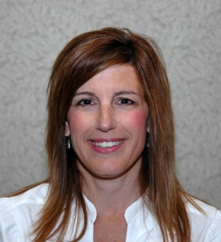
Ms. Kathi Shepherd, RDH, MS is the Director of the Dental Hygiene Program as well as Director of Educational Development and Assessment at the University of Detroit Mercy School of Dentistry. She graduated in 1982 from the University of Detroit and received a Master of Science in Healthcare. She has served as a Commission on Dental Accreditation (CODA) dental hygiene curriculum. She also serves on the CODA Task force for Developing Dental Therapy Standards and most recently is involved with leading the UDM dental hygiene program as an ADHA pilot model for preparing future dental hygienists. Ms. Shepherd has held numerous positions in professional organizations.
REGISTRATION
NAME___________________________________________________
CONTACT EMAIL AND PHONE#________________________________
ALL DAY: _______$30.OO ADHA MEMBERS _____$40.00 POTENTIAL MEMBERS

½ DAY: _______$25.00 ADHA MEMBERS _____$35.00 POTENTIAL MEMBERS
*****Please indicate AM or PM
MAKE CHECK PAYABLE TO MICHIGAN DENTAL HYGIENISTS’ ASSOCIATION (MDHA)
To reserve your place please mail or email this registration form to:
MDHA Attn: Joyce Losen 2310 Jolly Oak Rd Okemos, MI 48864 (517)381-8557 joyce@mdhatoday.org

