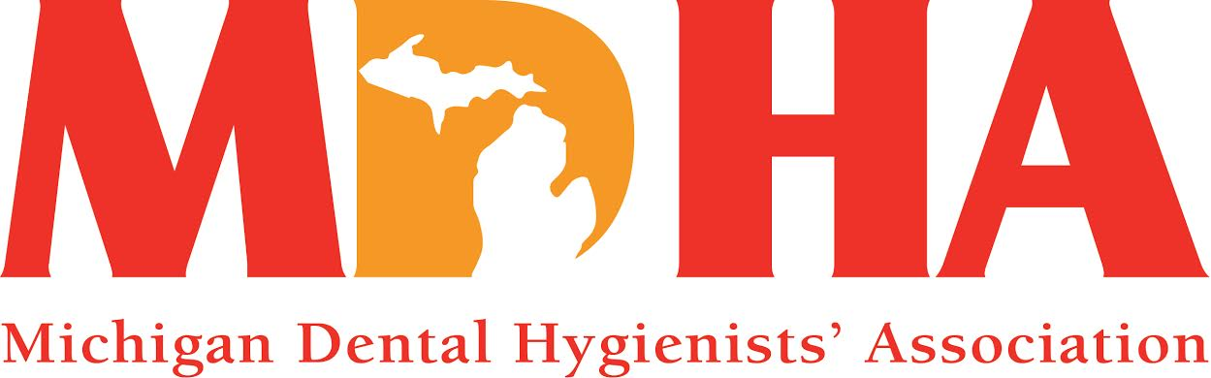

**November 2014 Newswire**

Description: Description: C:\Documents and Settings\HP_Administrator.HPBARRYMAIN\Local Settings\Temporary Internet Files\Content.IE5\ALVPQZNL\MC900072691[1].gif

Stay in contact with MDHA visit our website

<http://www.mdhatoday.org>

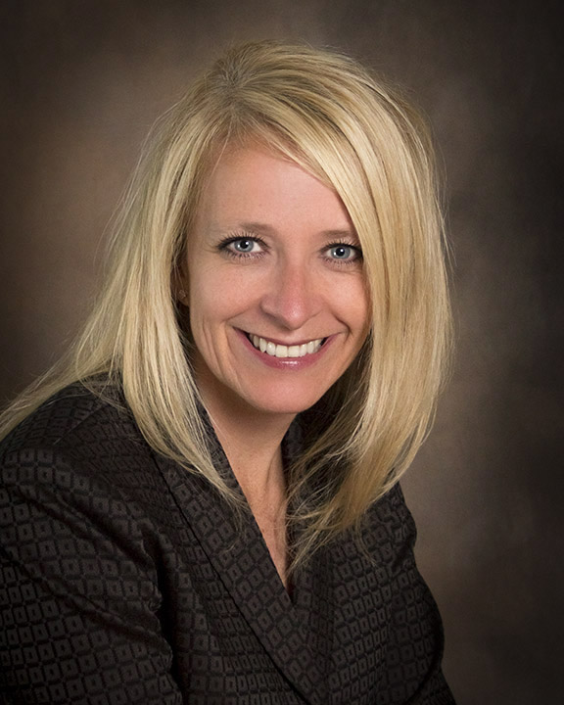

*3 Cheers for MDHA!! We are coming off of a successful House of Delegates in October, we have a vibrant team on our Board of Trustees and we are motivated to strengthen our Association and the members we serve!*

*You are an important part of the equation for success! You are a valued professional who understands the benefits of belonging to an Association that cares about you and protecting what you do.*

*We will be working hard this year to build relations, enhance our membership and strengthen our voices, so that we remain vital to the healthcare delivery system. An equation involves at least two quantities and states that two things are equal, so it will take all of us working together to achieve this balance.*

*To kick off our year, your Officers met with the officers from the Michigan Dental Association (MDA), and the Michigan Dental Assistants' Association (MDAA) for introductions and a joint dinner, which opened the lines of communication and created new relations. Last week, I was honored to speak to almost 500 students at Saginaw Valley State University who were attending the annual Student Member conference. The MDHA had a vendor table, where Vice-President, Vickie Yahn, and myself, greeted students and provided them with a member benefit package sent from ADHA, as well as an MDHA lip balm, which was a big hit!! I was selected to attend the ADHA Unleashing Your Potential weekend in Chicago in a few weeks and I feel very privileged to have this opportunity to strengthen my leadership skills. I am excited to bring back what I learn and help the MDHA succeed, which in turn will help our local Components succeed, which in turn helps you, the member, succeed!*

*It is an honor to be your MDHA President for 2014-15! My theme is "bringing harmony to the profession of dental hygiene" and I hope you will join me in making a difference! I look forward to representing the state of Michigan and MDHA into our 92nd year!*

*Please utilize our website,* [*www.mdhatoday.org*](http://www.mdhatoday.org)*, to get in touch with myself, or anyone you may need for assistance at any time.*

*Wishing you and your families a safe and fun-filled holiday season!*

*In harmony...*

*KATHY MIELKE, BS, RDH*

*MDHA President*

*Read President Mielke’s Installation Message here:*

[*http://www.mdhatoday.org/uncategorized/mdha-presidents-address-kathy-mielke/*](http://www.mdhatoday.org/uncategorized/mdha-presidents-address-kathy-mielke/)

Description: Description: C:\Documents and Settings\HP_Administrator.HPBARRYMAIN\Local Settings\Temporary Internet Files\Content.IE5\ALVPQZNL\MC900072691[1].gif

**VOLUNTEER OPPORTUNITIES**

**1.** The Michigan Osteopathic Association is hosting a local health learning event for school children.  At this mini-medical school, 5,500 local school children (Grades 1-5) will attend interactive session with medical/dental professionals to learn about their health.  Each profession will have 4 tables with 2-3 volunteers at each table.  This event will be held at the Breslin Center.  They would like to have 8-12 volunteers for each of the following sessions:

·       November 11 from 9-11 a.m. and from 12:30-2:30 p.m.

·       December 2 from 9-11 a.m. and 12:30-2:30 p.m.

      \*\*(volunteers need to arrive at least 45 minutes prior) to help set up and go over the schedule.  Volunteers could do only 1 time slot or multiple time slots if they are able.

If you are interested please contact:

**April Stopczynski** *Michigan Dental Association* *Manager of Access and Prevention*

3657 Okemos Rd. Okemos, MI 48864 [astop@michigandental.org](mailto:astop@michigandental.org) Direct Line:  [517/346-9417](tel:517%2F346-9417)

**2. The Coalition For Oral Health For the Aging** is looking for RDH’s who would be willing to present oral health education to seniors. We want to fill current requests from around the state including Barry, Emmet, Hillsdale, Isabella, and Lenawee counties (multiple requests in this county). We would also like to expand our speaker’s pool from all across the state so please let us know if you are interested even if your county is not listed. For more information and to learn how you can positively impact the oral health of our aging communities please contact:

**Suzanne Tanis**, COHA Education Chair

**Email:** [suzannetanis@continuingconnections.org](mailto:suzannetanis@continuingconnections.org)

**Phone:** 231.557.1195

**Website:** [www.micoha.org](http://www.micoha.org)

Description: Description: C:\Documents and Settings\HP_Administrator.HPBARRYMAIN\Local Settings\Temporary Internet Files\Content.IE5\ALVPQZNL\MC900072691[1].gif

**FUNDRAISERS**

**MDHA Annual Coffee Sale**

***ORDERS ARE DUE TO JAN POPOWICH BY NOVEMBER 15.***

Eve Sidney, RDH [sidneyej@gmail.com](mailto:sidneyej@gmail.com) Jan Popowich, RDH [janp2@wowway.com](mailto:janp2@wowway.com)

MDHA Coffee Sale Co-Chairmen 586-468-9561 (Jan)

Do you need ideas for holiday gifts? Look no further. The annual MDHA coffee sale can help. The following coffees will be available for purchase during the fall sale. Coffee will be delivered at the December BOT meeting-just in time to enjoy during the December holidays. Regular coffee is $16.00 and decaf coffee is $18.00 a bag.

Check with your components for fall coffee order due dates and delivery! Help support MDHA with a cup of coffee a day!

The following coffees will be featured during the Fall 2014 sale.

Unflavored Coffee

**Breakfast Blend**: This mix of four beans roasted light and dark makes for a slightly stronger taste. Perfect for the morning commute or anytime. *Caff or Decaf*

**Bunches**: A blend of three beans from Central America, Africa and Indonesia, resulting in a mild but flavorful cup of coffee. *Caff or Decaf*

**Winter’s Blend**: A very popular blend of both light and dark roasted Costa Rican. This makes a smooth, full flavored and clean cup of coffee. *Caffeinated only*

**Colombian Supremo**: Rich, well balanced, and deep with a medium body. A very popular coffee around the world. *Caffeinated only*

**Flavored Coffee**

**Coffee Cake:** You can smell it baking in the oven! A hint of nuts, ginger, orange, cinnamon and spices. ***Caffeinated only***

**Cookie Doodle:** Just like a popular old fashion cookie! Light cinnamon with hazelnut and vanilla. ***Caff or Decaf***

**Jamaican Me Crazy:** A cool blend of Caramel, Kahlua, and Vanilla. A top seller! ***Caff or Decaf***

**Holiday Flavored Coffee**

**Christmas Spice:** Egg nog with cinnamon and spices. A Favorite! ***Caffeinated only***

**Pumpkin Spice:** Fresh baked pumpkin pie right from the oven. Just add whipped cream! ***Caffeinated only***

Description: Description: C:\Documents and Settings\HP_Administrator.HPBARRYMAIN\Local Settings\Temporary Internet Files\Content.IE5\ALVPQZNL\MC900072691[1].gif



Description: Description: C:\Documents and Settings\HP_Administrator.HPBARRYMAIN\Local Settings\Temporary Internet Files\Content.IE5\ALVPQZNL\MC900072691[1].gif

**LEGISLATIVE COUNCIL NEWS**

**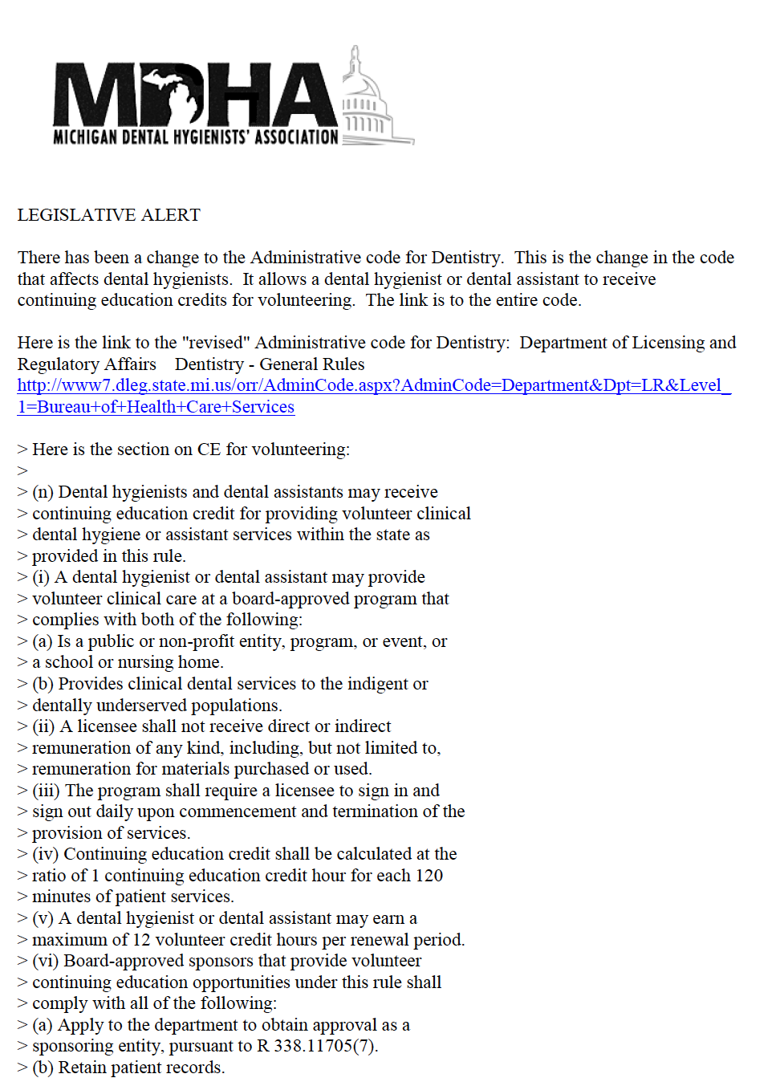**

Description: Description: C:\Documents and Settings\HP_Administrator.HPBARRYMAIN\Local Settings\Temporary Internet Files\Content.IE5\ALVPQZNL\MC900072691[1].gif

**COMPONENT NEWS**

Thank you to Central, Northland, and Sunrise Side

for their financial support of MDHA Publications

Description: Description: C:\Documents and Settings\HP_Administrator.HPBARRYMAIN\Local Settings\Temporary Internet Files\Content.IE5\ALVPQZNL\MC900072691[1].gif

Redistricting Components - MDHA Making History

**Theodore Roosevelt said;**

**"Every man owes a part of his time and money to the business or industry in which he is engaged, and no man has a moral right to withhold his support from an organization that is striving to improve conditions within his sphere.  An association *can do things with you* but *they can't do things for you*."**

A couple of years ago at the American Dental Hygienists’ Association’s (ADHA) annual meeting there was a mega issue question asking what members thought of the tripartite structure of our association, if changed could it be better? A few options were discussed: (1) national and state, with no local components; (2) national and local with no state association; or (3) just state and local, with no national organization. Overwhelmingly the response was to keep the existing structure. But streamlining operations within the states is imperative to operate efficiently.

Michigan is one of the states with the most components. Like many states we are losing members—so much so that we have lost a delegate to the ADHA for 2015. Due to the decrease in our membership we continue to struggle with a decreasing budget. Without funds to carry out membership retention/recruitment efforts, legislative initiatives, and everyday functions that enhance our organization, MDHA could become ineffectual, to the detriment of our members.

We need to make ourselves more relevant to our members through communication, advocacy, and education. In an effort to do this, we redistricted our components by enlarging their geographical boundaries. This will lessen the drain on leadership positions and reduce costs by maintaining a smaller board of trustees (BOT).

**As our president Barack Obama so eloquently stated, “Change will not come if we wait for some other person or some other time. We are the ones we’ve been waiting for. We are the change that we seek.”**

Currently with 18 components, the state as a whole needed to elect 18 presidents, 18 trustees, and 18 treasurers, to remain in compliance. Several components are inactive and do not have officers so they were not able to communicate with members or offer continuing education opportunities. Keep in mind the goal is to increase the leadership pool and be fiscally responsible. The choice was either revoke the charters of non-functioning or incompliant components or aid those components by blending them with another component, creating opportunities. We as officers and trustees have a fiduciary responsibility and can be held liable for the actions of the components that we have issued charters.

At our December BOT meeting we held a brainstorming session facilitated by Beth Nicely our District V trustee. We developed a task force which included trustee and non-trustee members. Heather Beavers was the chair of the task force. It included Pam Aguis, Meagan McClintic, Rene Louchart, Nancy Goodyear, Brenda Lale, and Stephanie Moor. We thank them for their loyalty and commitment to the Michigan Dental Hygienists’ Association.

They used the book Race for Relevance by Harrison Coerver as their guide. They worked diligently over the last nine months to come up with recommendations for our board of trustees (BOT). It is the responsibility of our BOT to determine the geographical boundaries’ of the components; as per our Bylaws Article VII Components. Our trustees took their recommendations and consolidated a few additional of the less active components with others. We went from 18 components to 9.

The Michigan Dental Hygienists’ Association is not alone. Associations throughout the country are struggling to remain relevant to their members. To successfully gain relevance, there is a national trend towards smaller boards. The Michigan Dental Association (MDA) also reduced their number of components to 9. However, their trustees are at large members selected by a nominating committee. Our members will still elect their trustees, one from each component. That has not changed.

**President John F. Kennedy once said, “Change is the law of life. And those who only look to the past or present are certain to miss the future”.**

We are looking to the Future. Our profession is at a crossroads. We need to be strong, efficient, and accountable to be respected as essential primary oral health care professionals.

**“The new ADHA strategic plan changed most significantly through our core ideology and vision statement. The core ideology reflects our commitment to leading the transformation of the profession to improve the public’s oral and overall health,” said ADHA President Kelli Swanson Jaecks, MA, RDH.  She goes on to say…“Our vision is to integrate dental hygienists into the health care delivery system as essential primary care providers to expand access to oral health care. The opportunities that lie before us to profoundly transform dental hygiene are truly exciting, and afford us the chance to impact and improve both the public and our profession in ways never done before.”**

Redistricting was a bold move. We know that change is difficult. Reaching out from your comfort zone and doing things differently is not easy. The BOT voted overwhelming in favor of redistricting by a blind vote, in writing (17- yes, 2- abstained, 2-not present, 1 –no) well over the two-thirds requirement. This was a necessary move if we are to remain a viable organization. We need to become more relevant to our members and potential members. We ask you all too please open your minds and heart, be welcoming to one another; we are all dental hygienists seeking the best for our profession and the public. We will be stronger.

Early next year, all members will receive a letter explaining the change, and all component presidents and trustees will receive guidelines on how to go about blending your components. Your charge will be to determine a new name if necessary, elect officers for the blended component and to determine how the bank accounts will be consolidated and divided. Included will be instructions on how to complete the necessary paperwork for the state and the IRS. Members have always had a choice as to which component they belong to, that has not changed. The choice is yours.

I am so proud of our board of trustees. I believe the trustees looked at the big picture and did what is best for the organization. We are determined to become more relevant to our membership. We are dental hygienists, the preventive oral health specialists, essential primary care providers of oral health care needs and we will be at the table to help determine the future of our profession.

Respectfully Submitted by,

Cheryl Bentley, RDH

MDHA Immediate Past President

Description: Description: C:\Documents and Settings\HP_Administrator.HPBARRYMAIN\Local Settings\Temporary Internet Files\Content.IE5\ALVPQZNL\MC900072691[1].gif

**Communication Council News**

visit

www.mdhatoday.org

Please remember, if you have information regarding seminars, newsletters, or anything you feel it is pertinent for your members and students, please post it on the MDHA website, [www.mdhatoday.org](http://www.mdhatoday.org/)!!

If you have any questions, please contact our webmaster, [jen\_suminski@yahoo.com](mailto:jen_suminski@yahoo.com).

Description: Description: C:\Documents and Settings\HP_Administrator.HPBARRYMAIN\Local Settings\Temporary Internet Files\Content.IE5\ALVPQZNL\MC900072691[1].gif

**CONTINUING EDUCATION**

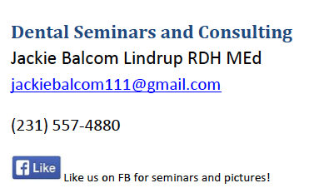

**Dec. 5th** Dental Ergonomics through PT and MAPS – Michigan Automated Prescription System and Narcotics abuse… $60.00 Earlybird registration, then $80.00

Seminars in Muskegon at GVSU Marec Food by Grand Traverse Pie

**Russell W. Bunting Periodontal Society**  **Seminars**

Friday November 14, 2014 Speaker: Allan G. Farman, BDS, PhD Trends and Influences Affecting Dentistry through Multidimensional Imaging Location: Weber's Inn, Ann Arbor Registration 8:30 am Lecture 9-5 Visit Website, [Russell W. Bunting Periodontal Society](http://www.buntingperio.org/)

**Ferris State University Dental Hygiene Workshops**

The link to all of our dental offerings is: <http://www.ferris.edu/HTMLS/administration/academicaffairs/extendedinternational/cps/pages/dentalhygiene/index.htm>

Description: Description: C:\Documents and Settings\HP_Administrator.HPBARRYMAIN\Local Settings\Temporary Internet Files\Content.IE5\ALVPQZNL\MC900072691[1].gif

**JOB OPPORTUNITIES**

Did you know that you can find great job opportunities on the MDHA website? Check it out today, visit http://www.mdhatoday.org/members/Employment%20Opportunities.html

Description: Description: C:\Documents and Settings\HP_Administrator.HPBARRYMAIN\Local Settings\Temporary Internet Files\Content.IE5\ALVPQZNL\MC900072691[1].gif



Description: Description: C:\Documents and Settings\HP_Administrator.HPBARRYMAIN\Local Settings\Temporary Internet Files\Content.IE5\ALVPQZNL\MC900072691[1].gif

Become familiar with [www.mdhatoday.org](http://www.mdhatoday.org) and learn to navigate MDHA’s website!! There is an easy link for a membership application, and many opportunities for continuing education credits through various components. Description: Description: C:\Documents and Settings\HP_Administrator.HPBARRYMAIN\Local Settings\Temporary Internet Files\Content.IE5\ALVPQZNL\MC900072691[1].gif

**Advertisers**: This Newswire is being sent bimonthly to approx. 1000 registered dental hygienists throughout the state. It reaches these RDH’s and then some! If you would like to have your logo appear in this publication, please visit our website [**www.mdhatoday.org**](http://www.mdhatoday.org) and click on the “advertisers” link. To our readers, you are encouraged to patronize our sponsors! Thank you!

