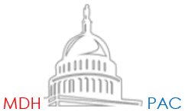
2019 PAC EVENT
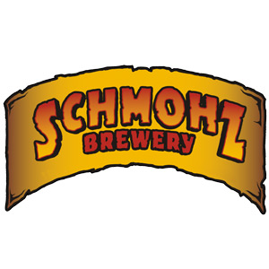
Come Join friends for Pizza and beer at Schmohz Brewery
Cost $25 Donation to the MDH PAC
Located across the street from the Double Tree Hotel
*Pizza provided
*Cash Bar and for wine drinkers if you bring your own $5 corking fee
Friday October 18, 2019 7-9pm
Send checks payable to MDH PAC to:
MDH PAC; Acuitas;110 W Michigan Ave. Ste 100; Lansing MI 48933
Name_________________________________________________________________________________________
address_______________________________________________________________________________________
Employer and employer address and phone__________________________________________________________
_____________________________________________________________________________________________
Paid for by the MDH PAC

