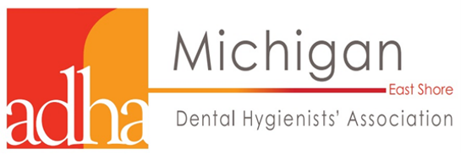
“The Latest Trends in Orthodontics”
2 CE credits
Speaker Andrew DeHaan, DDS, MS,
Orthodontic Specialist

Location: Center Campus Macomb Community College 44575 Garfield Rd, Macomb Township
Registration & Payment due January 7th, 2022
Check-In & Announcements 6:00-6:30
Lecture 6:30-8:30
Pick up CE Certificate of Attendance 8:30-8:45
Seminar Fee $60
ADHA Member $30
Student $15
Invite your friends & co-workers to attend with you!

Course Objectives
- Update on clear aligners
- DIY tooth movement trends
- How young is too young?
- Why is an 8 year old in braces?
- What happens at an ortho consult?

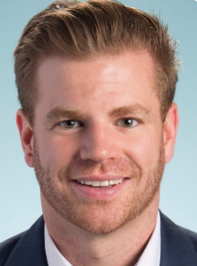
Dr.Andrew DeHaan is an orthodontist in solo practice in Lake Orion, MI. Shortly after graduating from the UDM Orthodontics Residency, Dr. DeHaan joined his aunt, Dr. Deborah DeHaan, in practice. Dr. DeHaan brings a unique perspective of new trends in orthodontics, to contrast with traditional and trusted methods. Dr.DeHaan is passionate about educating dental professionals on the importance of early orthodontic intervention, clinical orthodontic treatment, and new trends that attract patients. Dr. DeHaan has been an active member of the American Dental Association and the Michigan Dental Association since 2006. Recently, Dr. DeHaan held officer positions with the Oakland County Dental Society and is currently serving on the MDA’s Committee of Endorsed Services.
Register for this event Name: ________________________ Phone: _______________________
Email: ______________________ Address: _________________________________________________________
Select Profession: RDH RDA/CDA DMD/DDS Student Other: ________
Professional License Number: _________________________ ADHA Number: ______________________
Please make checks payable to: East Shore Dental Hygienists’ Association
Mail this registration form and check to: Ms. Lauren Eischer, RDH 17600 Longfellow St, Roseville MI, 48066

Parking Guide for Macomb Community College Center Campus
‘